**SCHOOL OF COMPUTER SCIENCE**

**UNIVERSITY OF PETROLEUM AND ENERGY STUDIES**

**DEHRADUN, UTTARAKHAND**



**IT DATA SECURITY**

**LABORATORY FILE**

**(2024-2025)**

**For**

**Vth Semester**

**Submitted To: Submitted By:**

Prof. Abhishek Yadav Mr. Akshat Negi

Assistant Professor S.S. 500106533(SAP ID)

[Vth Semester] R2142220414(Roll No.)

School of Computer Sciences B.Tech. CSF (Batch-1)

**LAB EXPERIMENT – 1 (a)**

**NMAP on Different Sites**

Nmap, which stands for **Network Mapper**, is a robust open-source tool utilized for network discovery and security auditing. It is extensively used by network administrators, security experts, and even hackers. Nmap enables users to detect devices and services operating on a network and to collect relevant information about them.

* Here are some typical applications of Nmap:
* Network Discovery: Nmap can scan networks to uncover hosts, services, and open ports, making it valuable for network inventory and mapping.
* Port Scanning: It can examine open ports on a target system, aiding in the identification of potential vulnerabilities and the services associated with those ports.
* Service Version Detection: Nmap can attempt to ascertain the version of services running on open ports, which assists in vulnerability assessment and patch management.
* OS Detection: Occasionally, Nmap can identify the operating system on a target host by analyzing the responses observed in the network.
* Scripting: Nmap features a scripting engine known as the Nmap Scripting Engine (NSE), enabling users to create and execute scripts that automate tasks, conduct sophisticated network scans, and extract more information from targeted systems.
* Firewall Detection: Nmap has the capability to identify the presence of firewalls and other security devices by examining the responses it receives from its probes.

Remember that while Nmap serves as a beneficial tool for network administrators and security experts, its robust functions can also be exploited by malicious individuals. Thus, it’s crucial to utilize Nmap in a responsible and ethical manner, adhering to the laws and regulations related to network security and privacy.

**Enhanced Scan Results:** The results from Nmap scans executed with the -sC option may contain supplementary information collected by the default scripts, offering users more detailed scan results.

**Nmap and Nping On 4 Different Websites:**

* 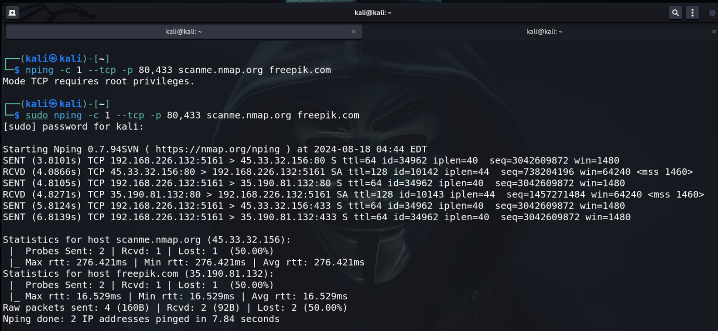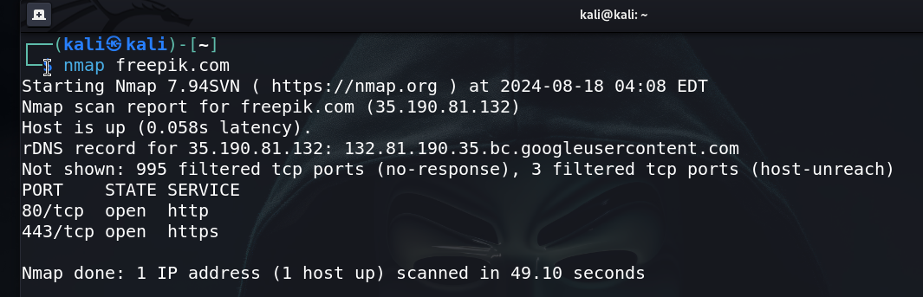**freepik.com**
* **martingarrix.com**

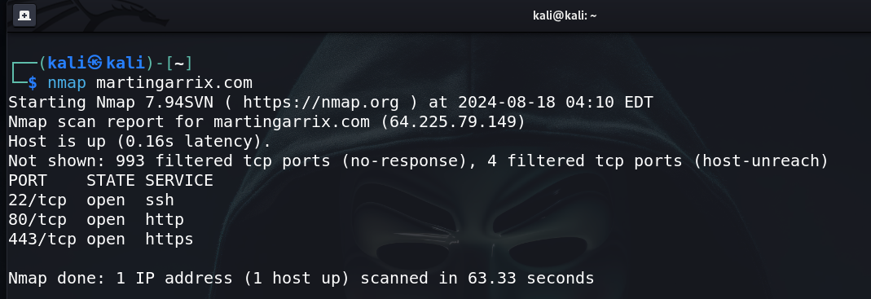

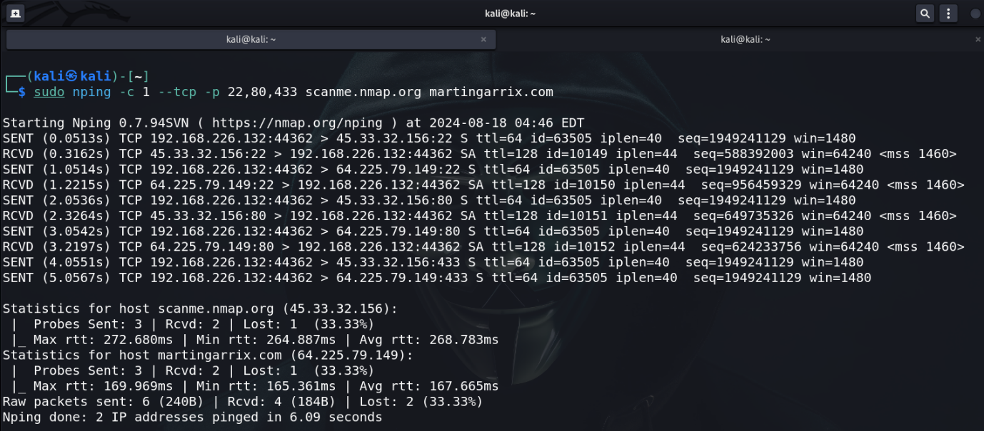

* **igetintopc.com**

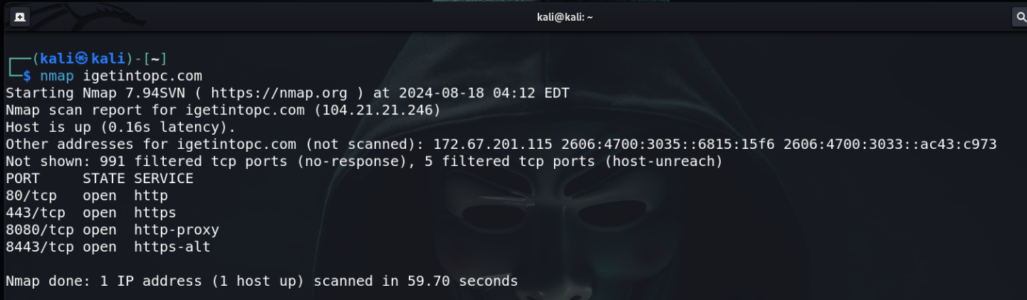

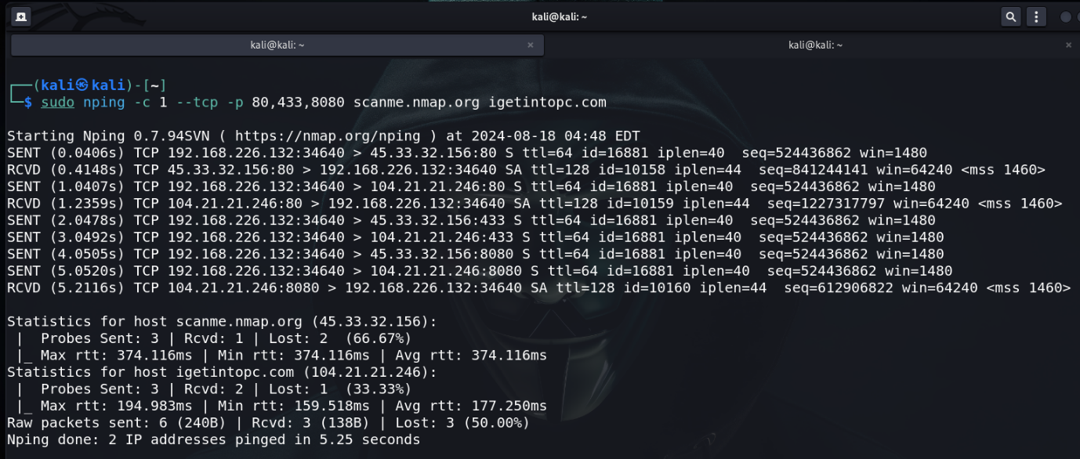

* 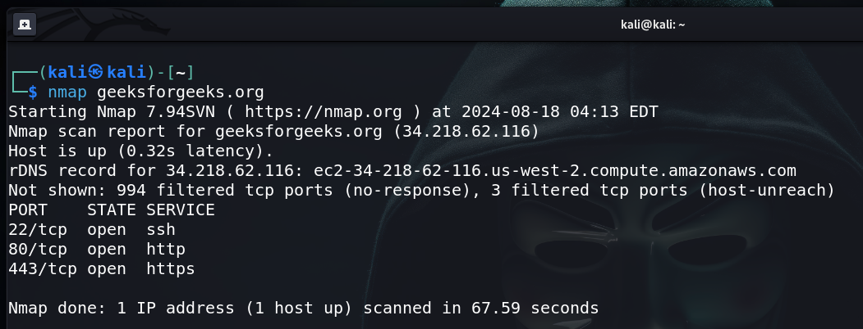**geeksforgeeks.org**

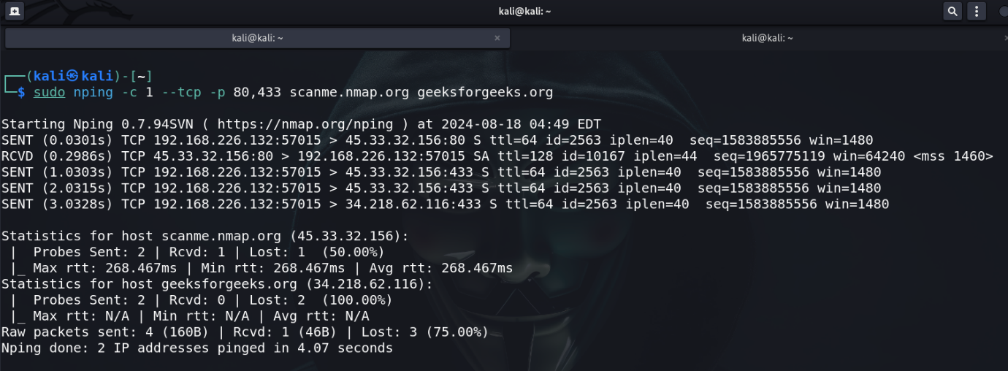

**Ncat Usage between Windows and VM Kali Linux.**

* **Installation of Ncat on Windows.**

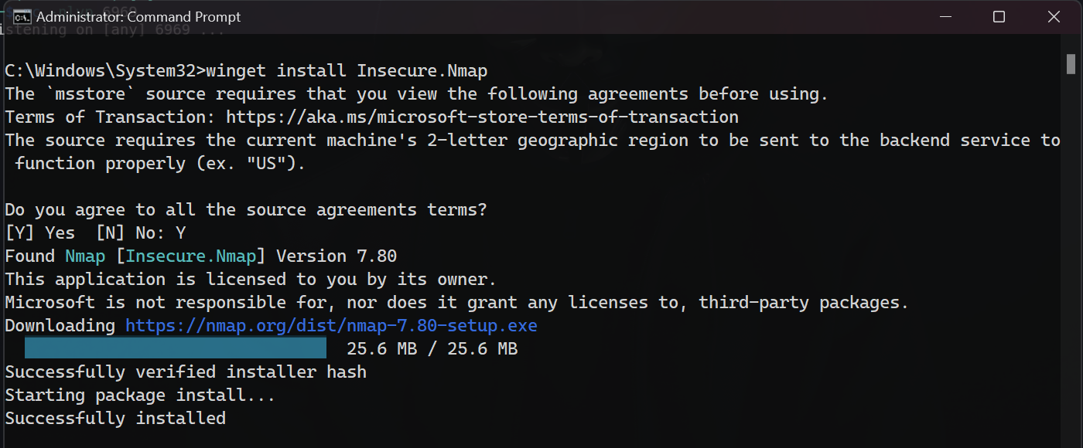

* 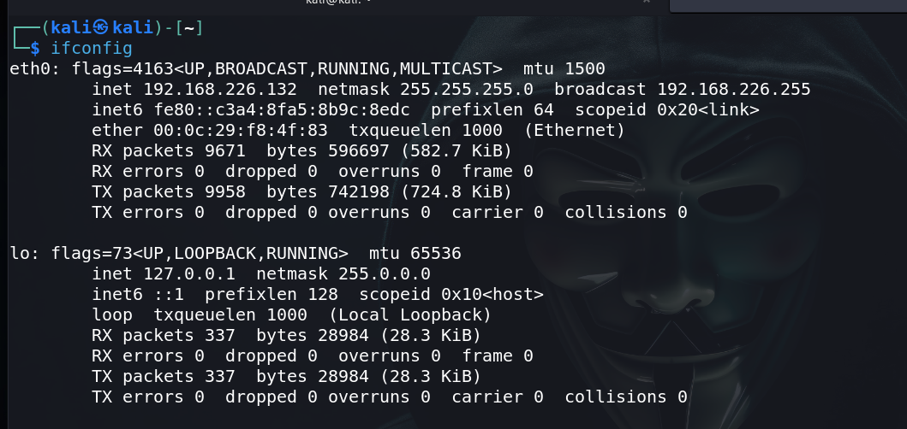**Check the IP on Kali Linux. i.e., 192.168.226.132**
* 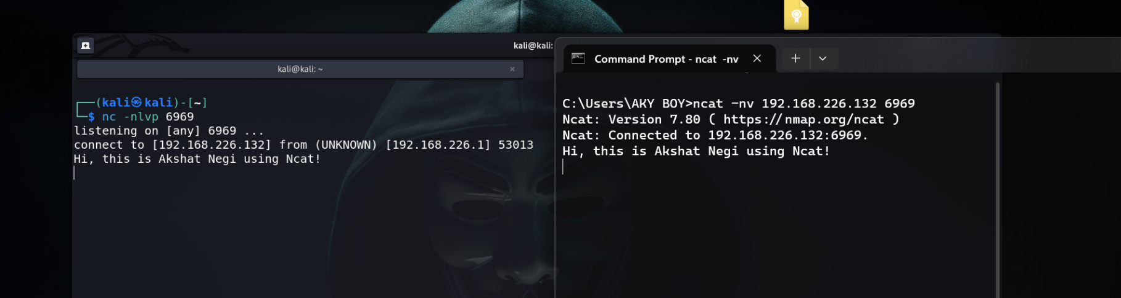**Connected and Interaction between two machines on a Network using Ncat.**

**LAB EXPERIMENT – 1 (b)**

**Wireshark and**

**Nagios Network Analyzer**

**Wireshark** is a free and open-source packet analyzer. It is used for network troubleshooting, analysis, software and communications protocol development, and education. Originally named Ethereal, the project was renamed Wireshark in May 2006 due to trademark issues.

**Nagios Network Analyzer** is a cloud-based bandwidth monitoring and utilization solution that provides details on network traffic sources, potential security threats and bandwidth consumption data. It is suitable for businesses of all sizes and in various industries.

**Personal Router Traffic Analysis**

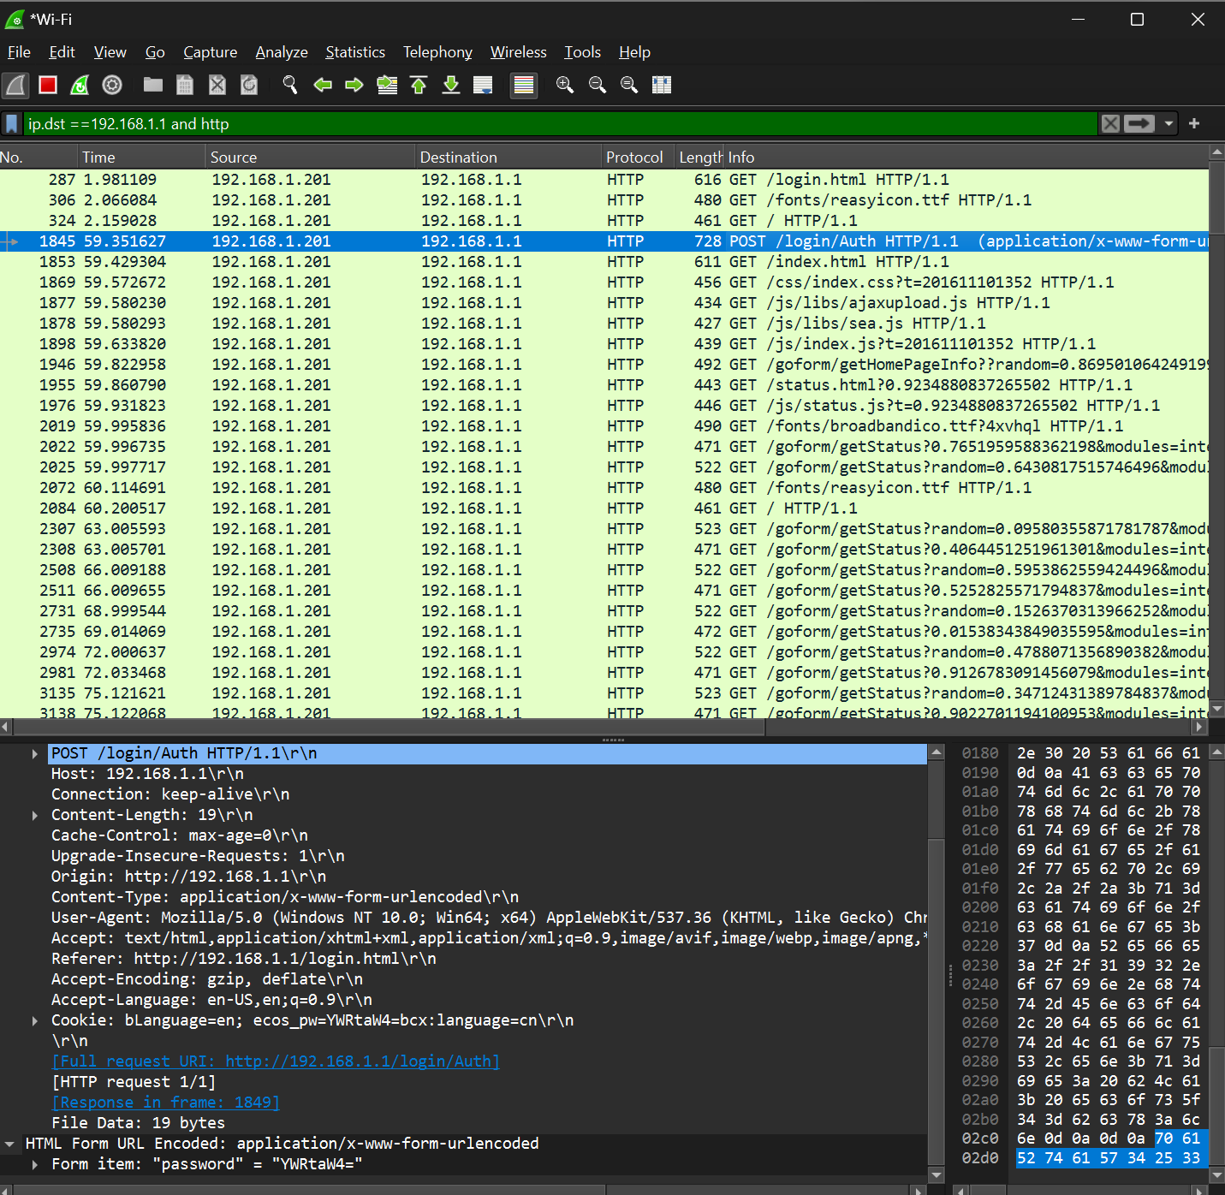

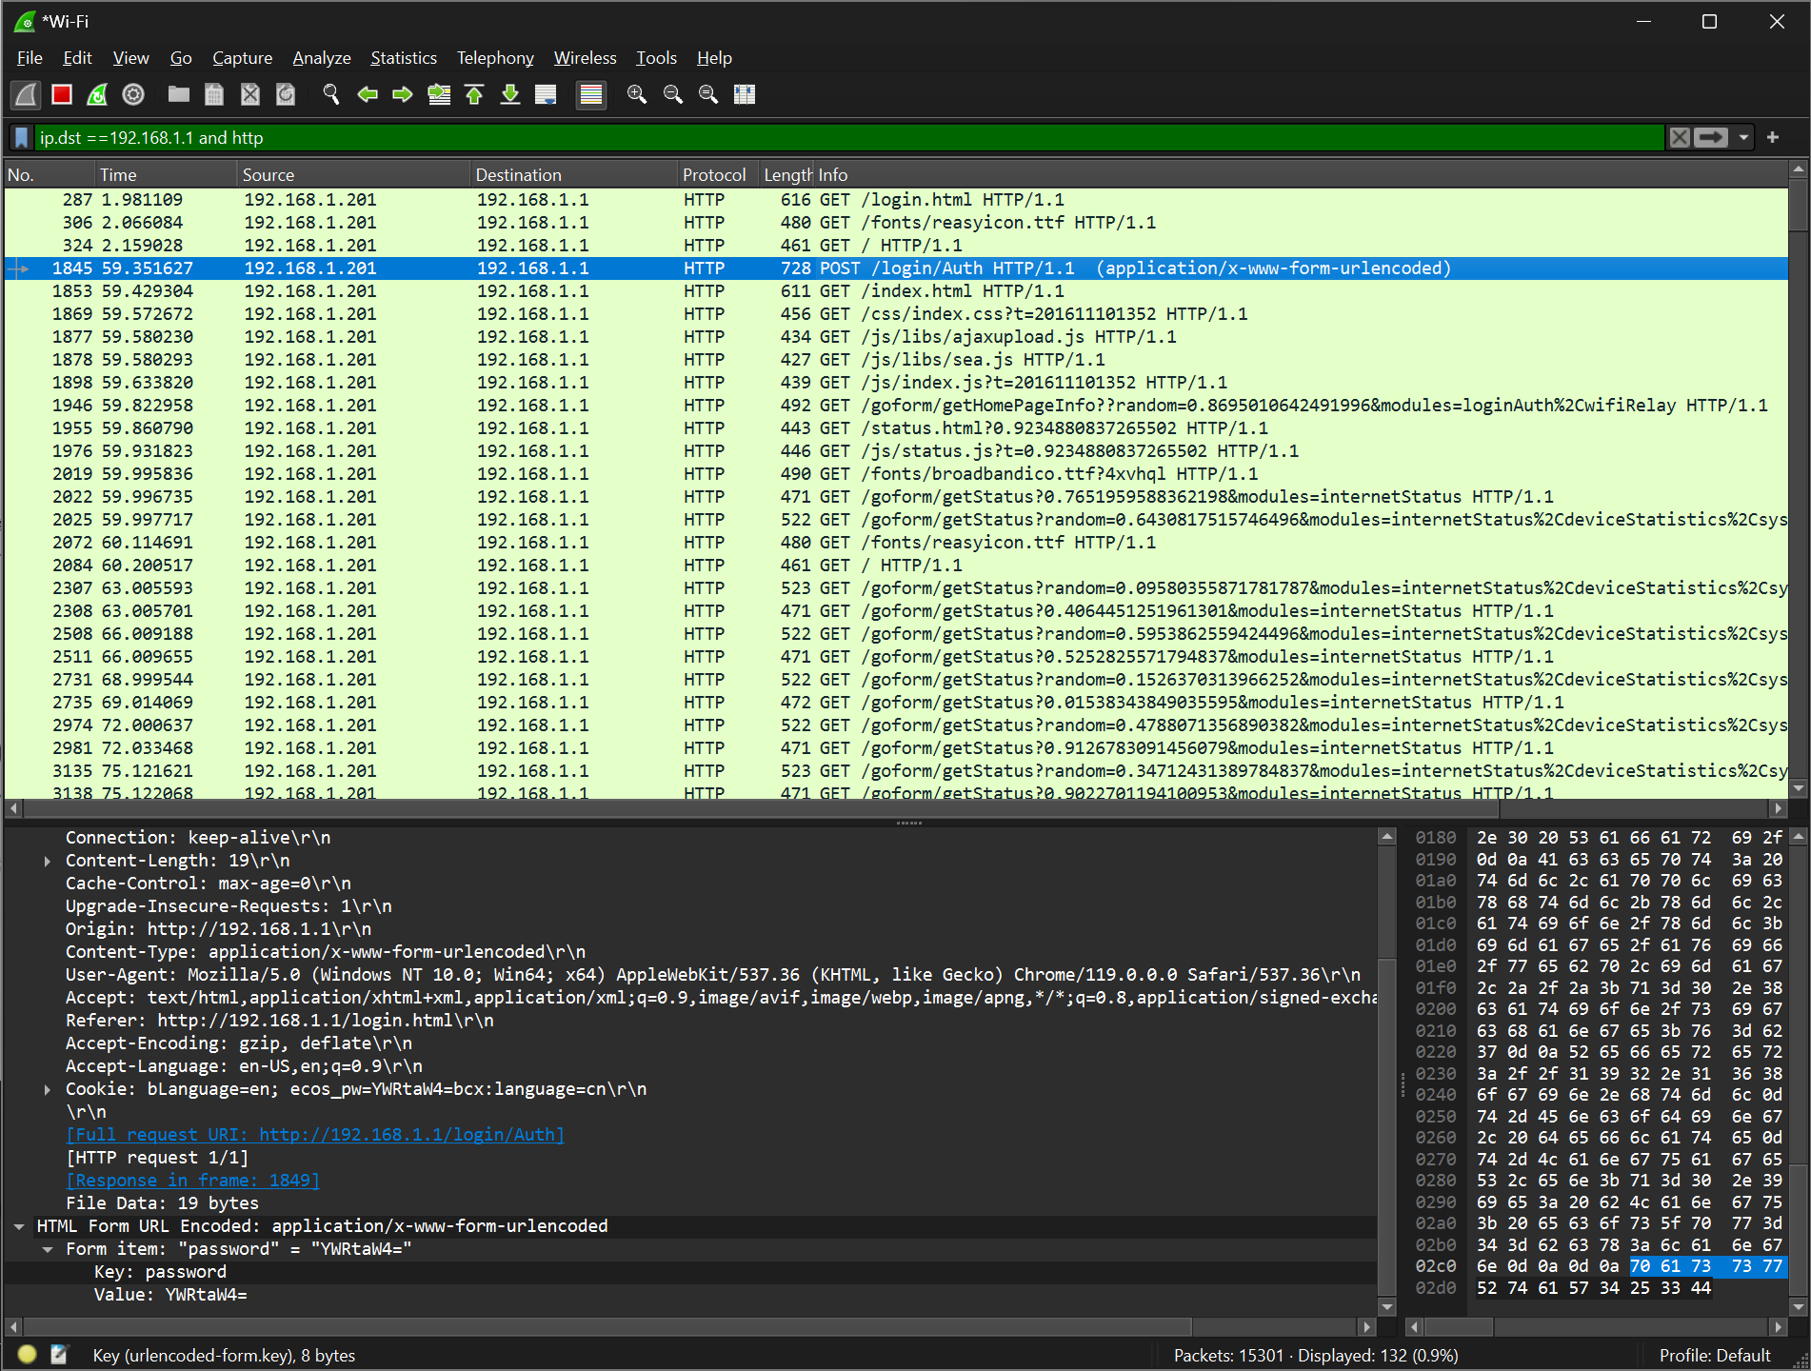

**Information Gathering from the following website:**

[**http://testphp.vulnweb.com/login.php**](http://testphp.vulnweb.com/login.php)

**Gathered the username and password using the Hyper-Text Transfer Protocol**

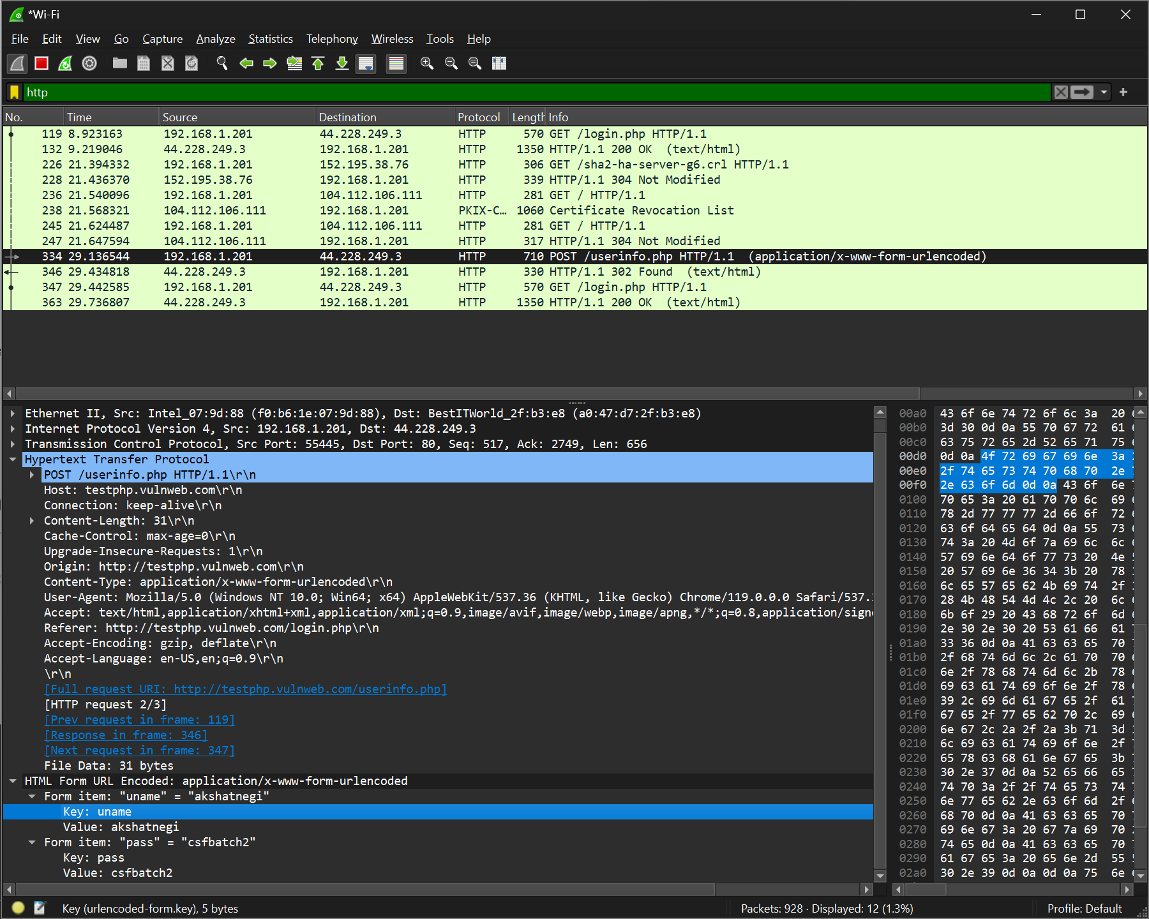

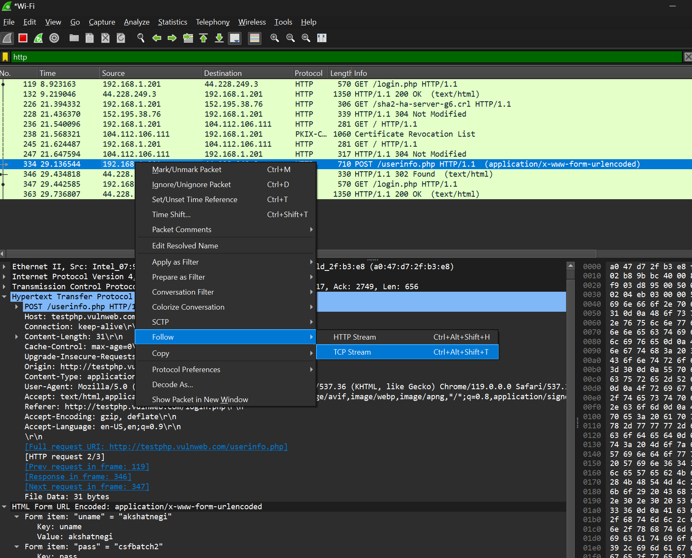

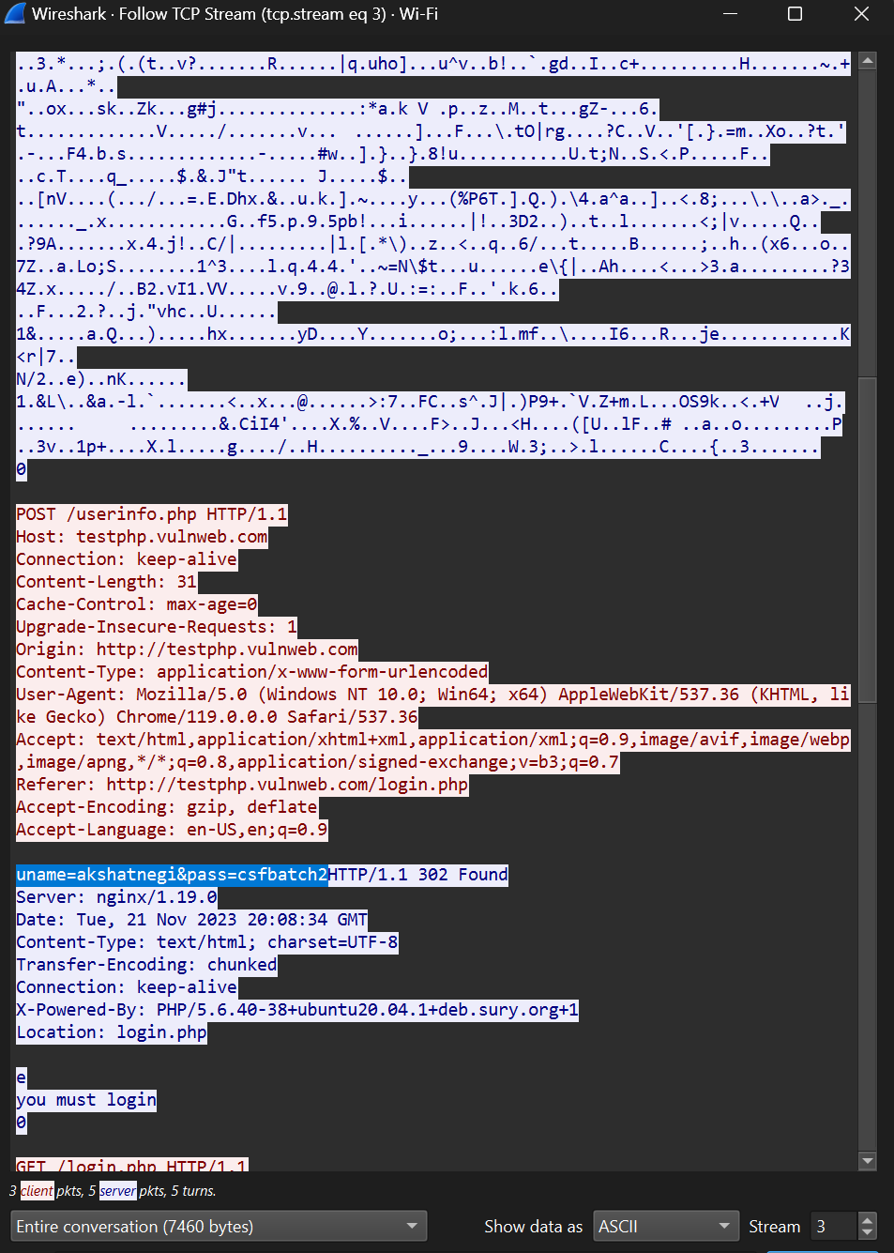

**UDP Filter**

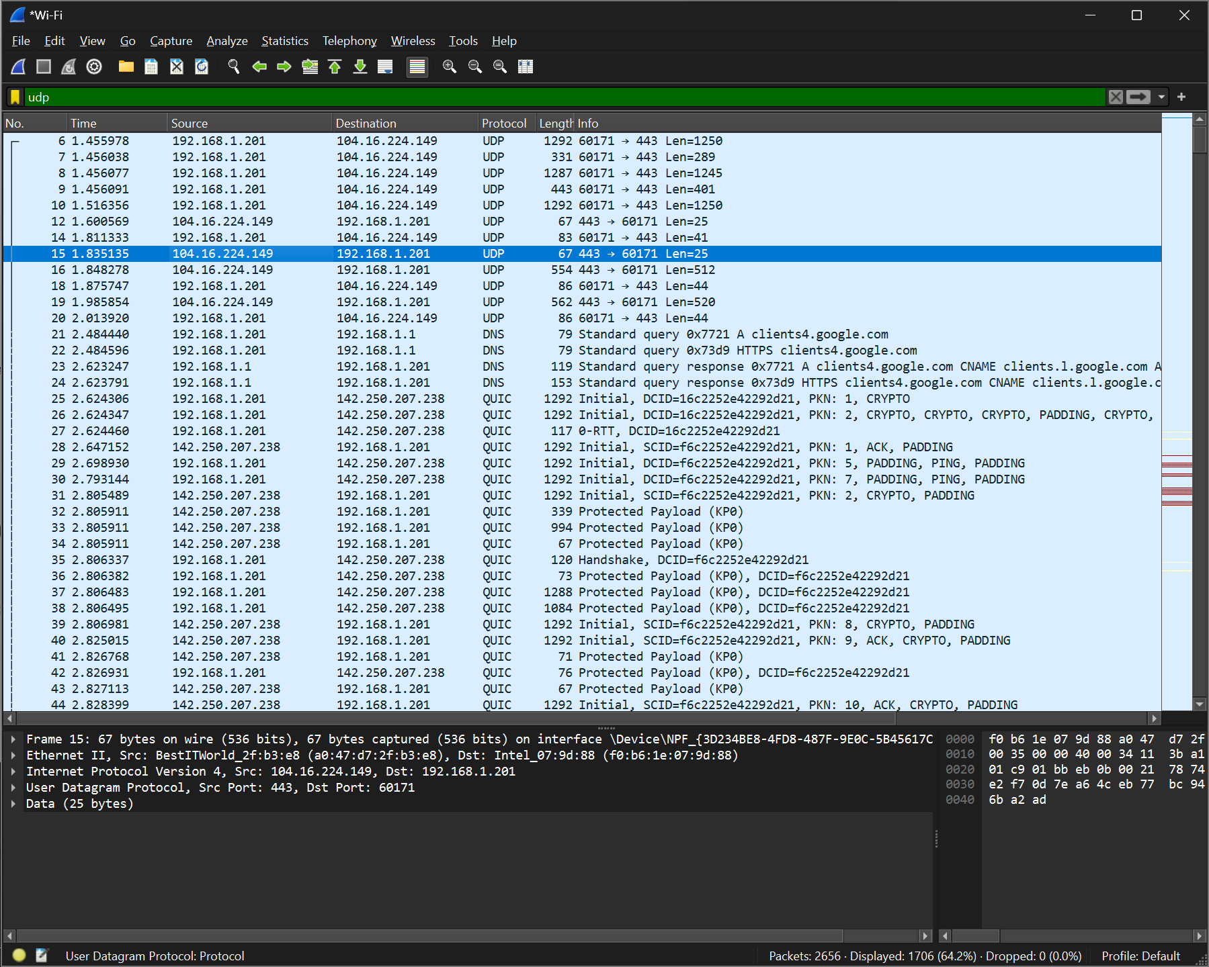

**TCP Filter**

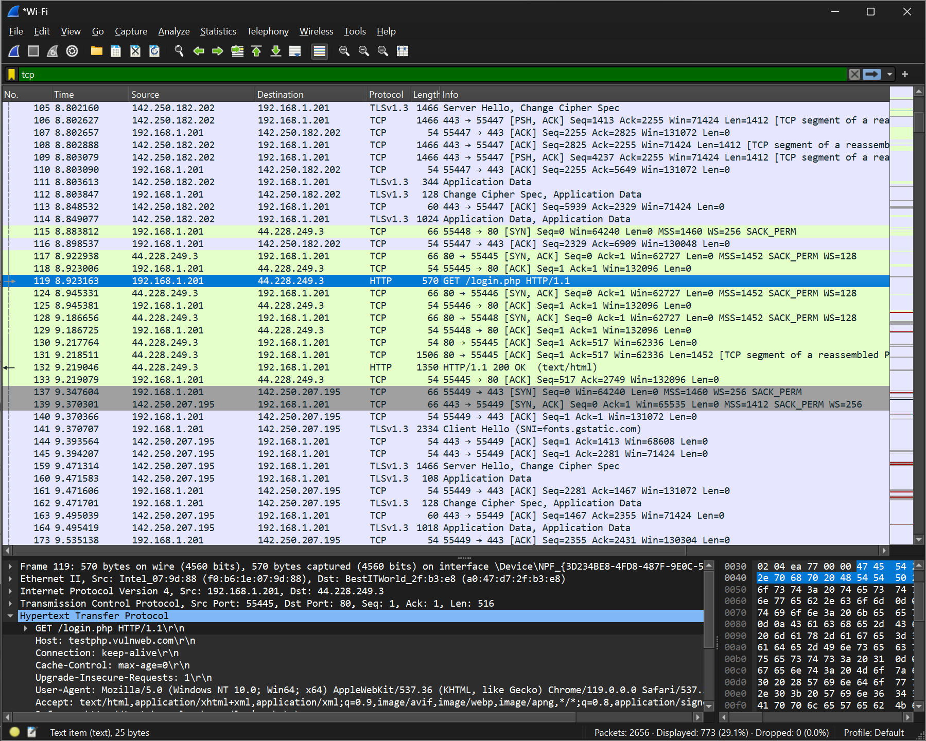

**HTTP Filtered**

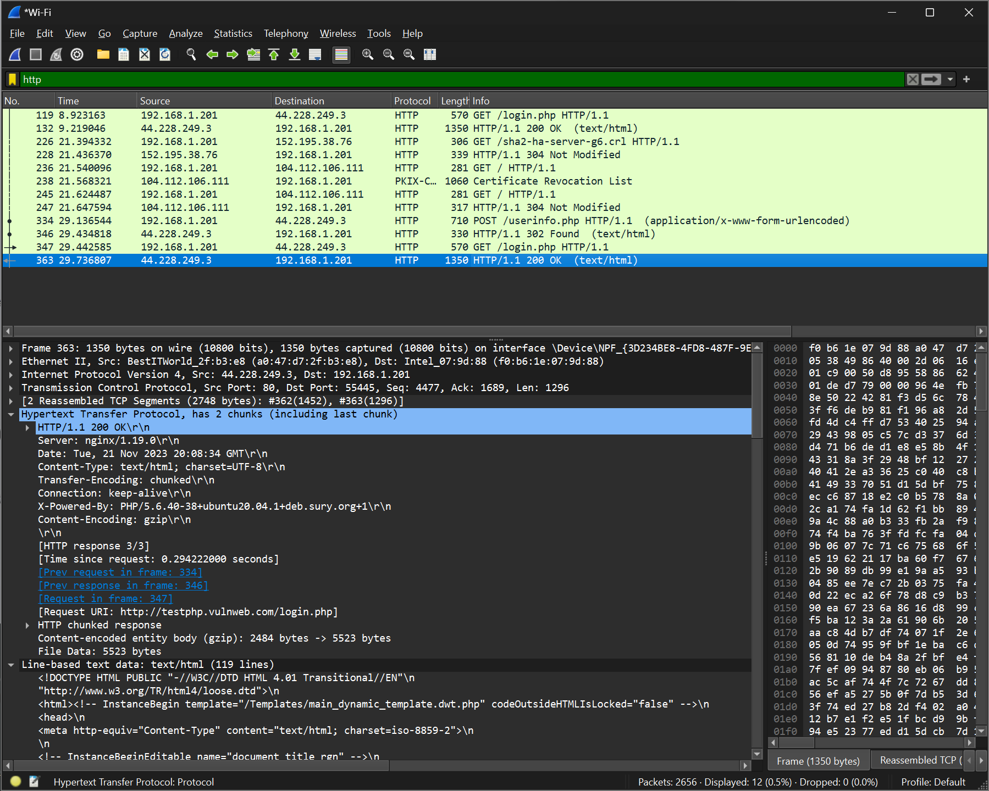

**To check which websites are surfed on a network (only http websites)**

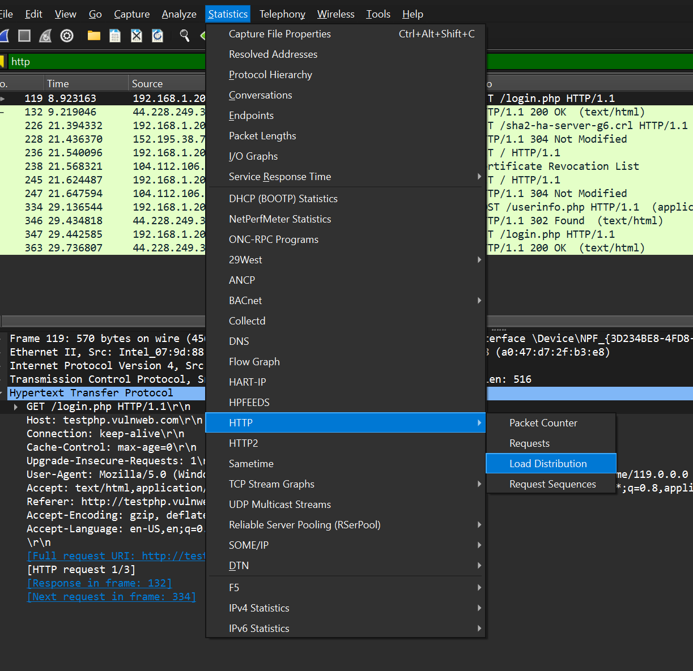

**Nagios Network Analyzer Installation and Analysis on VM**

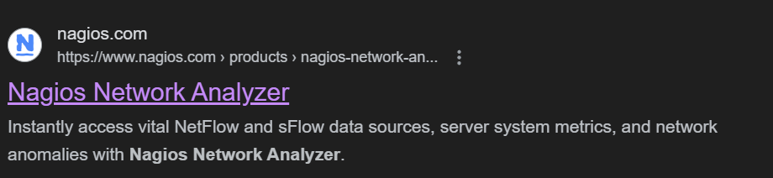

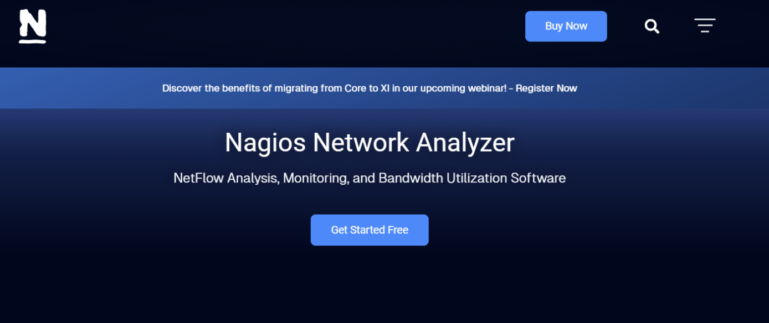

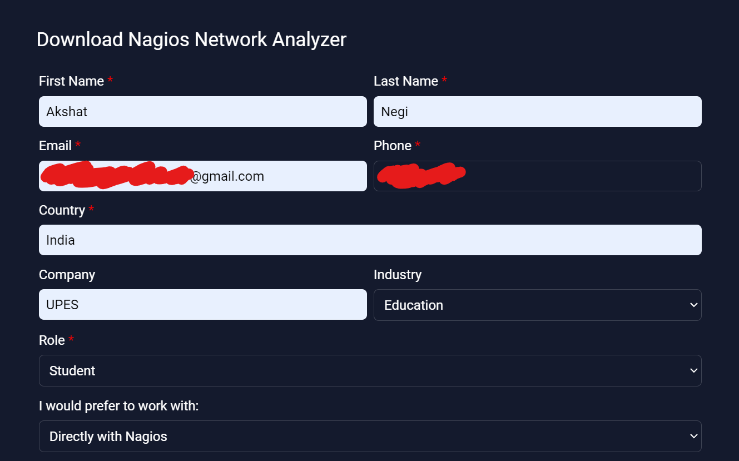

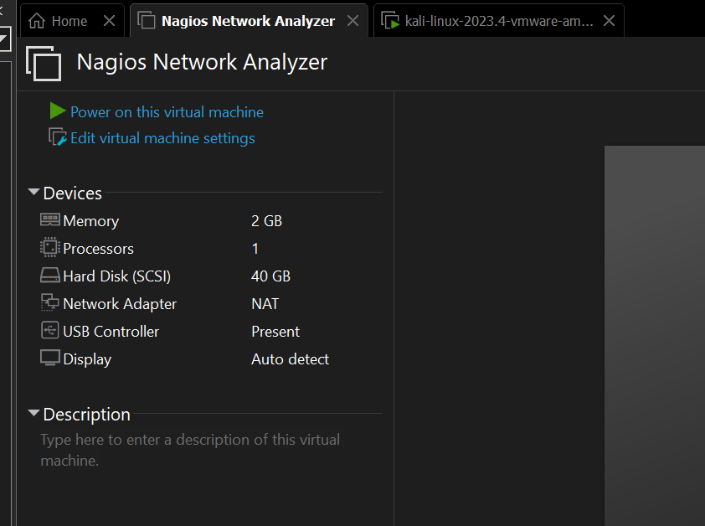

**Nagios Network Analyzer Interface VM**



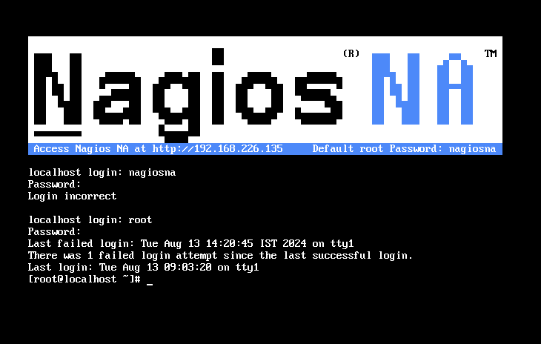

**LOGIN CREDENTIALS**

**ID - nagiosadmin**

**Password - kali**

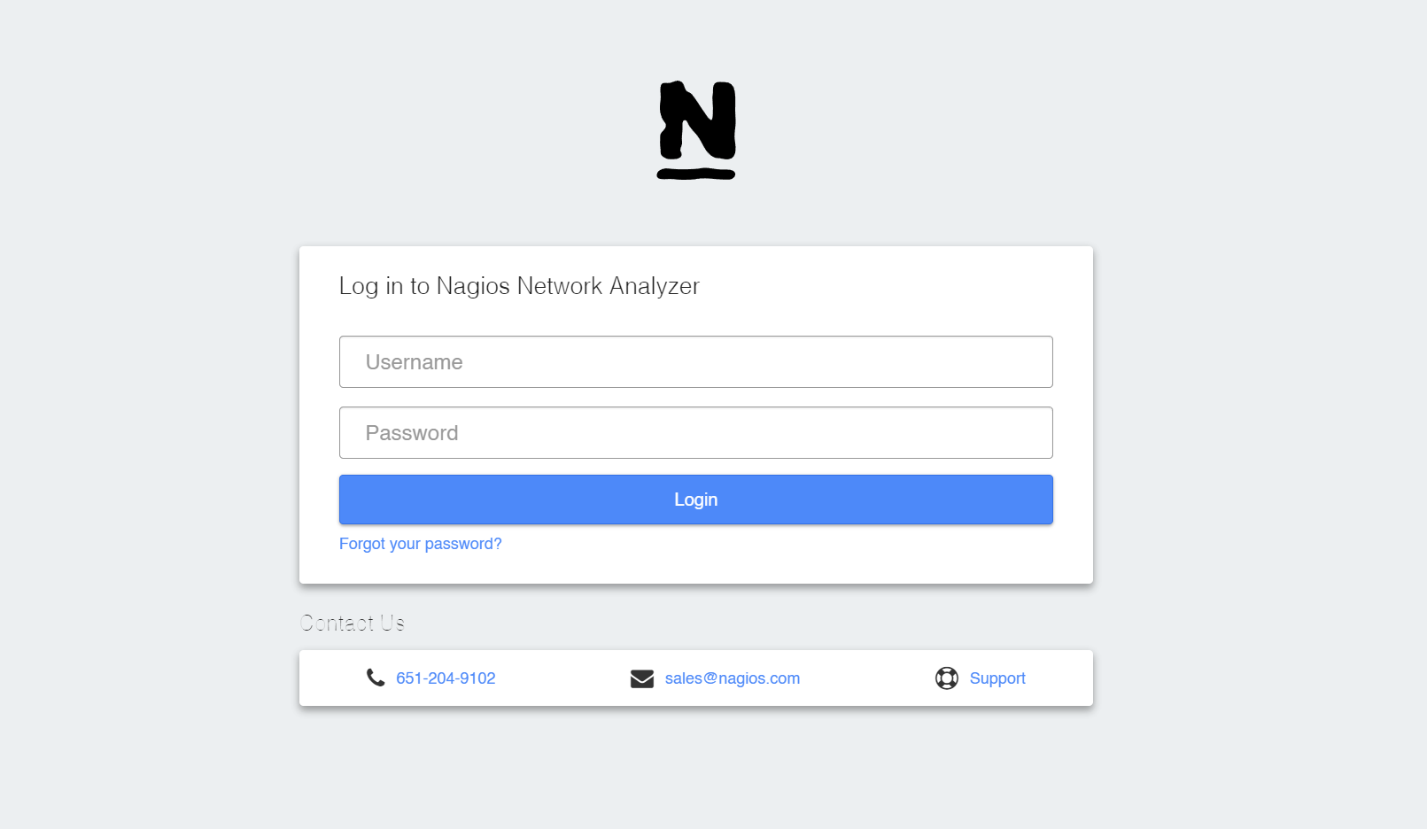

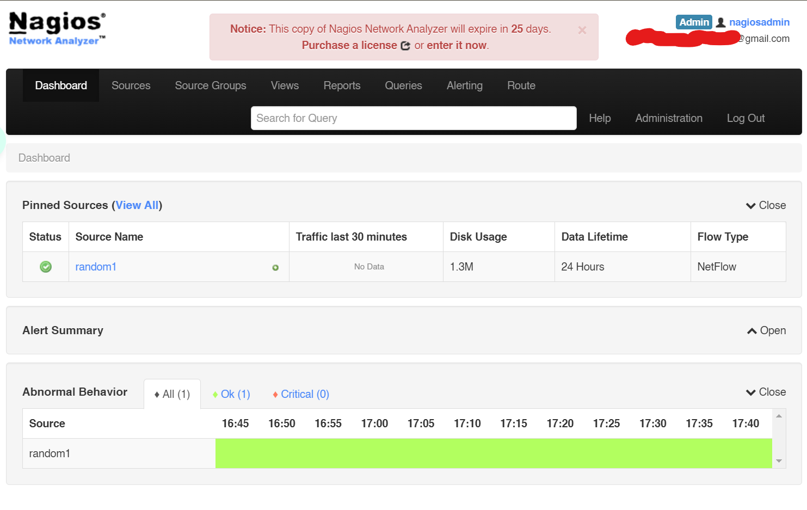

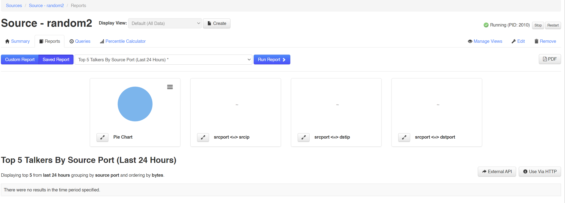

**LAB EXPERIMENT – 2**

**FIREWALL**

In Kali Linux, several firewall tools are available to help secure your system. Below are some common firewall software options in Kali Linux:

**1.** UFW (Uncomplicated Firewall)

* **Description:** UFW is a front-end for iptables, designed to make managing a firewall easier.

**Installation:**

sudo apt-get install ufw

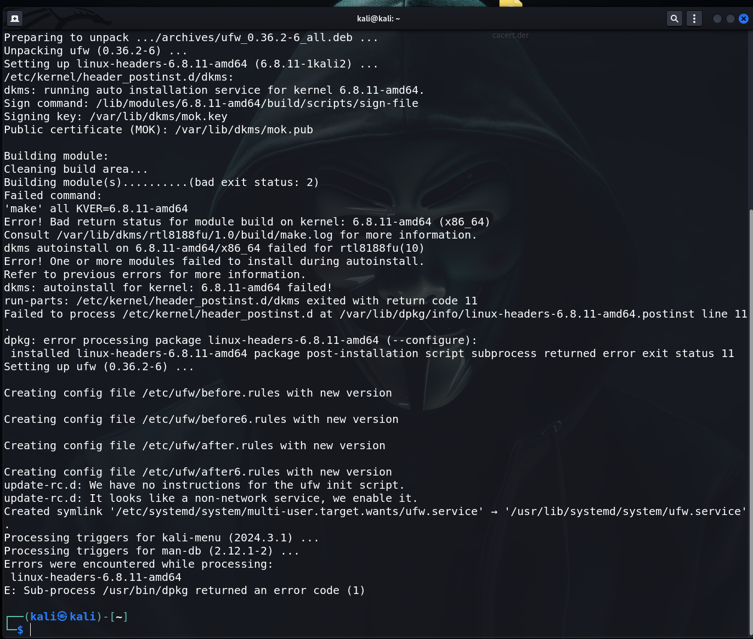

* **Basic Commands:**
  + Enable UFW:

sudo ufw enable

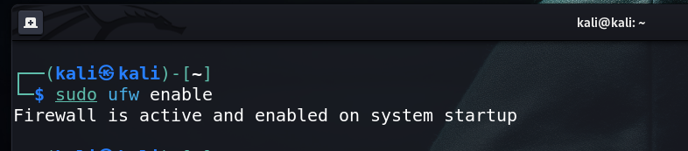

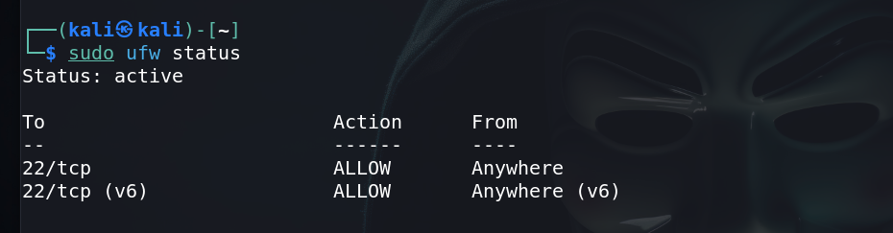

* + Allow specific port (e.g., SSH on port 22):

sudo ufw allow 22/tcp

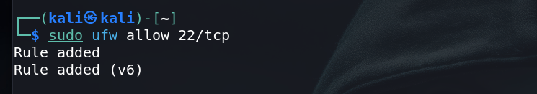

* + Deny a specific port:

sudo ufw deny 80/tcp

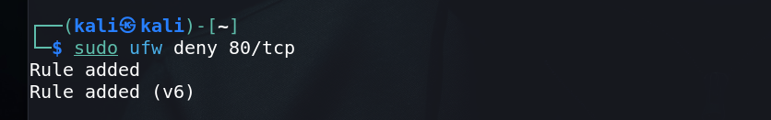

* + Check status:

sudo ufw status

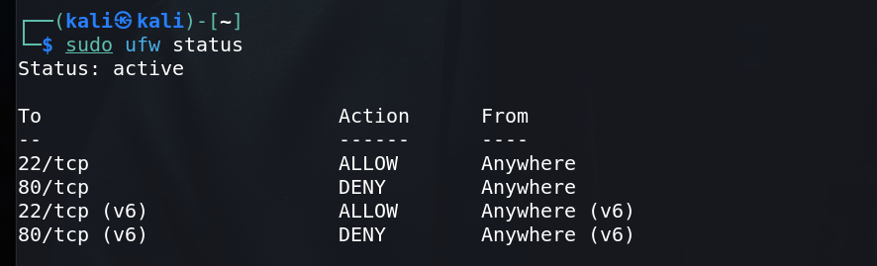

**2.** iptables

* **Description:** iptables is a command-line utility for configuring Linux kernel firewall implemented within the Netfilter project. It's more advanced and flexible than UFW.
* **Basic Commands:**
  + List current rules:

sudo iptables -L

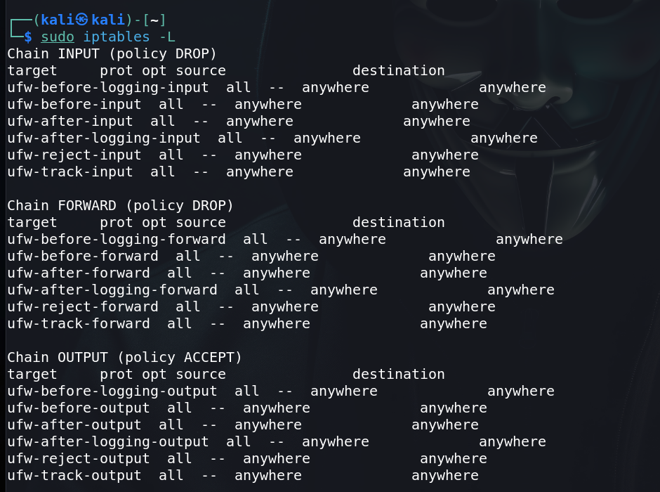

* + Allow a specific port (e.g., HTTP on port 80):

sudo iptables -A INPUT -p tcp --dport 80 -j ACCEPT

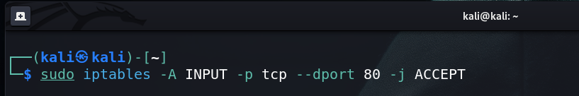

* + Block a specific IP address:

sudo iptables -A INPUT -s 192.168.1.100 -j DROP

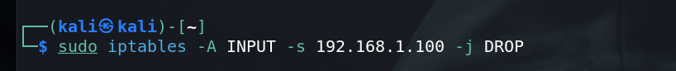

* + Save rules:

sudo iptables-save > /etc/iptables/rules.v4

**3.** Firewalld

* **Description:** Firewalld is a firewall management tool that supports both IPv4 and IPv6 firewall settings. It provides a dynamically managed firewall with support for network/firewall zones to define the trust level of network connections or interfaces.
* **Installation:**

sudo apt-get install firewalld

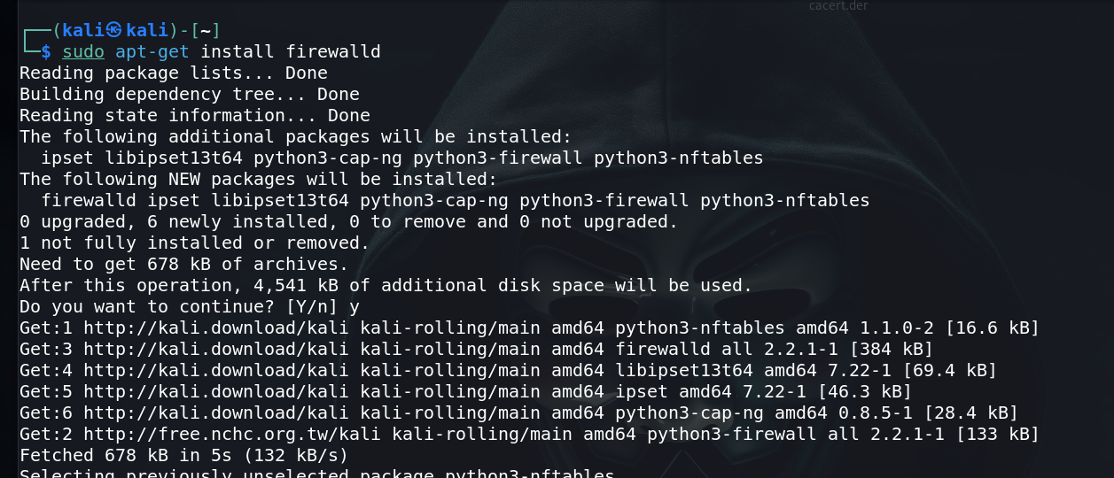

* **Basic Commands:**
  + Start Firewalld:

sudo systemctl start firewalld

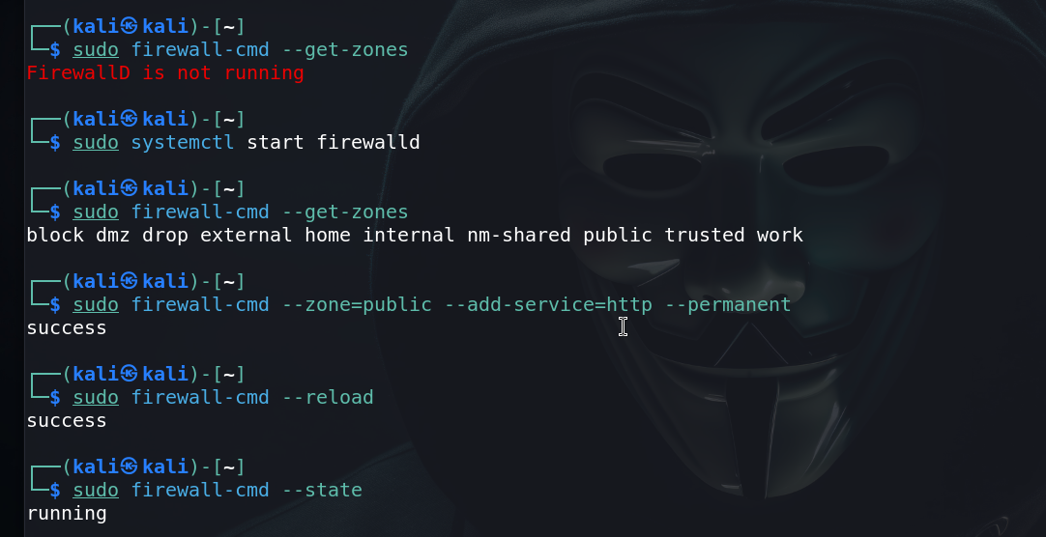

* + Enable Firewalld on boot:

sudo systemctl enable firewalld

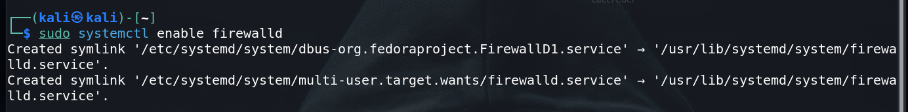

* + List all available zones:

sudo firewall-cmd --get-zones

* + Allow a service (e.g., HTTP) in the public zone:

sudo firewall-cmd --zone=public --add-service=http --permanent

sudo firewall-cmd –reload

* + Check the status of the firewall:

sudo firewall-cmd –state



**4.** GUFW (Graphical Interface for UFW)

* **Description:** GUFW is a graphical user interface for UFW, making it even easier for beginners to configure their firewall.
* **Installation:**

sudo apt-get install gufw

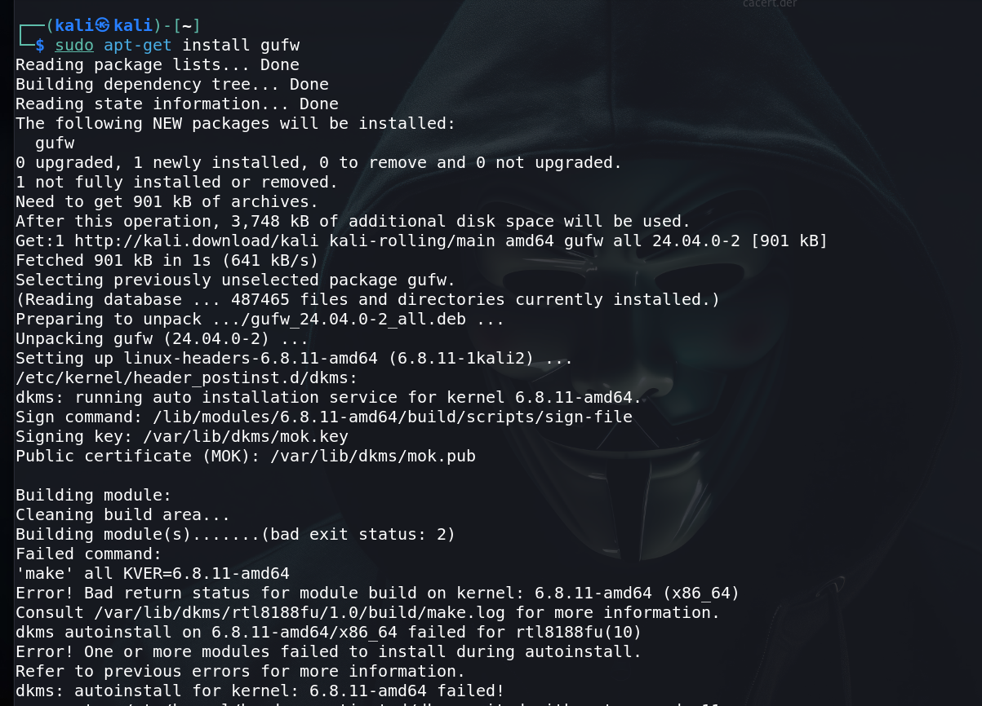

* **Usage:**
  + After installation, you can launch GUFW from the applications menu and use its simple interface to enable/disable the firewall, allow/deny ports, and manage rules.



**5.** OpenSnitch

* **Description:** OpenSnitch is an application firewall for Linux, similar to the macOS application Little Snitch. It monitors outgoing connections and allows you to block or allow them.
* **Installation:**

sudo apt-get install opensnitch

* **Usage:**
  + Once installed, OpenSnitch runs in the background and prompts you whenever an application tries to make an outgoing connection.

**Firewall Configuration and Vulnerability Finding in Kali Linux**

Kali Linux provides a robust environment for configuring firewalls and finding vulnerabilities. Below is a guide to configuring a firewall using iptables and UFW, and finding vulnerabilities using tools like Nmap and OpenVAS.

1. Firewall Configuration

A. Configuring the Firewall with **iptables**

iptables is a powerful tool for configuring network packet filtering rules. Here’s how you can set up a basic firewall:

* **Step 1: View Current Rules**

sudo iptables -L



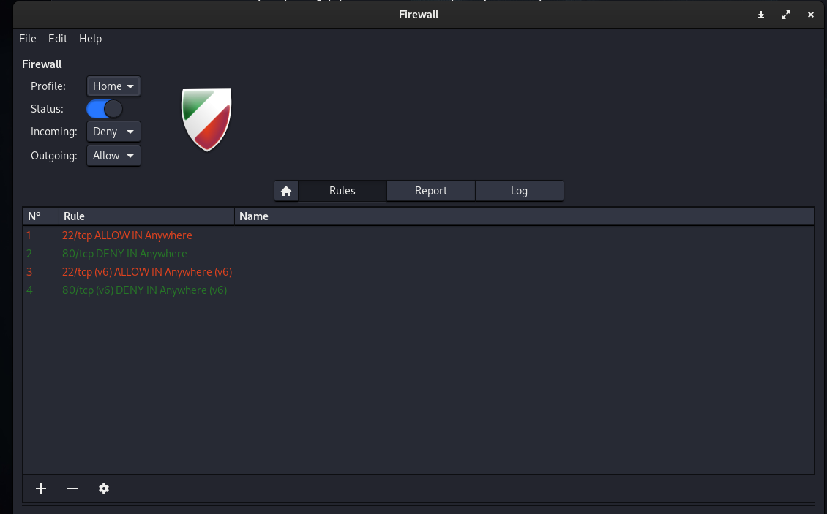

* **Step 2: Flush Existing Rules** If you want to start fresh, clear all existing rules:

sudo iptables -F

* **Step 3: Set Default Policies** Set the default policies to drop all incoming and forwarding traffic, while allowing outgoing traffic:

sudo iptables -P INPUT DROP

sudo iptables -P FORWARD DROP

sudo iptables -P OUTPUT ACCEPT

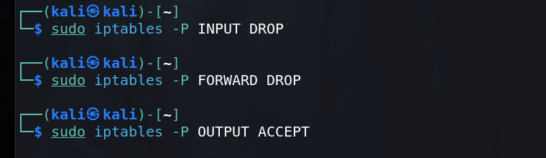

* **Step 4: Allow SSH Access** Allow SSH traffic on port 22:

sudo iptables -A INPUT -p tcp --dport 22 -j ACCEPT

* **Step 5: Allow Traffic on Specific Ports** Allow HTTP (port 80) and HTTPS (port 443) traffic:

sudo iptables -A INPUT -p tcp --dport 80 -j ACCEPT

sudo iptables -A INPUT -p tcp --dport 443 -j ACCEPT

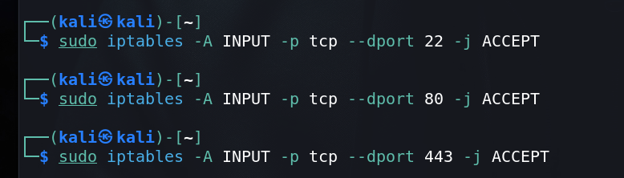

* **Step 6: Allow Traffic from Localhost** Allow traffic from the loopback interface:

sudo iptables -A INPUT -i lo -j ACCEPT

* **Step 7: Allow Established Connections** Allow established and related incoming connections:

sudo iptables -A INPUT -m conntrack --ctstate ESTABLISHED,RELATED -j ACCEPT

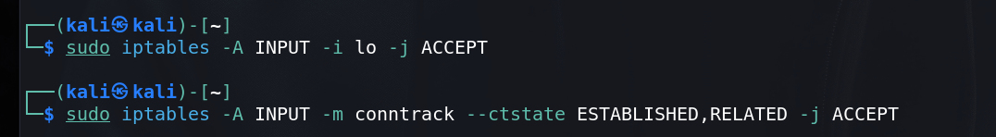

* **Step 8: Save the Rules** Save the configured rules so they persist after reboot:

sudo iptables-save > /etc/iptables/rules.v4

B. Configuring the Firewall with **UFW**

UFW (Uncomplicated Firewall) simplifies firewall management:

* **Step 1: Install UFW** UFW may already be installed on Kali. If not:

sudo apt-get install ufw



* **Step 2: Set Default Policies** Set default policies to deny incoming traffic and allow outgoing traffic:

sudo ufw default deny incoming

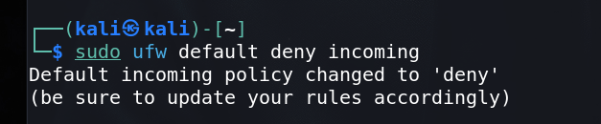

sudo ufw default allow outgoing

* **Step 3: Allow Specific Ports** Allow SSH, HTTP, and HTTPS traffic:

sudo ufw allow 22/tcp

sudo ufw allow 80/tcp

sudo ufw allow 443/tcp

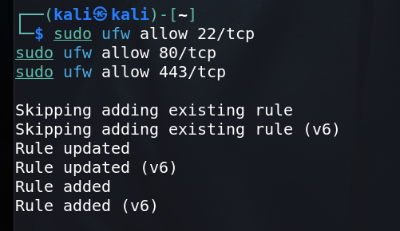

* **Step 4: Enable UFW** Enable UFW to activate the firewall:

sudo ufw enable



* **Step 5: Check UFW Status** Check the status of UFW and the rules configured:

sudo ufw status verbose

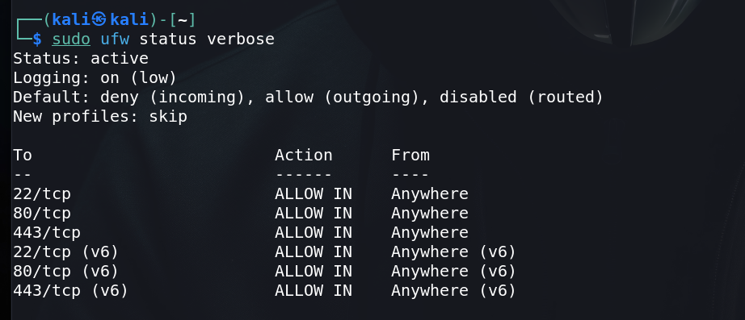

2. Vulnerability Finding

A. Vulnerability Scanning with **Nmap**

Nmap is a powerful network scanning tool that can be used to find open ports and potential vulnerabilities:

* **Step 1: Basic Host Scan** Scan a single host to find open ports:

sudo nmap -sS [target IP]

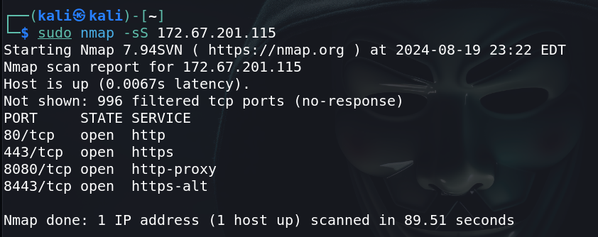

* **Step 2: Version Detection** Detect versions of services running on open ports:

sudo nmap -sV [target IP]

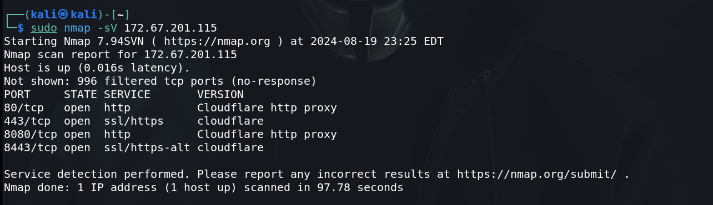

* **Step 3: Operating System Detection** Identify the target’s operating system:

sudo nmap -O [target IP]

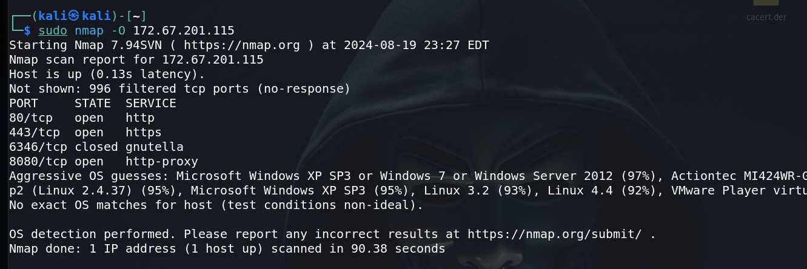

* **Step 4: Full Network Scan** Scan an entire subnet:

sudo nmap -p- [target IP range]

* **Step 5: Vulnerability Scripts** Use Nmap scripts to detect vulnerabilities:

sudo nmap --script vuln [target IP]

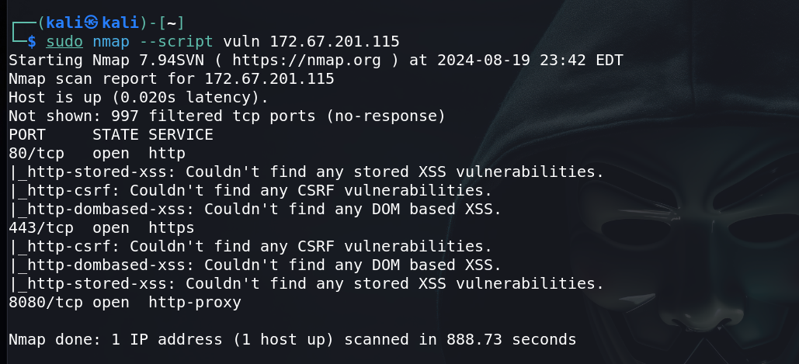

B. Vulnerability Scanning with **OpenVAS**

OpenVAS is a full-featured vulnerability scanner that’s part of the Greenbone Vulnerability Management (GVM) solution.

* **Step 1: Install and Setup OpenVAS** Install and set up OpenVAS on Kali Linux:

sudo apt-get update

sudo apt-get install openvas

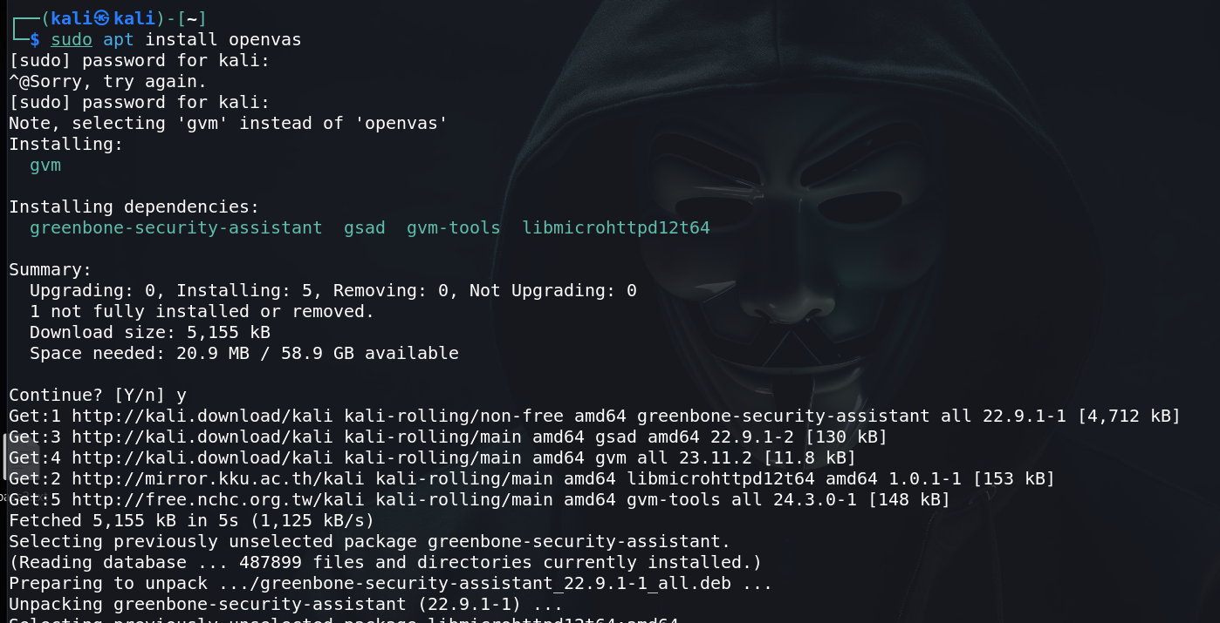

sudo gvm-setup

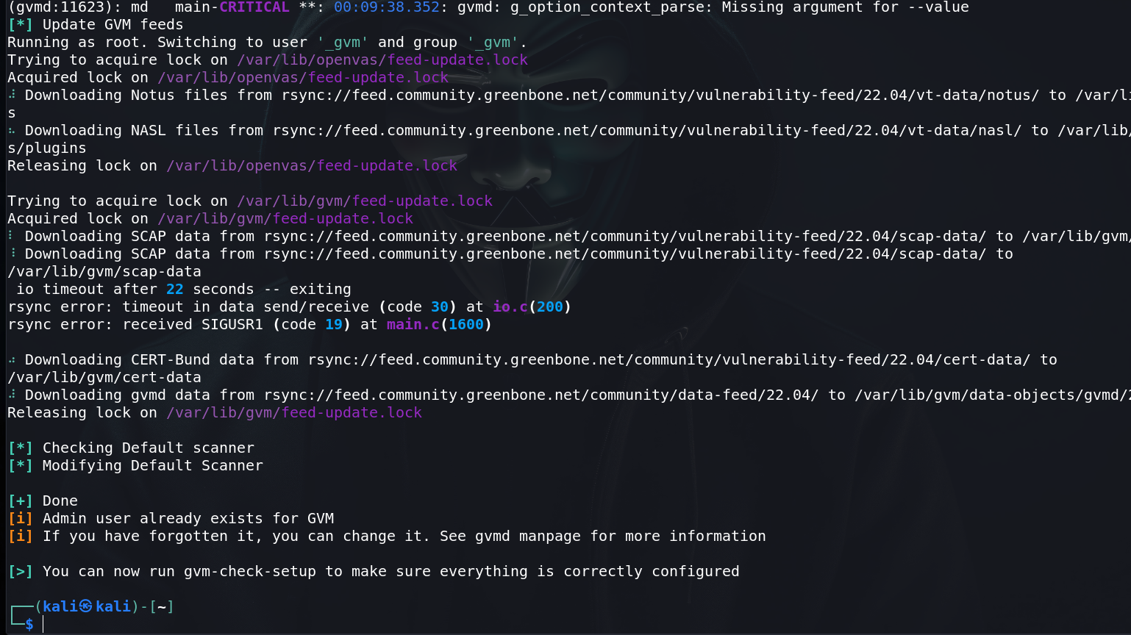

* **Step 2: Start OpenVAS Services** Start the OpenVAS services:

sudo gvm-start

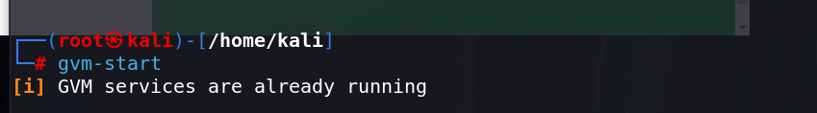

* **Step 3: Access OpenVAS Web Interface** Access the OpenVAS web interface through your browser:

<https://127.0.0.1:9392>

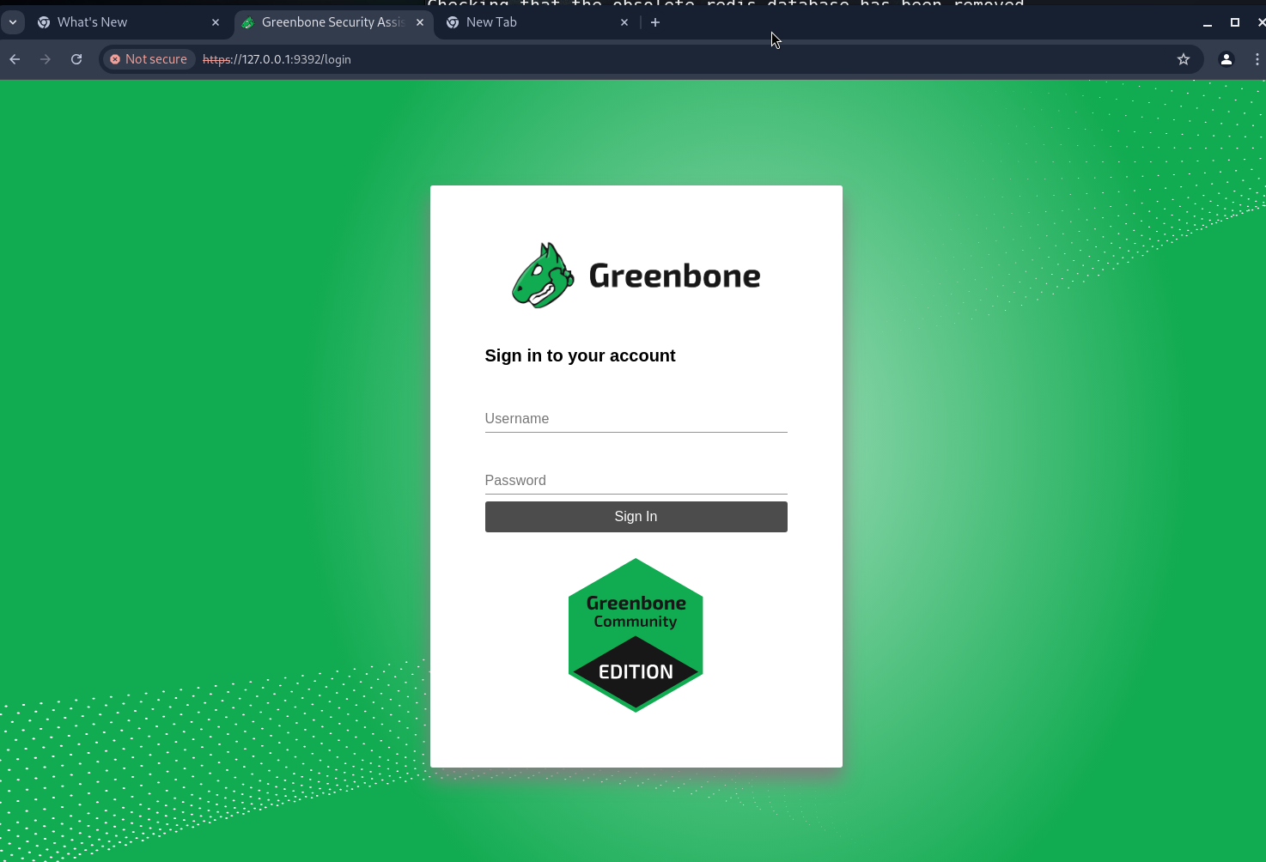

Log in using the credentials provided during the setup.

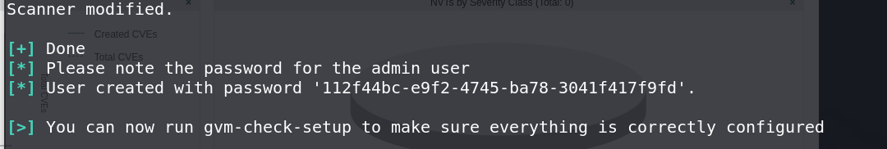

* **Step 4: Create and Run a Scan**
  1. Go to "Scans" in the web interface.
  2. Create a new scan target and specify the IP address or range.
  3. Launch the scan and wait for it to complete.

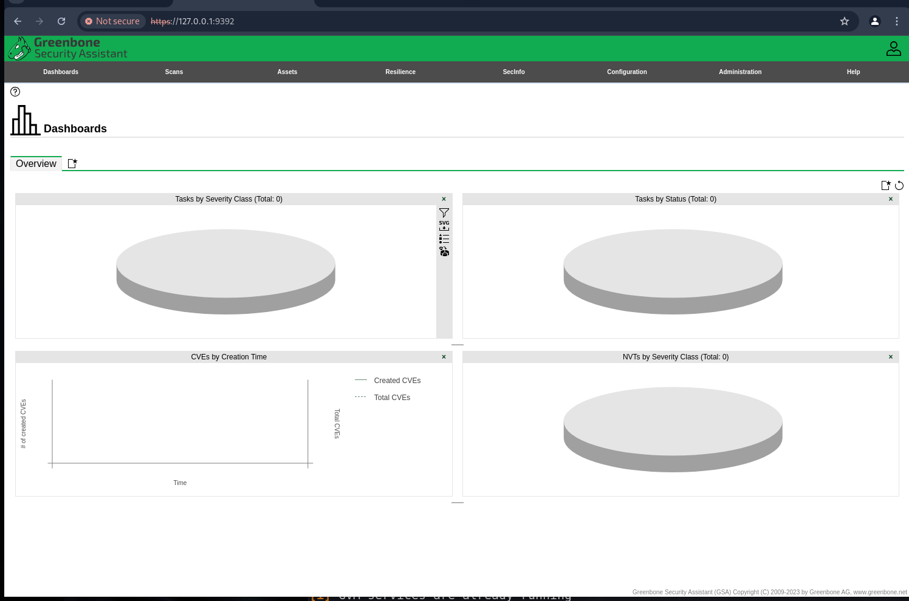

* **Step 5: Analyze the Scan Report** Review the scan report for vulnerabilities and recommended mitigations.

C. Other Vulnerability Tools

Consider using additional tools like:

* **Nessus**: Another popular vulnerability scanner that can be installed on Kali Linux.
* **Nikto**: A web server scanner that tests for vulnerabilities in web applications

**LAB EXPERIMENT – 3**

**ZENMAP AND SCUBA**

**Nmap (Network Mapper)** is a powerful tool with a wide range of applications. It is utilized to gather information about any device, both within and outside of our network. With Nmap, we can obtain details about any client simply by knowing their IP address. Nmap can be used to bypass firewalls, as well as all kinds of protection and security measures. In this section, we're going to learn some of the basic Nmap commands that can be used to discover clients that are connected to our network, and also discover the open ports on these clients.

**A cross-platform GUI for the Nmap Security Scanner**

**Zenmap** is the official **Nmap Security Scanner GUI**. This free and open-source application runs on multiple platforms (including Linux, Windows, Mac OS X, BSD, etc.) and is designed to make Nmap accessible for beginners while offering advanced features for seasoned users. Frequently used scans can be saved as profiles for easy reuse. A command creator enables users to interactively build Nmap command lines. Scan results can be saved for future viewing, and saved results can be compared to identify differences.

We're going to use **Zenmap**, which is the graphical user interface for Nmap. If we type zenmap on the Terminal, we'll bring up the application like this:

**Performing Intense scan:**

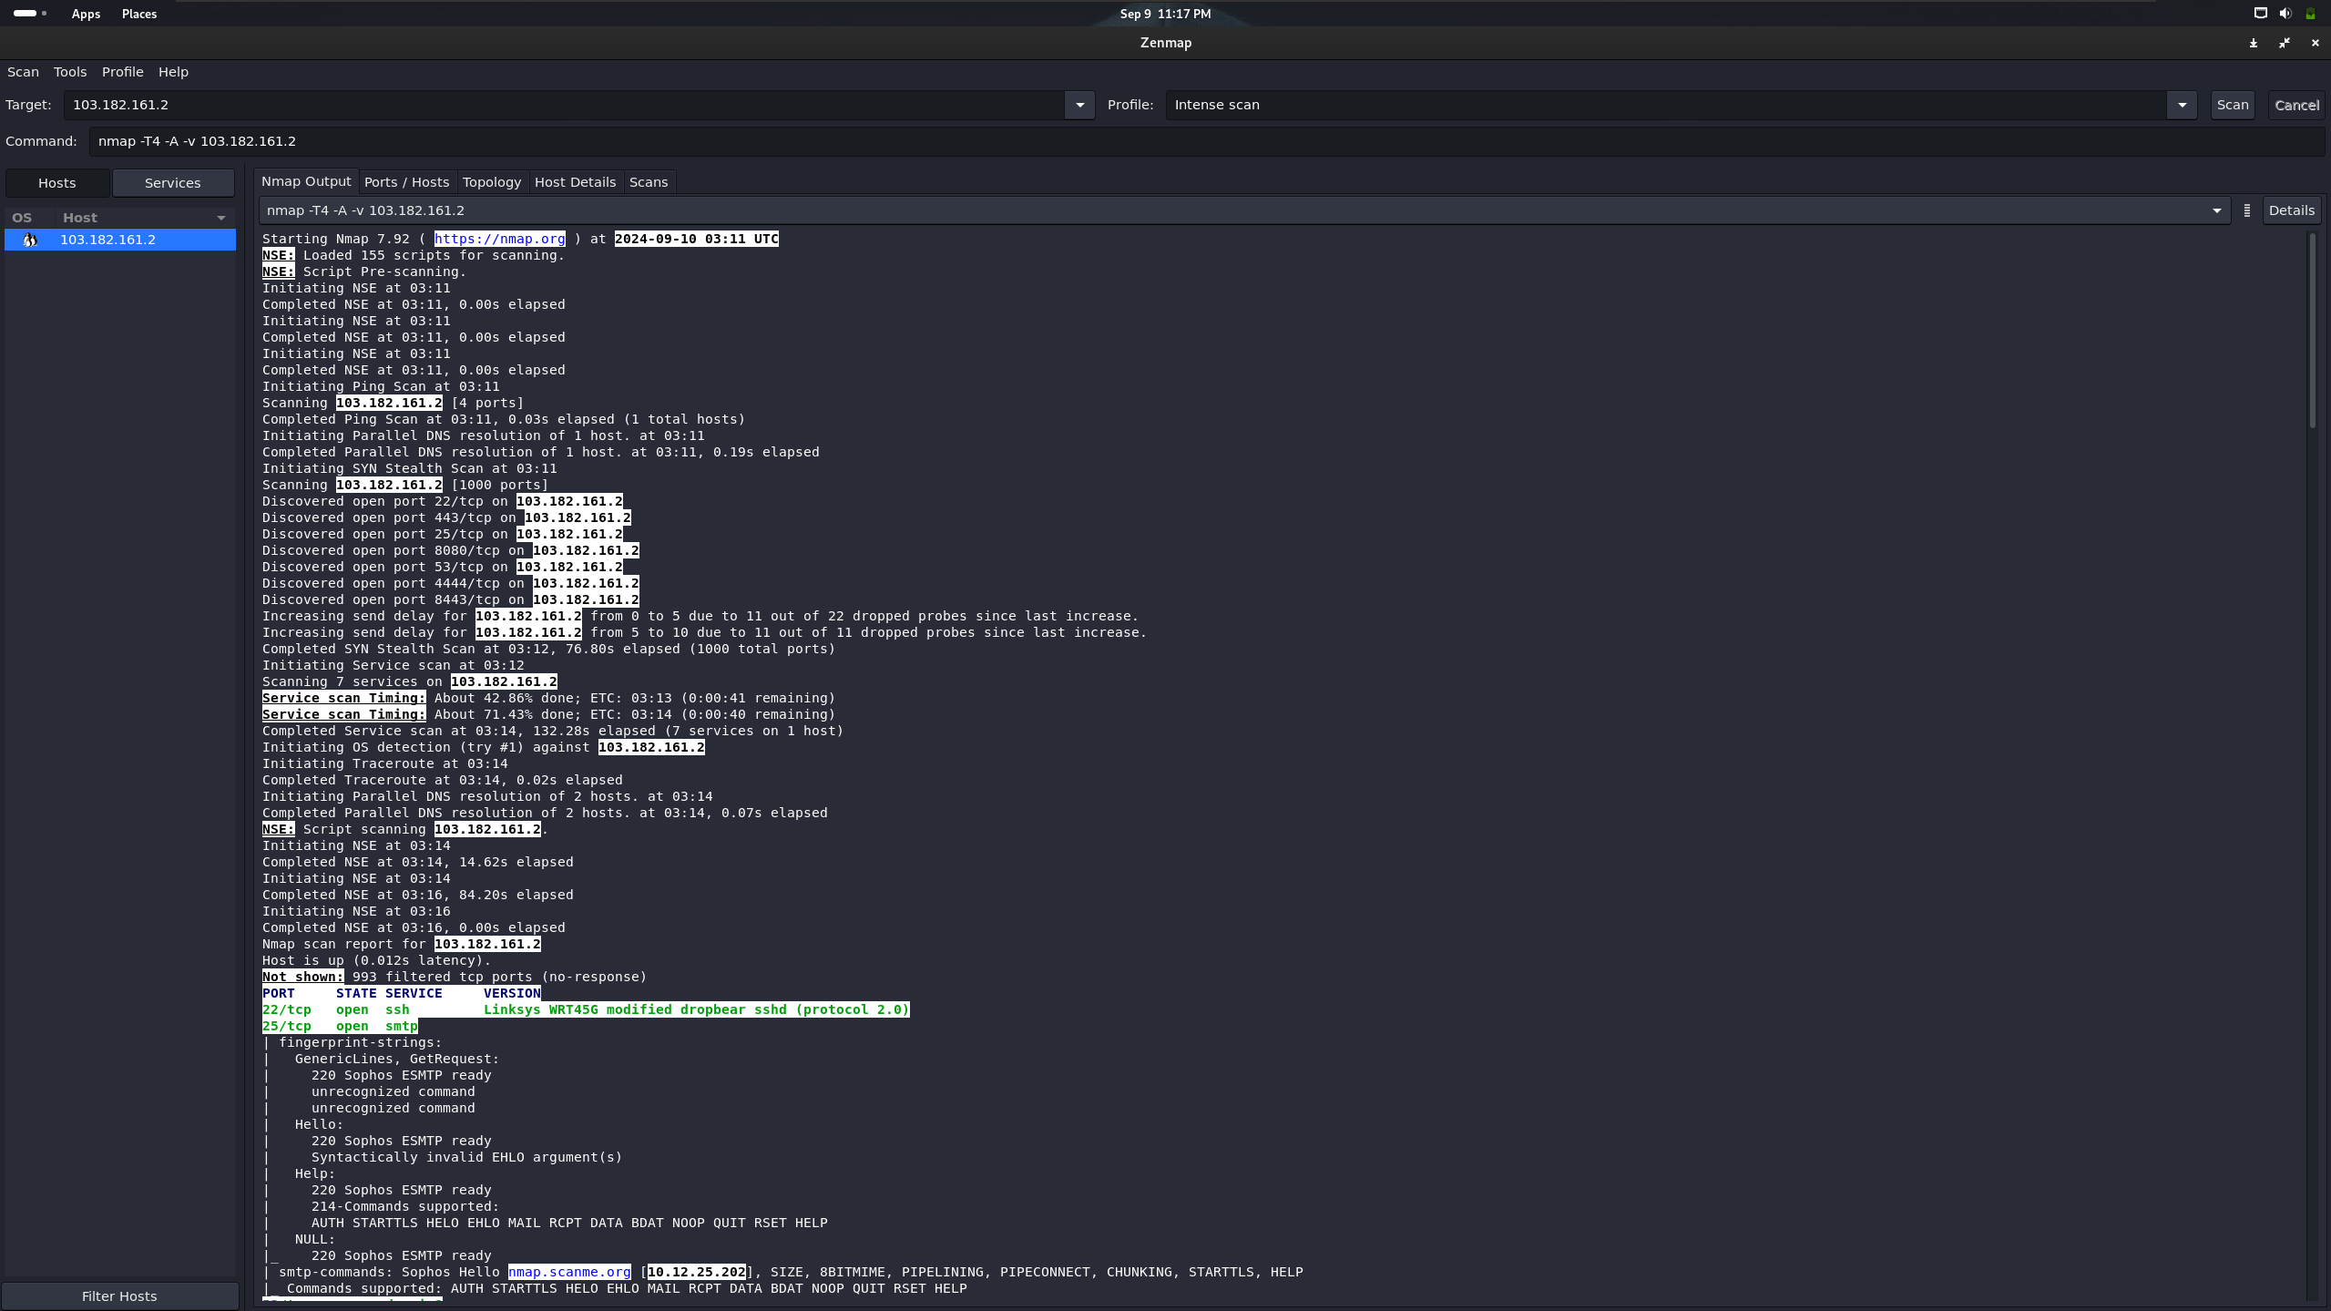

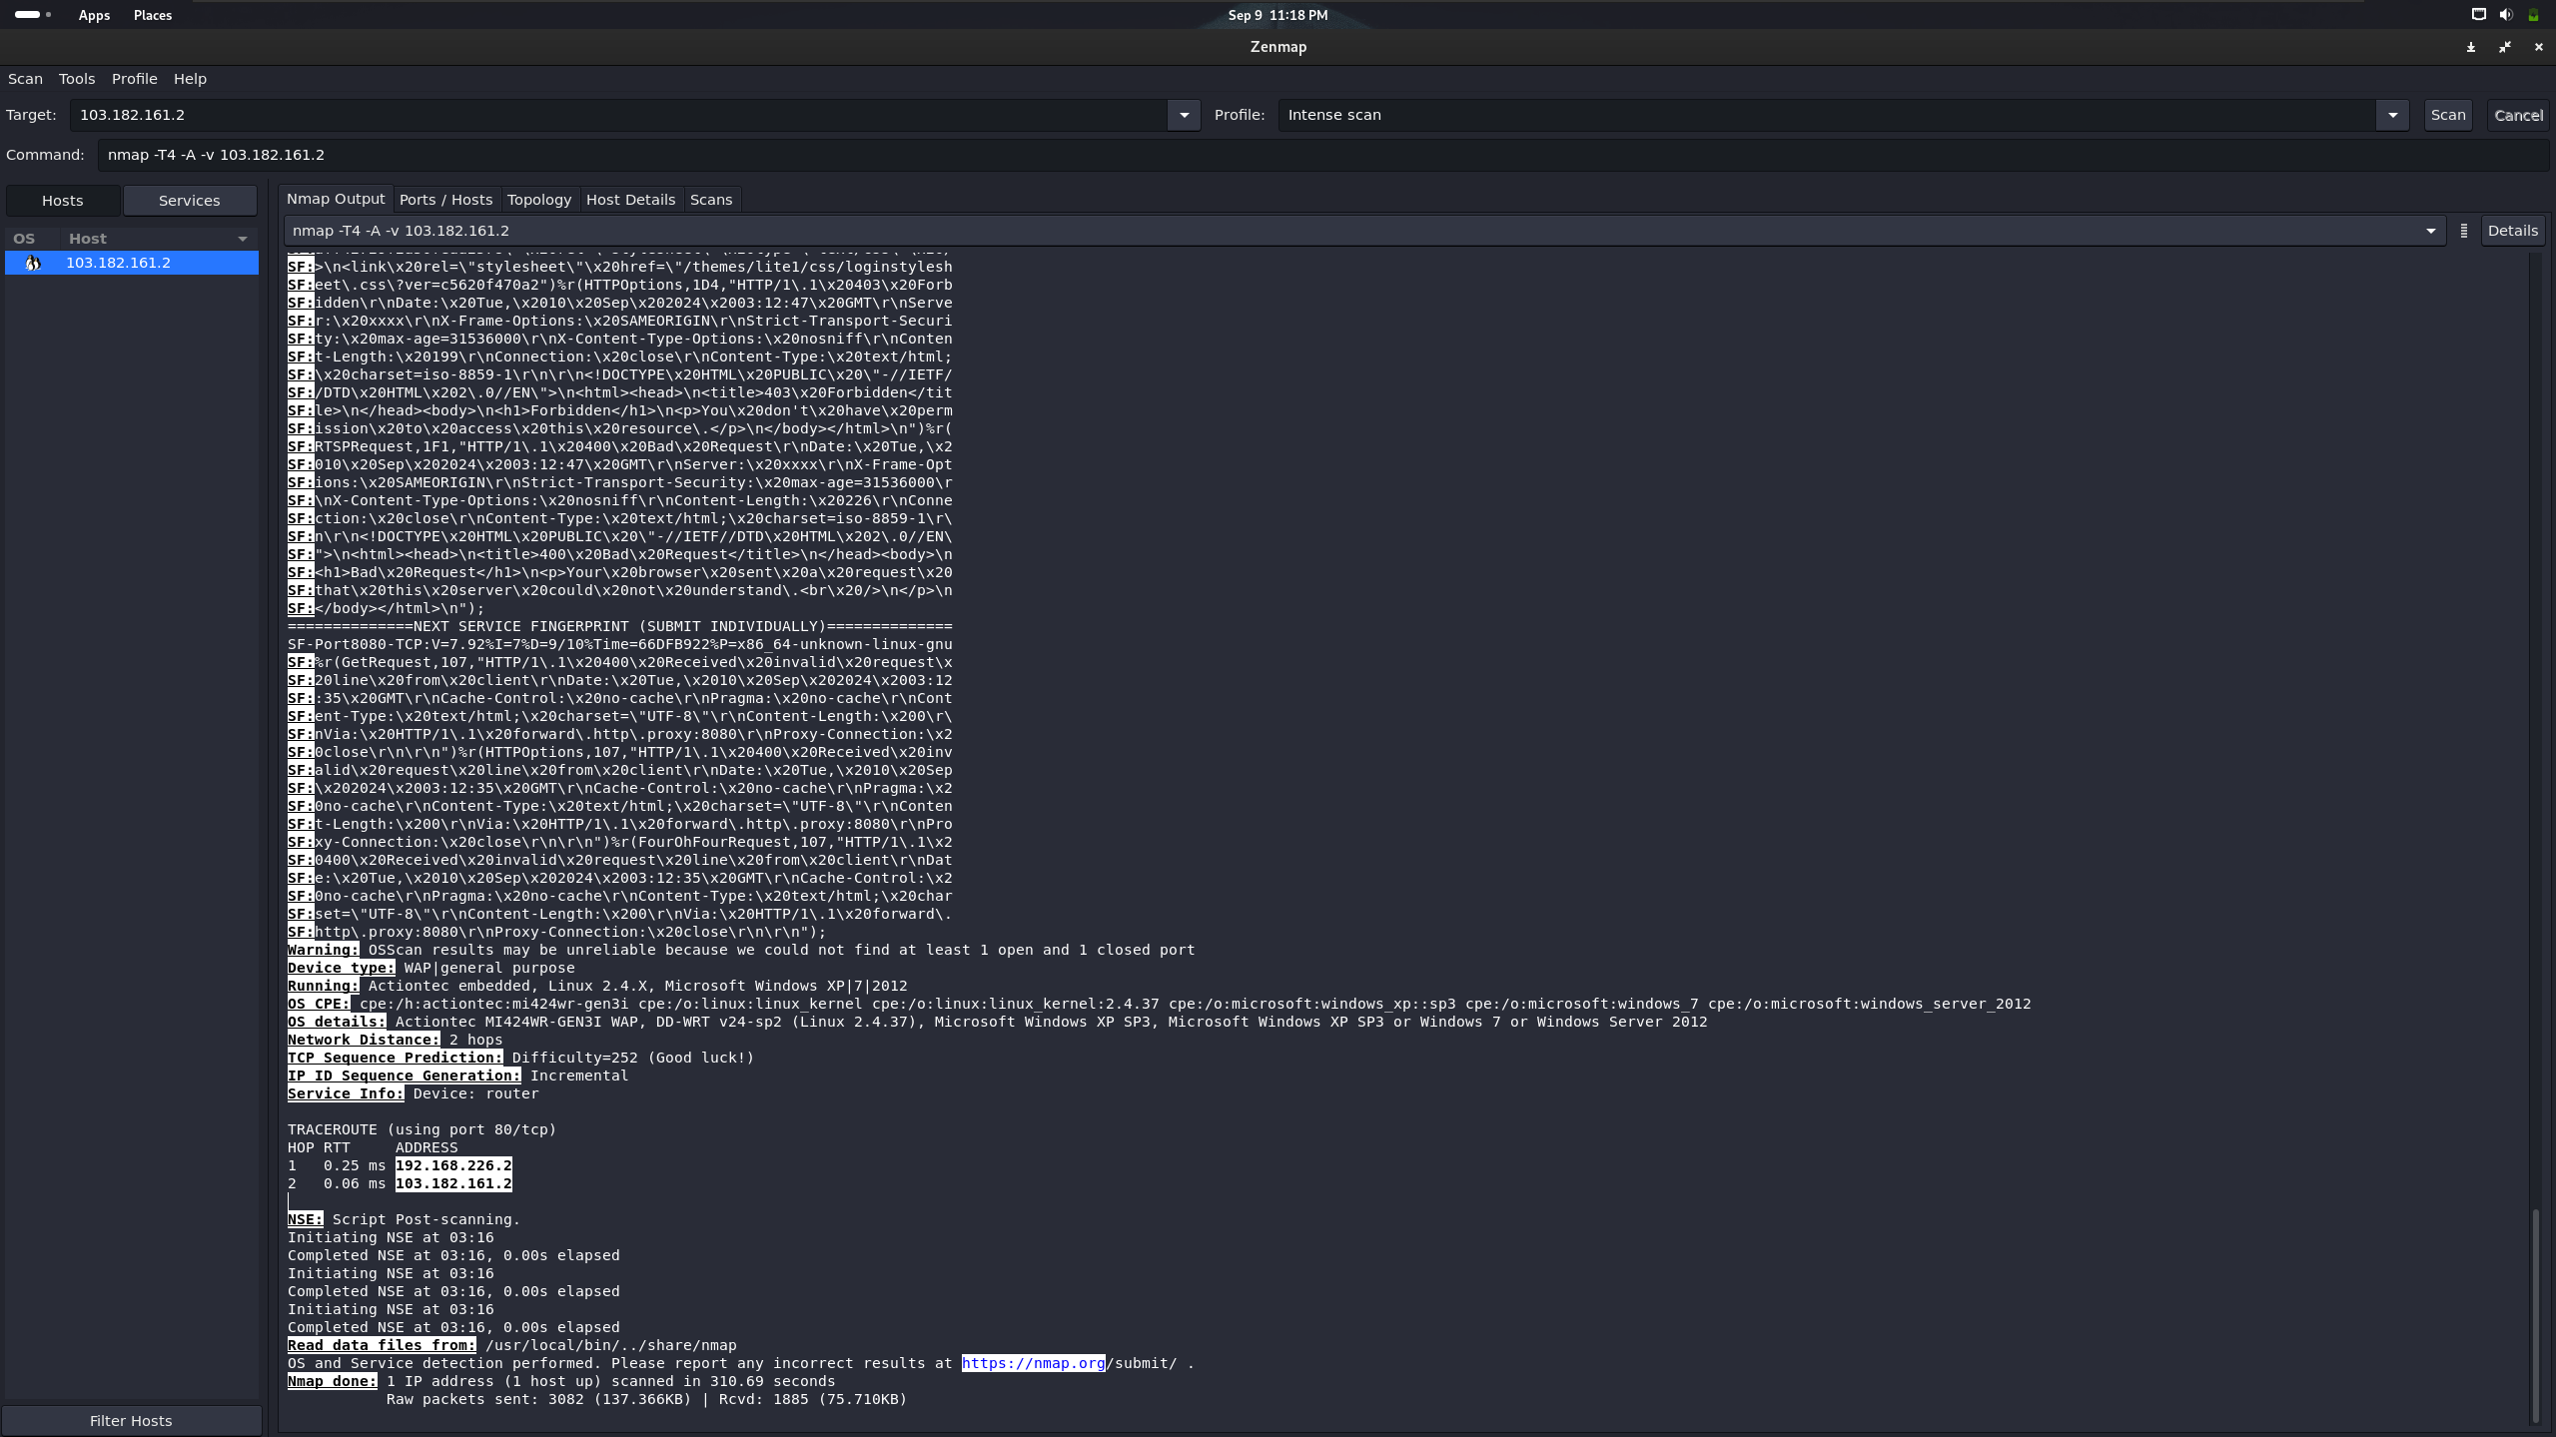

**Performing Ping scan:**

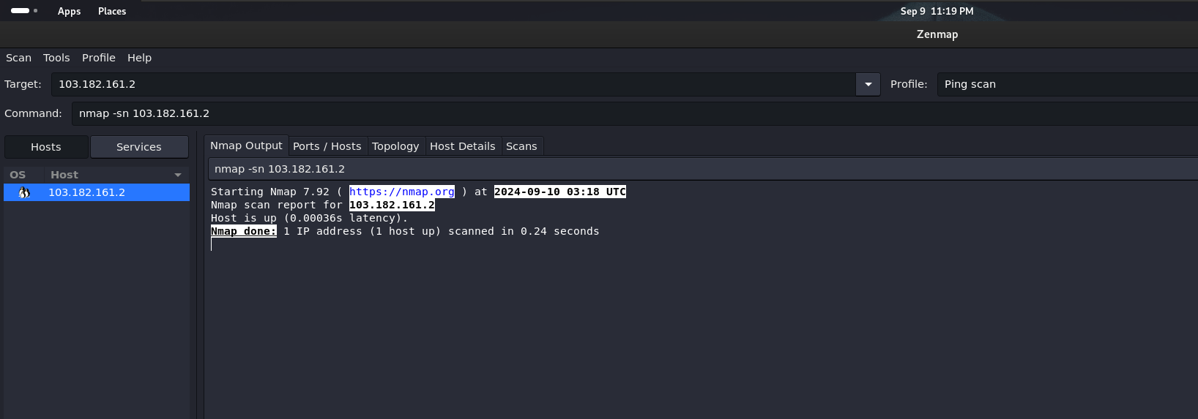

**Performing Quick scan:**

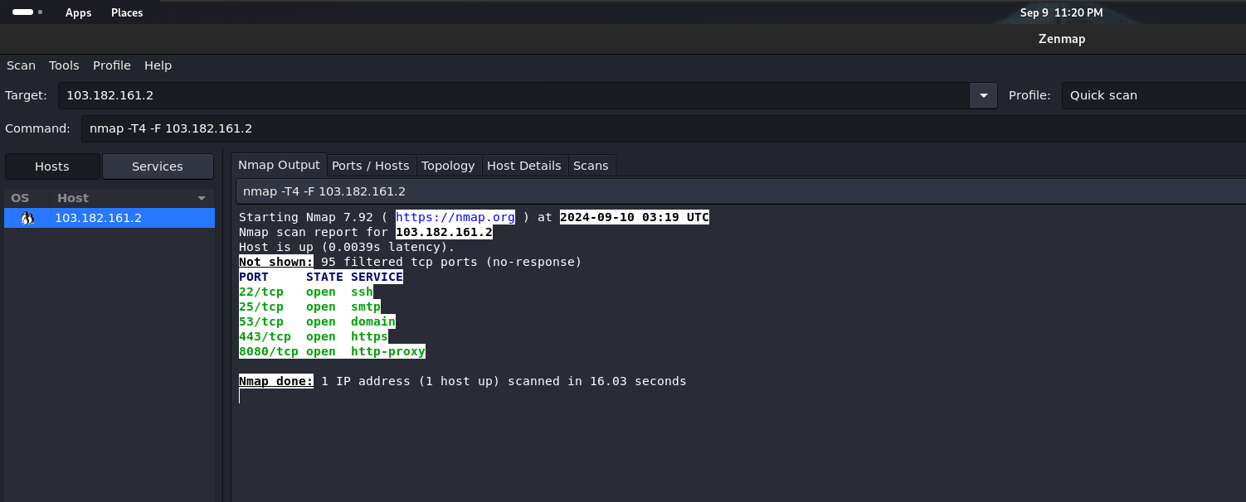

**Performing Regular scan:**

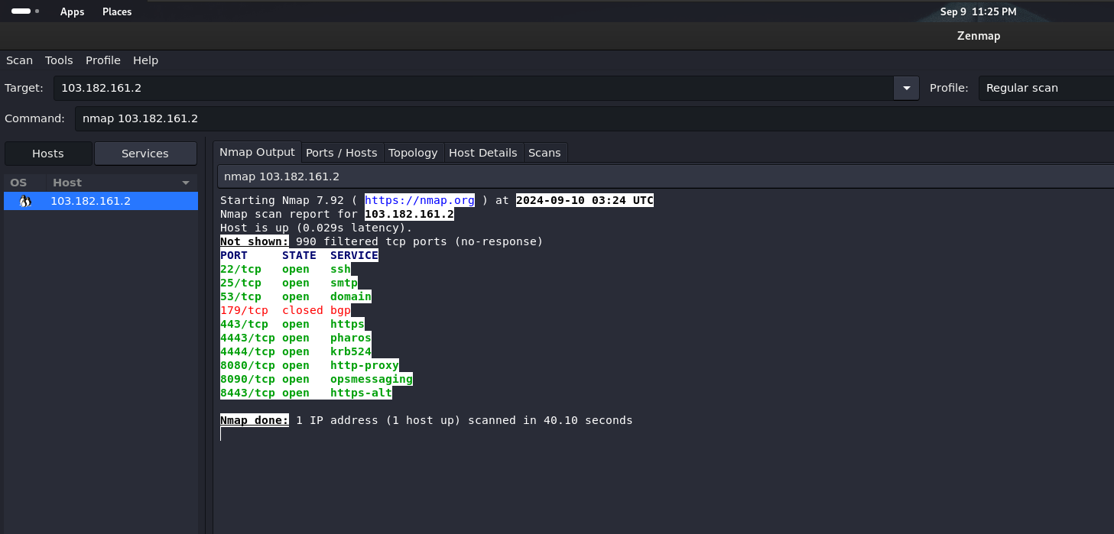

**DATABASE SCANNING WITH SCUBA**

**Scuba** is a powerful database vulnerability scanner designed to identify and assess potential security risks within various database systems. By automating the process of vulnerability detection, Scuba helps organizations proactively protect their valuable data and prevent unauthorized access.

**Benefits of Using Scuba**

* **Improved Data Security:** Scuba helps organizations protect their sensitive data from unauthorized access and exploitation.
* **Reduced Risk of Data Breaches:** By identifying and addressing vulnerabilities proactively, Scuba helps mitigate the risk of data breaches and their associated costs.
* **Enhanced Compliance:** Scuba can assist organizations in meeting compliance requirements such as GDPR, HIPAA, and PCI DSS.
* **Time and Cost Savings:** Automated scanning and vulnerability assessment can save time and resources compared to manual methods.

**With this tool you can:**

* Scan enterprise databases for vulnerabilities and misconfiguration
* Know the risks to your databases
* Get recommendations on how to mitigate identified issues

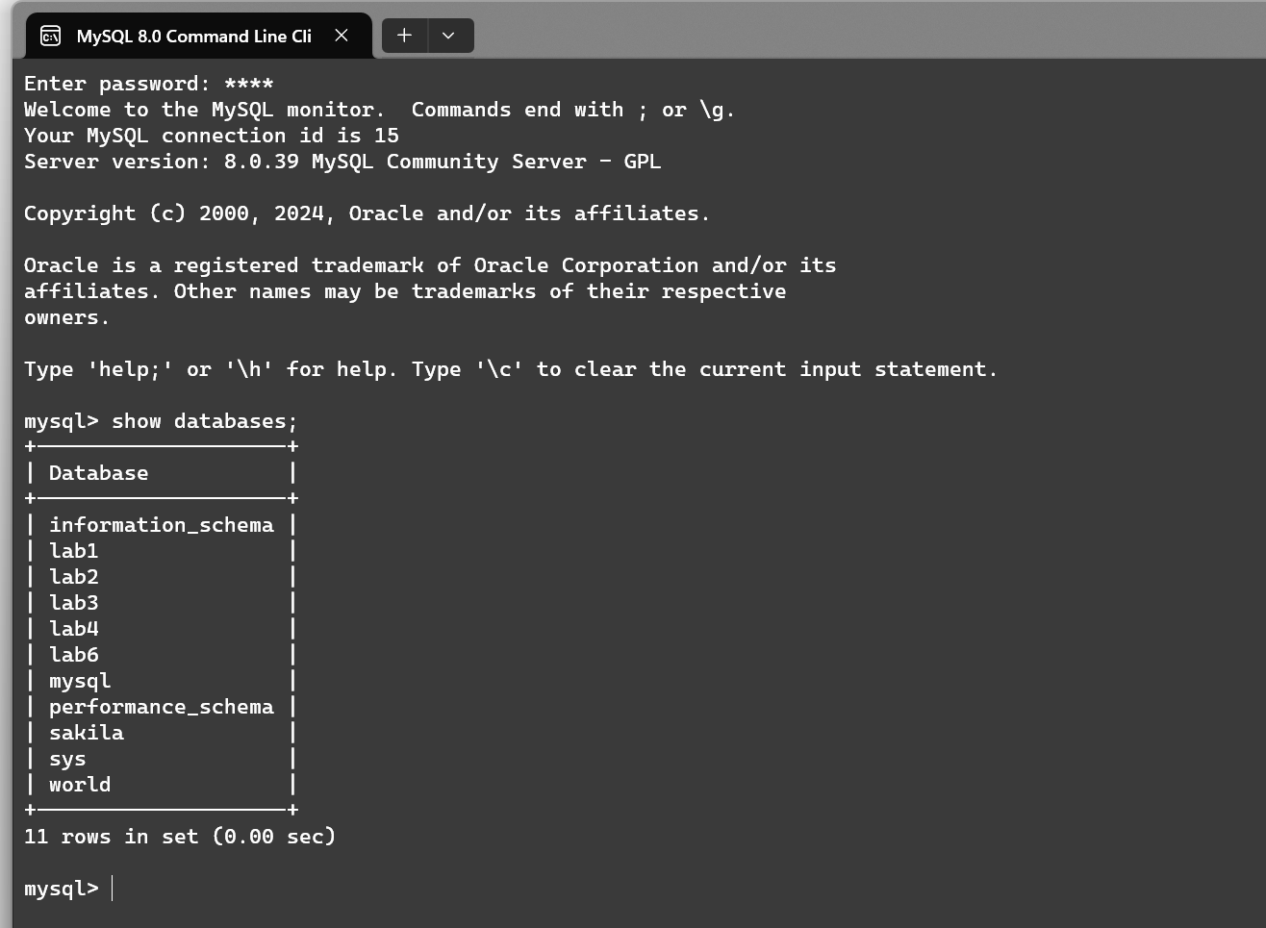

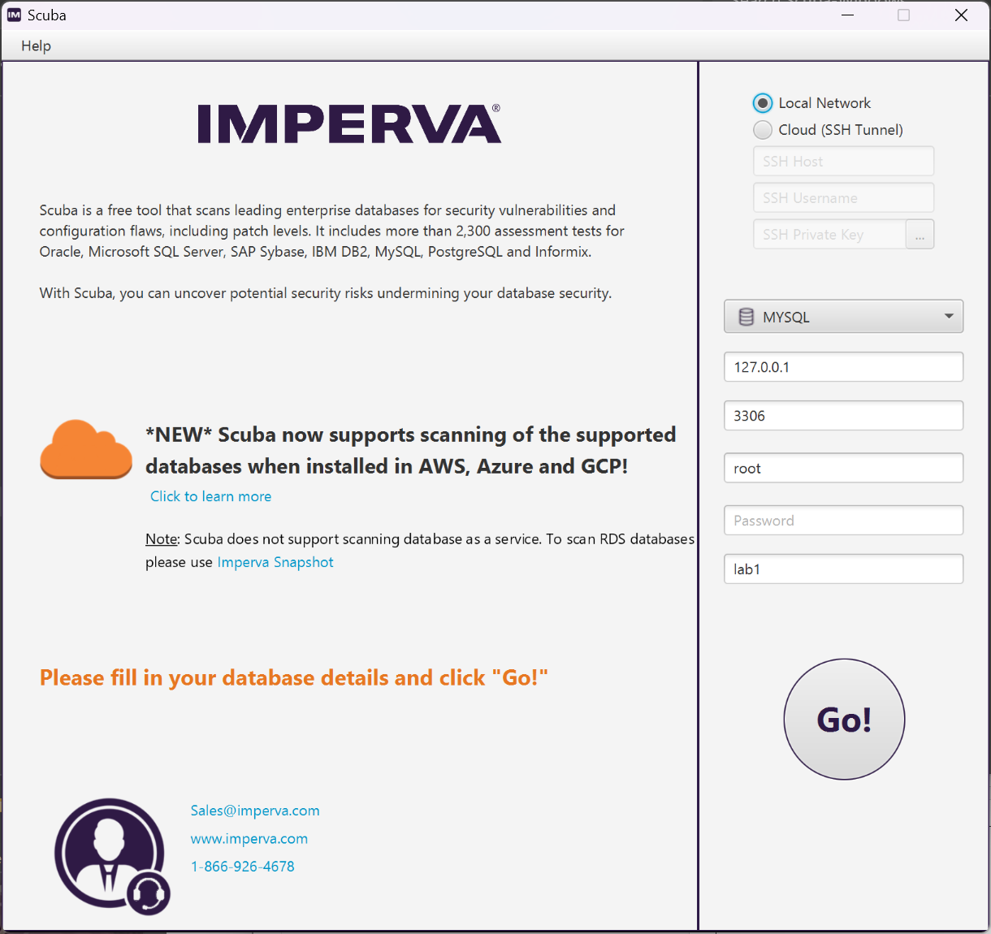

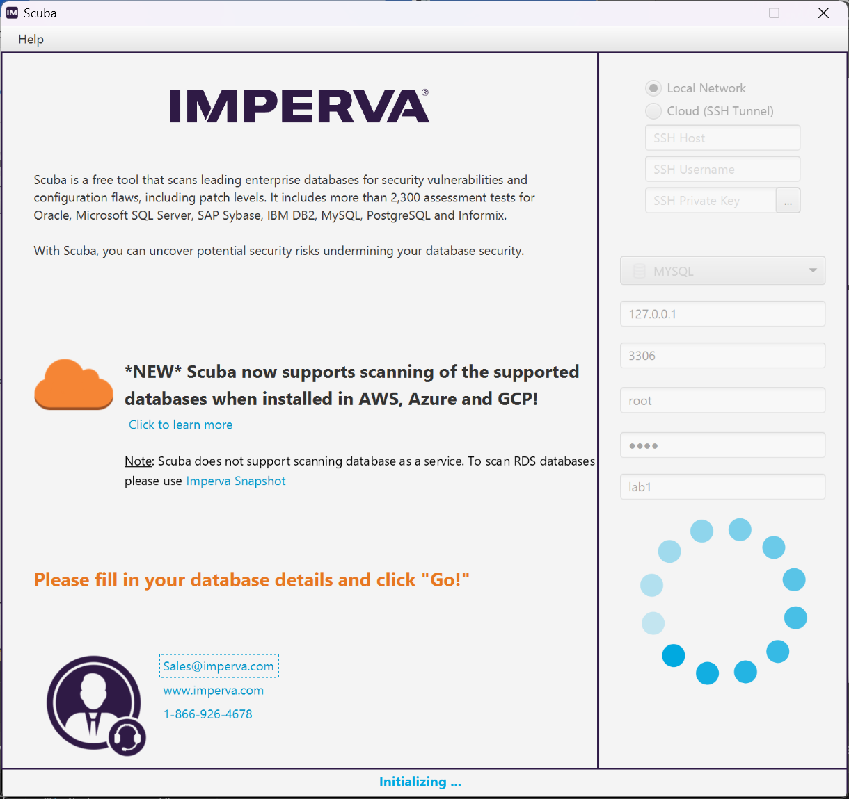

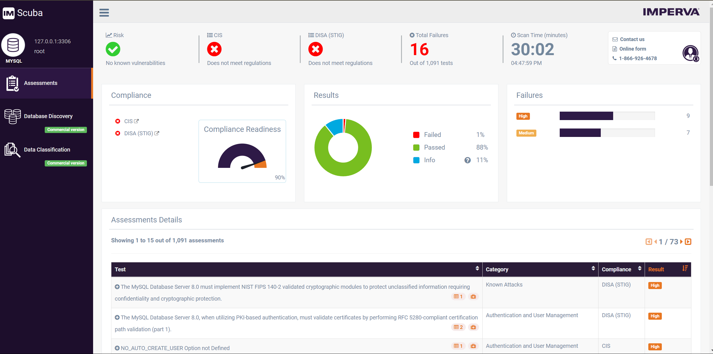

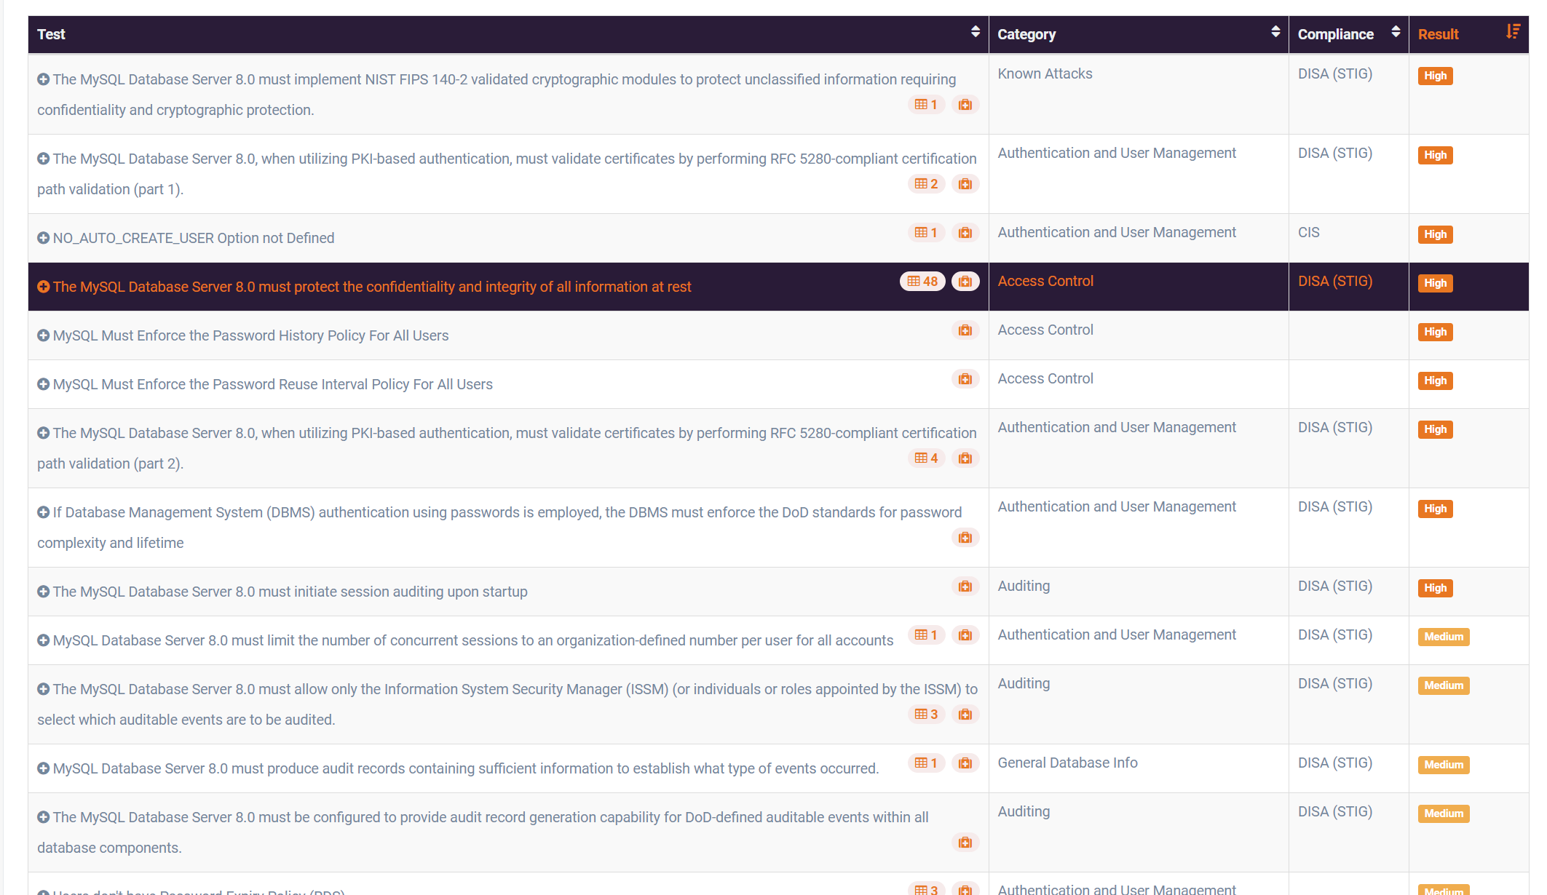

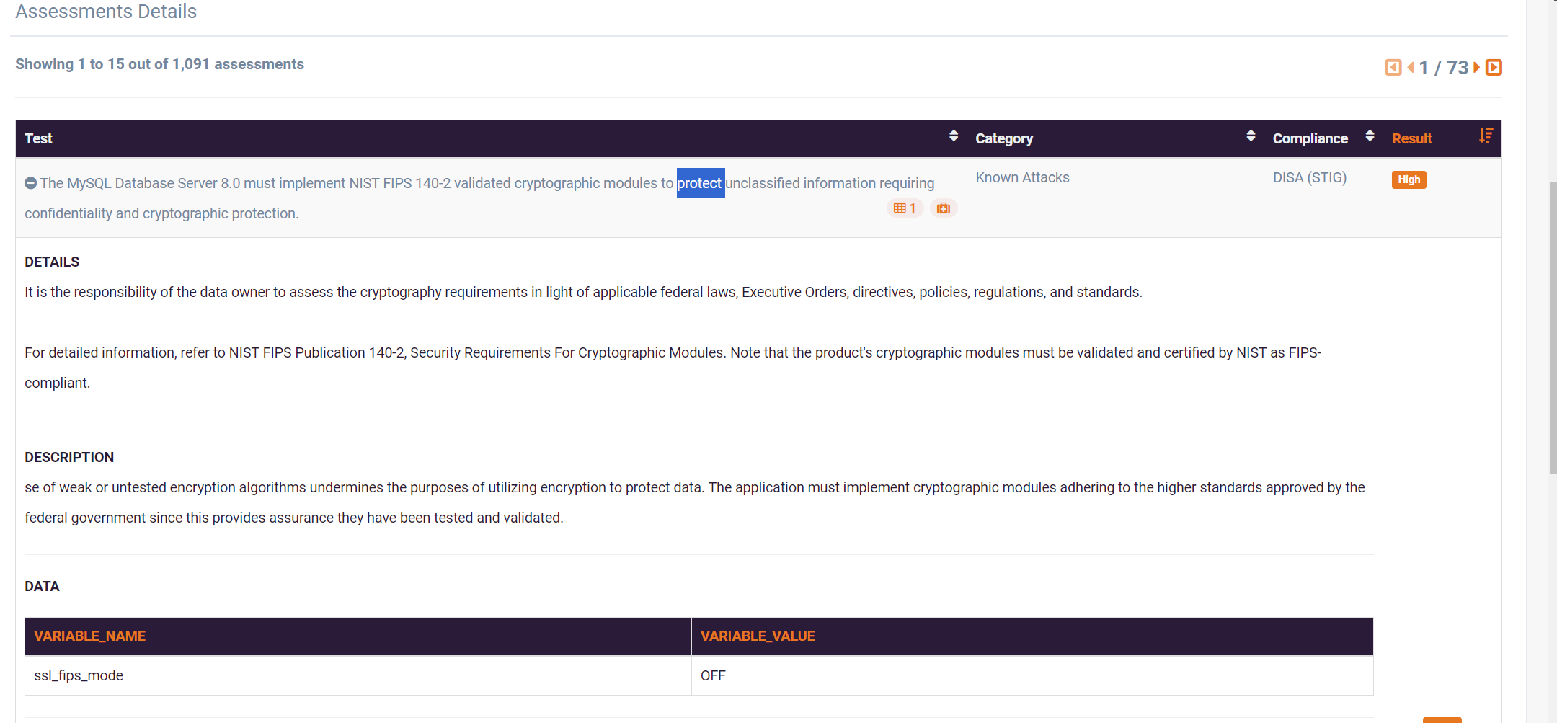

The provided Scuba scan summary indicates the following:

**Database:** MySQL

**Server:** 127.0.0.1:3306

**Scan Time:** 30 minutes and 1 second

**Total Failures:** 16

**Total Assessments:** 1,091

**Compliance Readiness:**

* Failed: 1% (11 out of 1,091 assessments)
* Passed: 88% (963 out of 1,091 assessments)
* Info: 11% (117 out of 1,091 assessments)

**Assessments Details:**

* The first two failed assessments are related to security best practices for the MySQL database server, such as implementing NIST FIPS 140-2 validated cryptographic modules and validating certificates using RFC 5280-compliant certification path validation.

**Overall, the scan identified 16 failures, indicating areas where the database system may be vulnerable.** It is important to address these issues to improve the security posture of the MySQL database.

**Additional Analysis:**

* **Failed Assessments:** A more detailed analysis of the failed assessments would be necessary to understand the specific vulnerabilities and their potential impact.
* **Compliance Readiness:** The high percentage of passed assessments (88%) suggests that the database is generally compliant with security standards. However, the 1% of failed assessments should be addressed to ensure full compliance.
* **Info Assessments:** These assessments may provide additional recommendations or information that can be used to improve the database's security.

**Recommendations:**

* **Address Failed Assessments:** Prioritize the remediation of the failed assessments to mitigate potential security risks.
* **Review Info Assessments:** Consider the recommendations and information provided in the info assessments to further enhance the database's security.
* **Regular Scanning:** Conduct regular Scuba scans to identify and address new vulnerabilities as they emerge.
* **Security Best Practices:** Implement and maintain security best practices for MySQL databases, such as strong authentication, encryption, and regular patching.

By following these recommendations, organizations can improve the security of their MySQL databases and protect their valuable data.

**LAB EXPERIMENT – 4**

**BSQL – BLIND SQL INJECTION**

1. **INSTALLATION OF DVWA**

Go to browser

Type 127.0.0.1/dvwa/setup.php

You will be redirected to DVWA

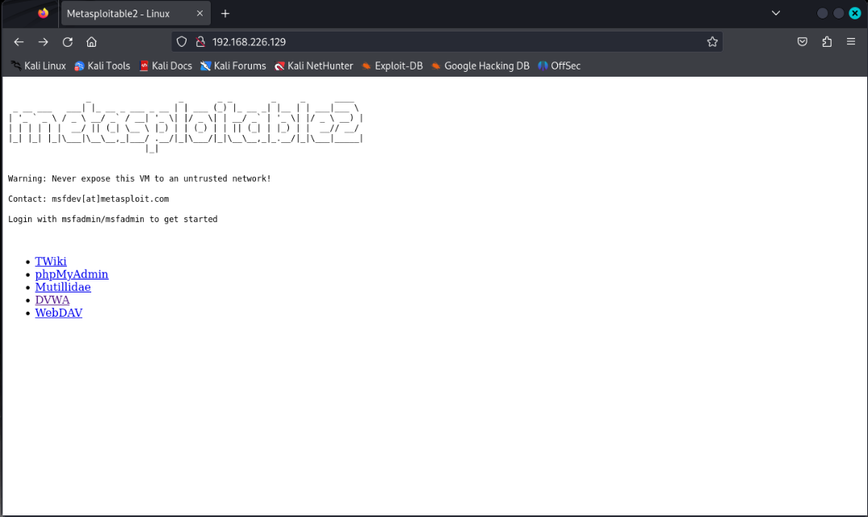

Blind SQL Injection Vulnerability Solution

1.Login to DVWA application and go to Blind SQL Injection challenge

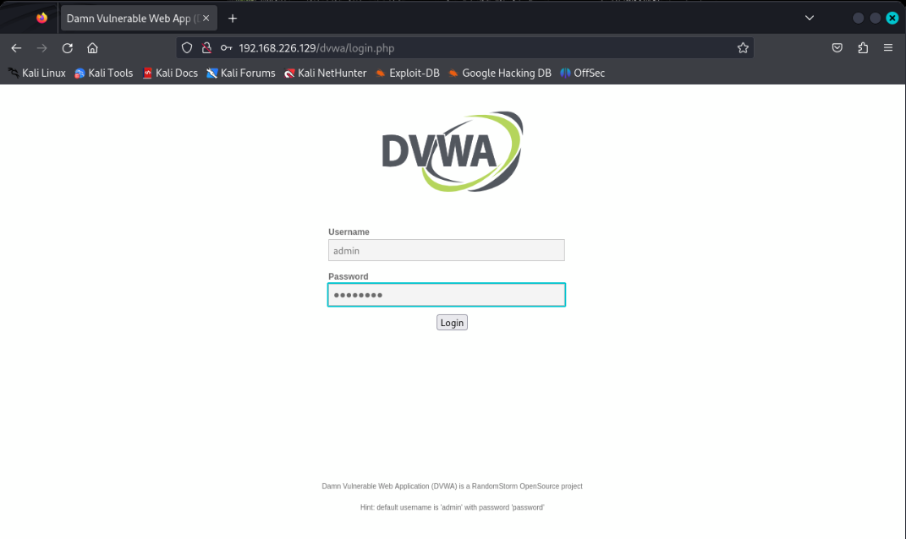

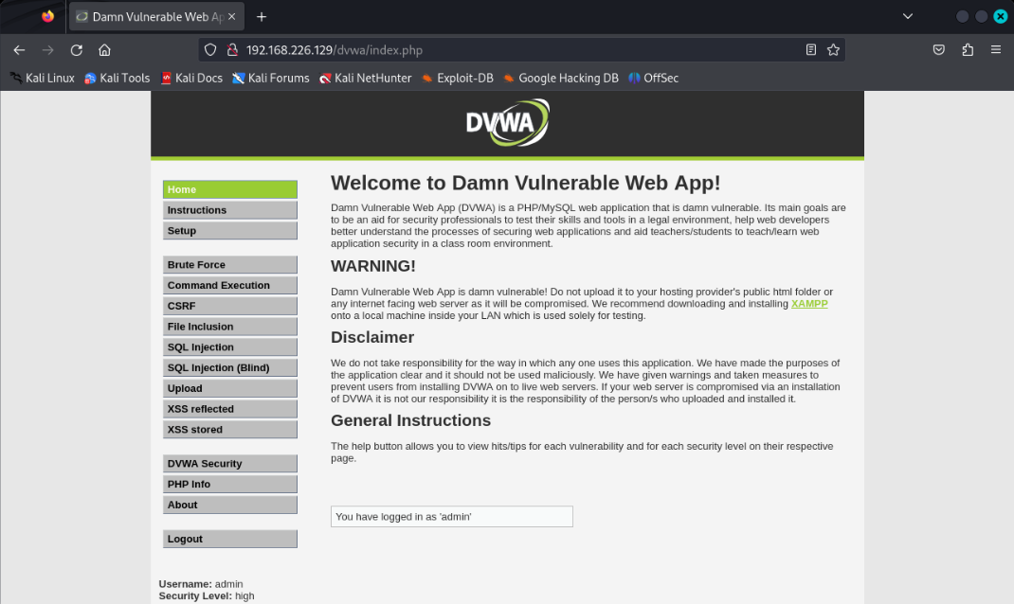

2.Its asking to provide User ID:

3.Let’s provide 1 as User ID

4.We received response as User ID exists in the database. for User ID 1

5.Now provide 9 as User ID

6.For 9, we received response as User ID is MISSING from the database.

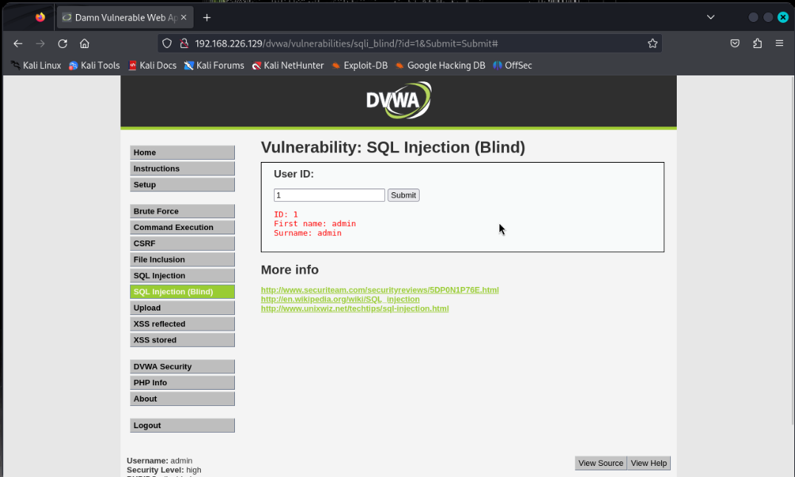

7. Now provide special character '

8.For ', response is - User ID is MISSING from the database.

So, for all invalid data we are getting response as User ID is MISSING from the database

9 Let’s prepare a payload which always return True value l.e. %' or '1'='1

10. We received a response as User ID exists in the database., for %' or '1'='1

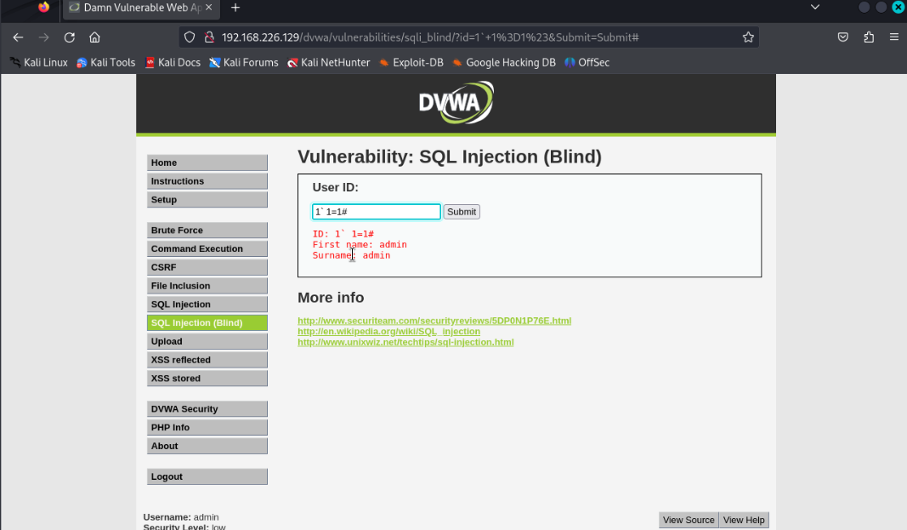

11.now modify the payload, which will return False response %' or '1'='2

12. Now response is - User ID is MISSING from the database.

13. Application considered %' or '1'='1, as a valid User ID.

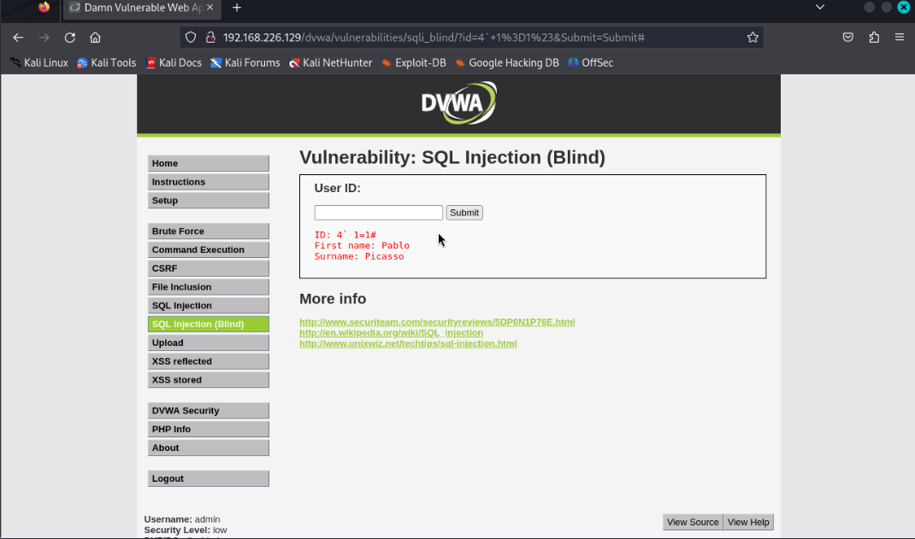

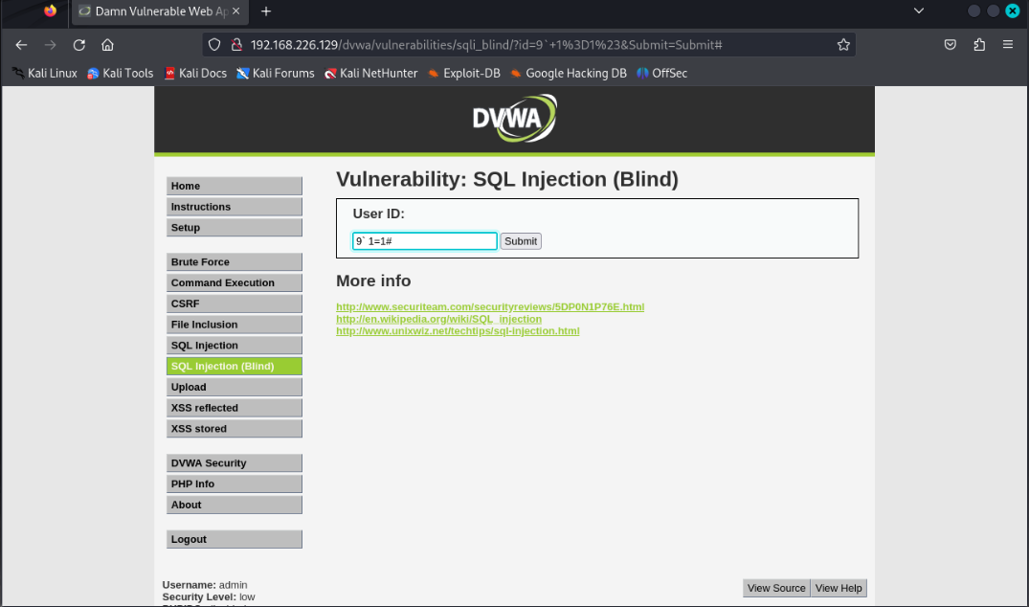

14. We can conclude an application is vulnerable to SQL Injection, though it's not disclosing any sensitive data such as SQL error, table name or database name.

15. We need to plan our attack further to get sensitive data.

**LAB EXPERIMENT – 5**

**SQL MAP**

**SQL-Map** is an open-source penetration testing tool designed to automate the detection and exploitation of vulnerabilities associated with SQL injection (SQLi). SQL injection is a hacking method that allows an attacker to insert SQL commands into a URL, leading to their execution by the back-end database. A database is a structured collection of information stored on a computer or web server, which can be accessed by a front-end client for retrieving data.

Use acunetix for web application vulnerability for SQL injection.

testphp.vulnweb.com/index.php

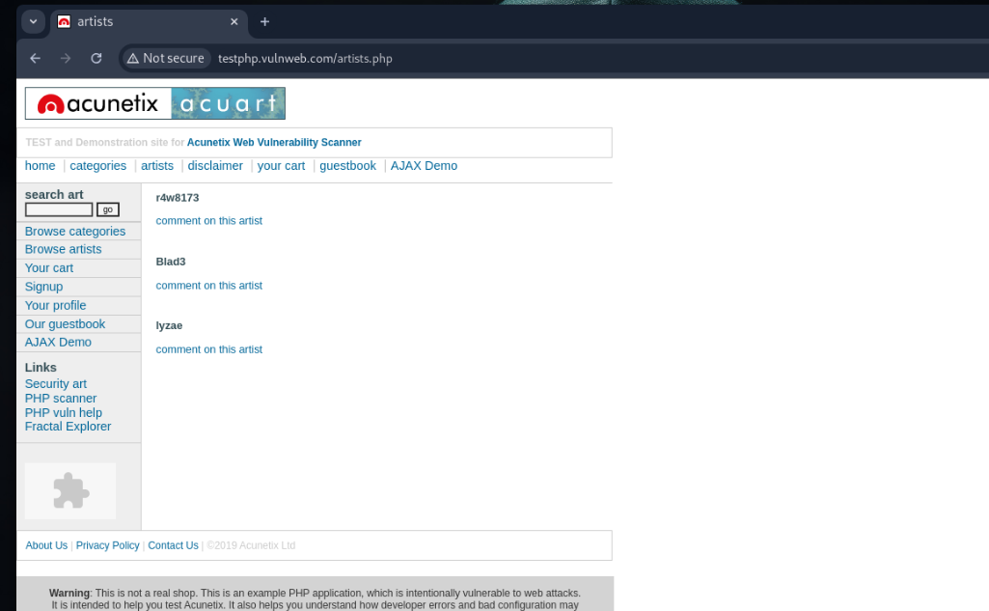

Type sqlmap -h, It will list all the available services.

Now you can see all the different switches that you can use with sqlmap and since we know that acunetix website is vulnerable to a sql injection we can now attempt to find the databases ,what is and how many sql type are running on the server.

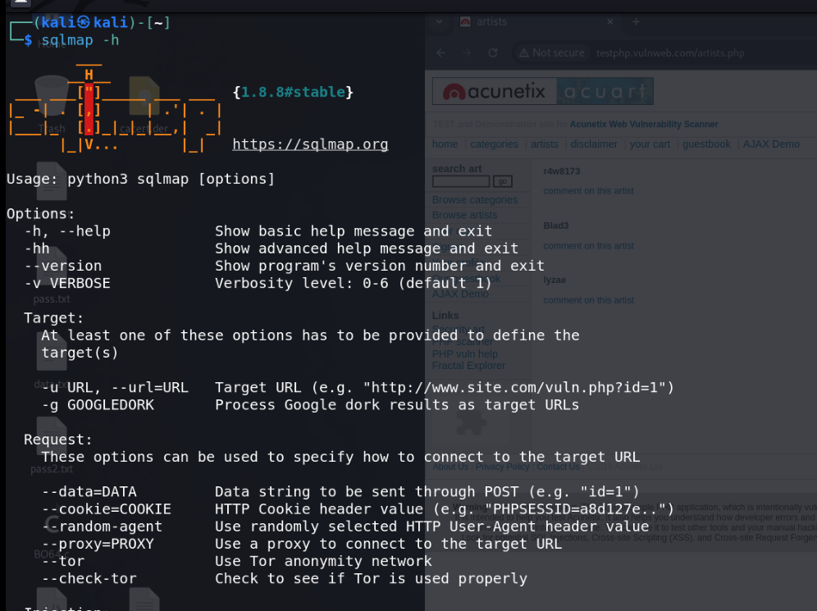

For accessing database type this command.

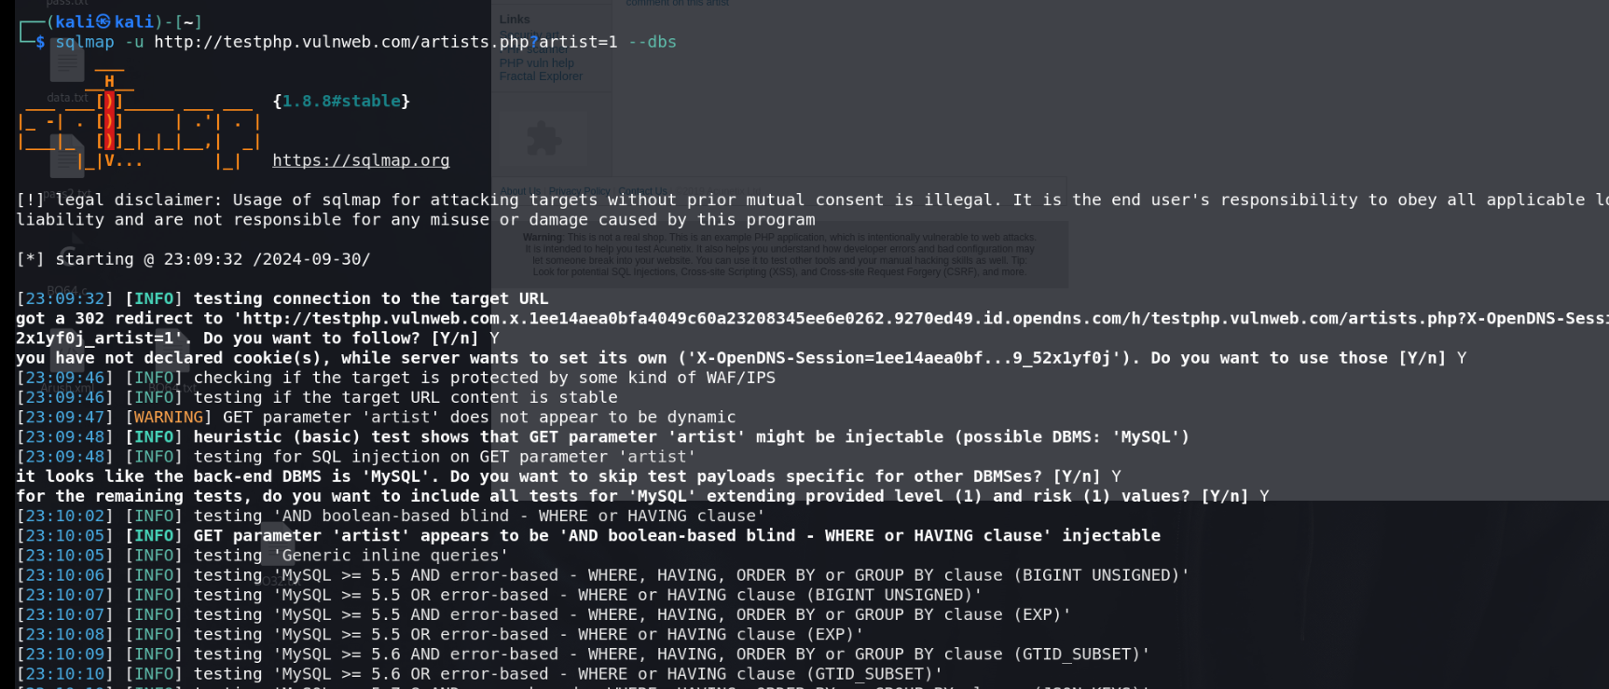

It will show 2 databases

1. acurat

2. Information_schema

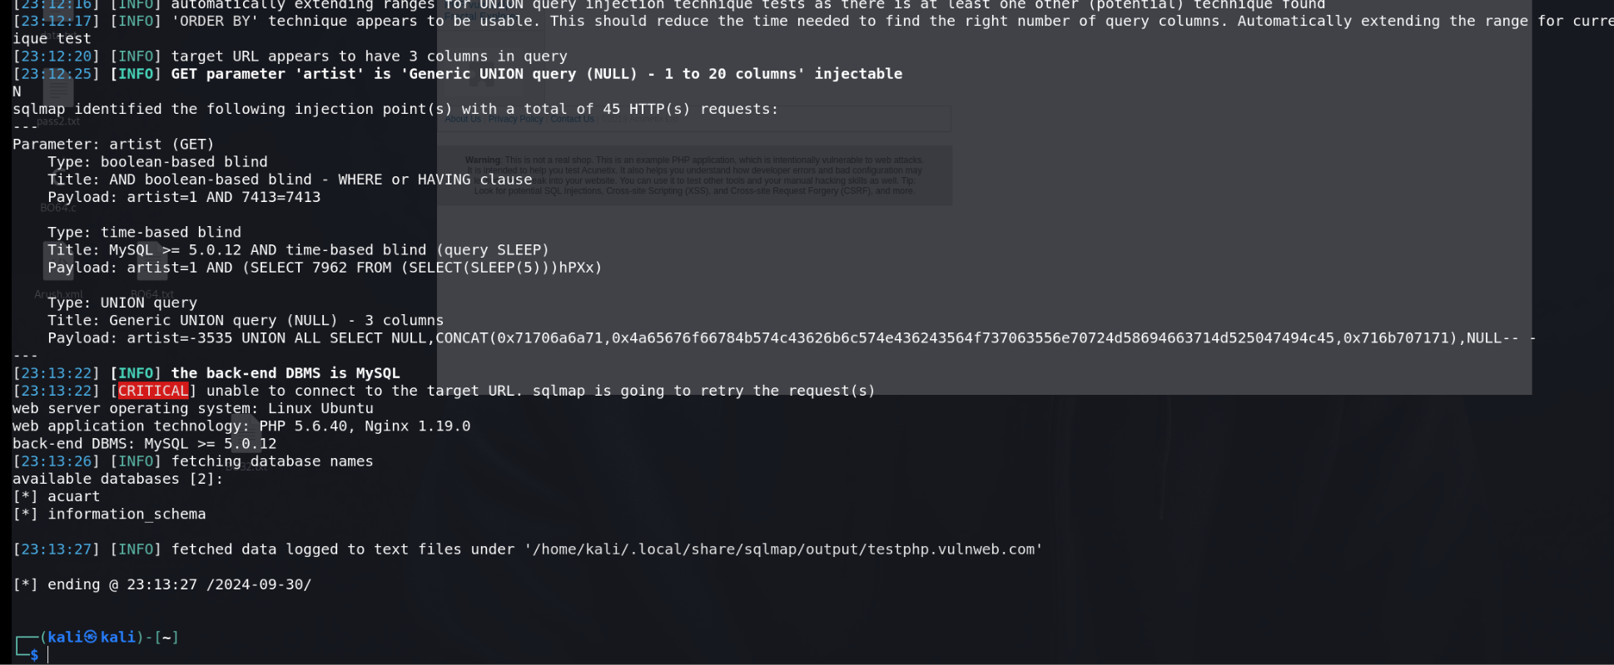

For accessing tables in database

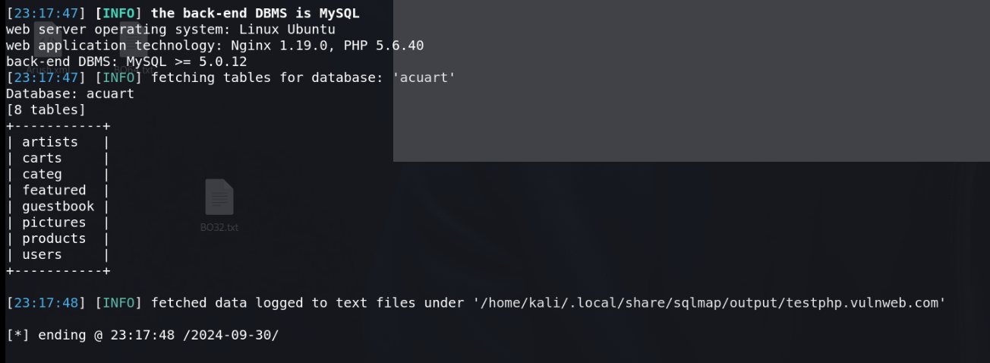

It will show all the present columns.

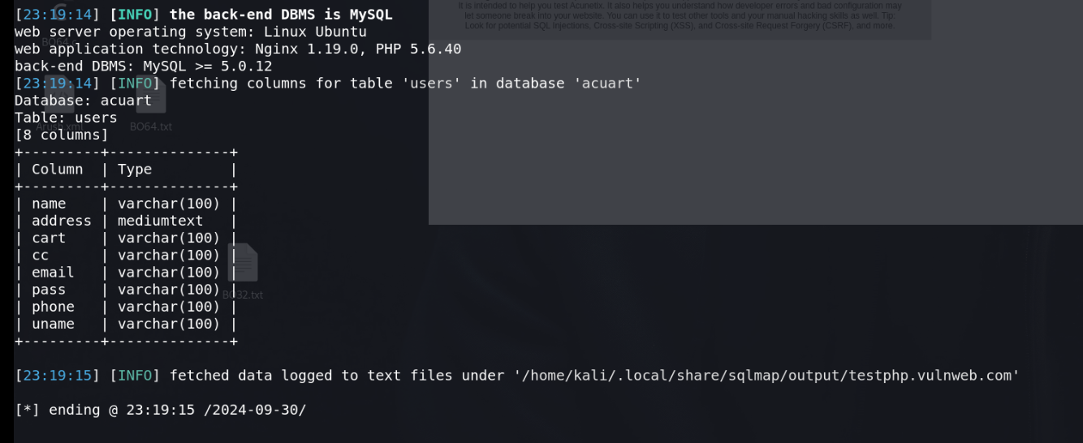

It will show the entry in uname column

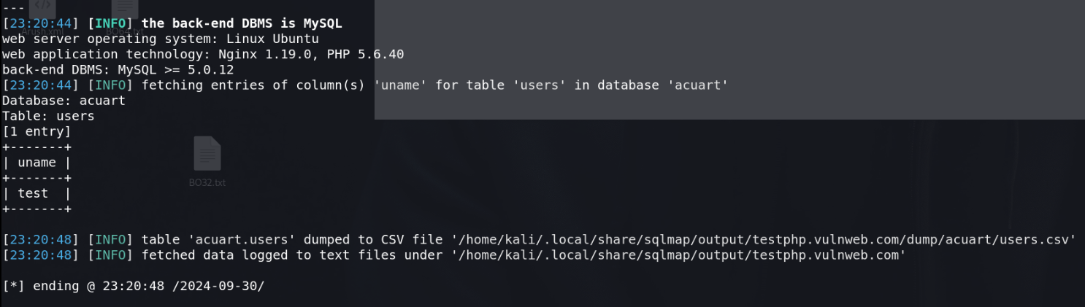

For altering the complete table

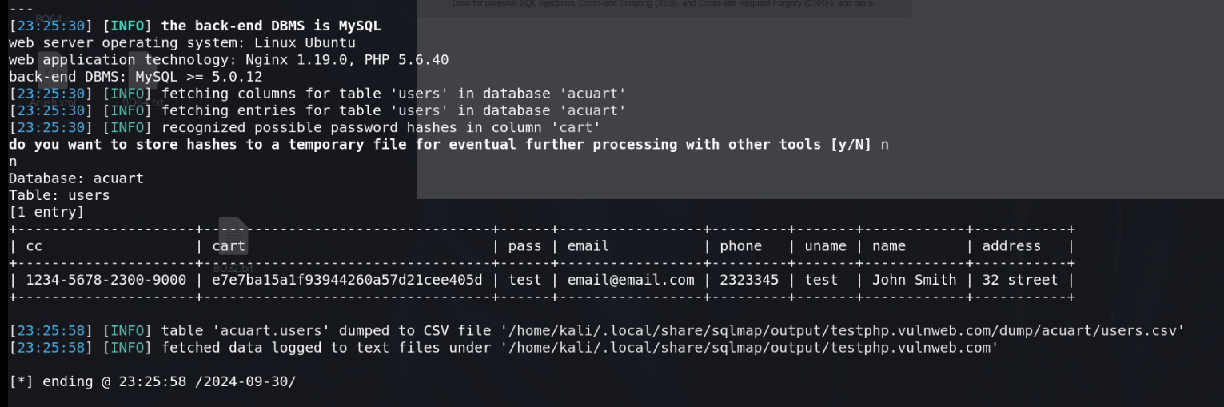

**NETBIOS ENUMERATION**

Network basic input output system,

NetBIOS is used to communicate over a Lan, file share, connect printers

TCP/IP devices identification

Netbios (windows) ,System in windows are known through netbios

Network - Unique and limit 16 char , 15 char are reserved for devices name .

16- identify services

Netbios enumeration tools – Netstat tool

Functions - Tells us about the established connection

**Commands**

netstat -h

It will tells us about all the flags.

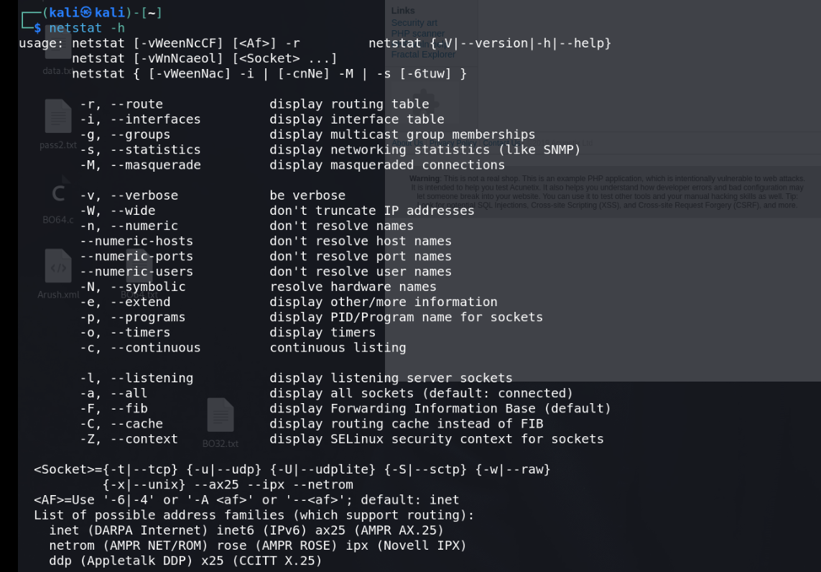

netstat -a

It will tells us about main tables

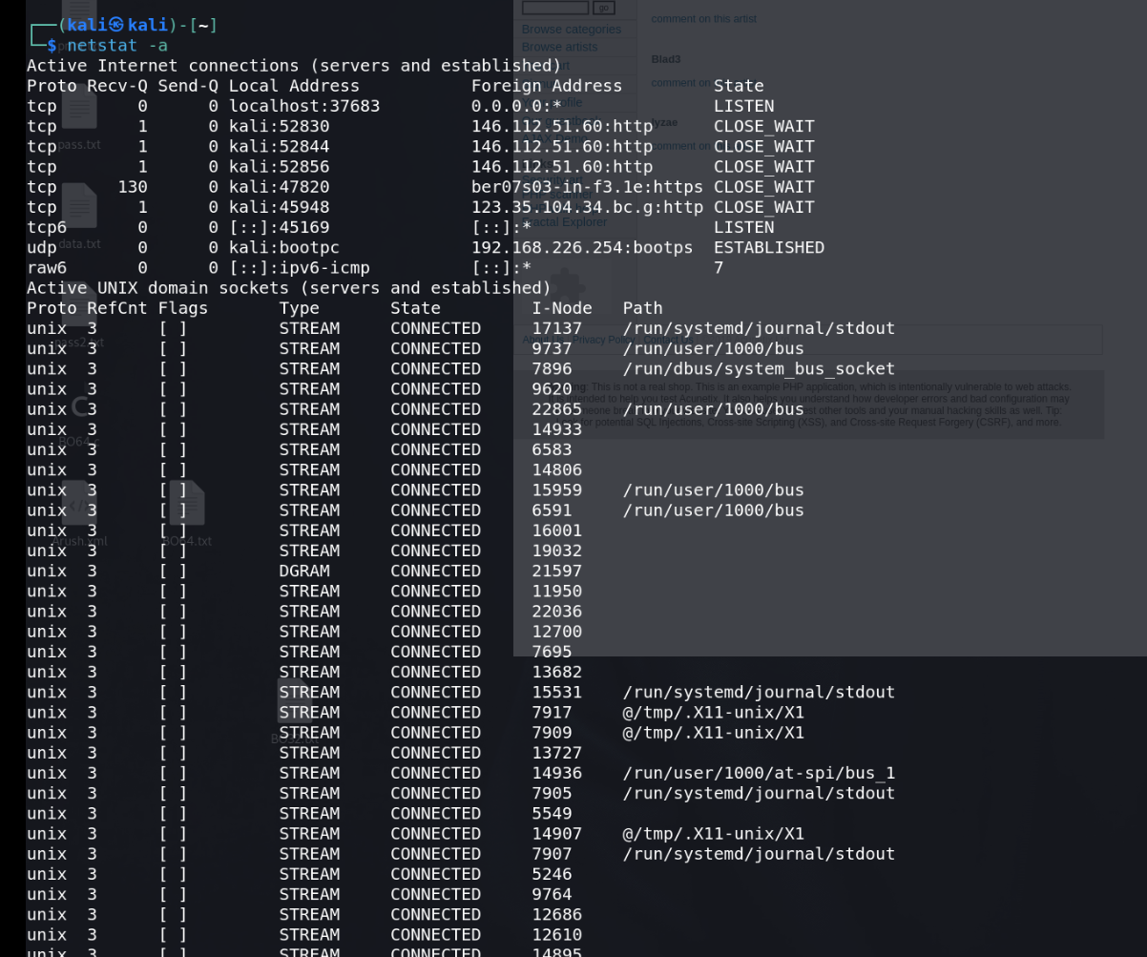

netstat -g

It will tells us about groups regarding ipv4/ipv6

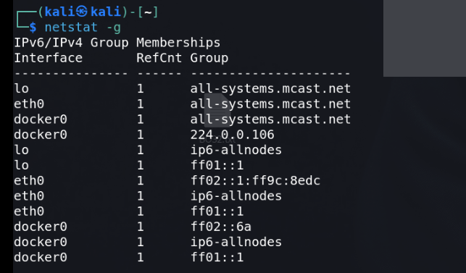

netstat -i

It will tells us about kernel interface table

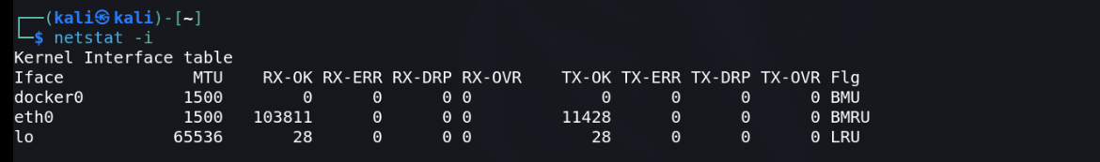

netstat -c

It will tells us about system cache information.

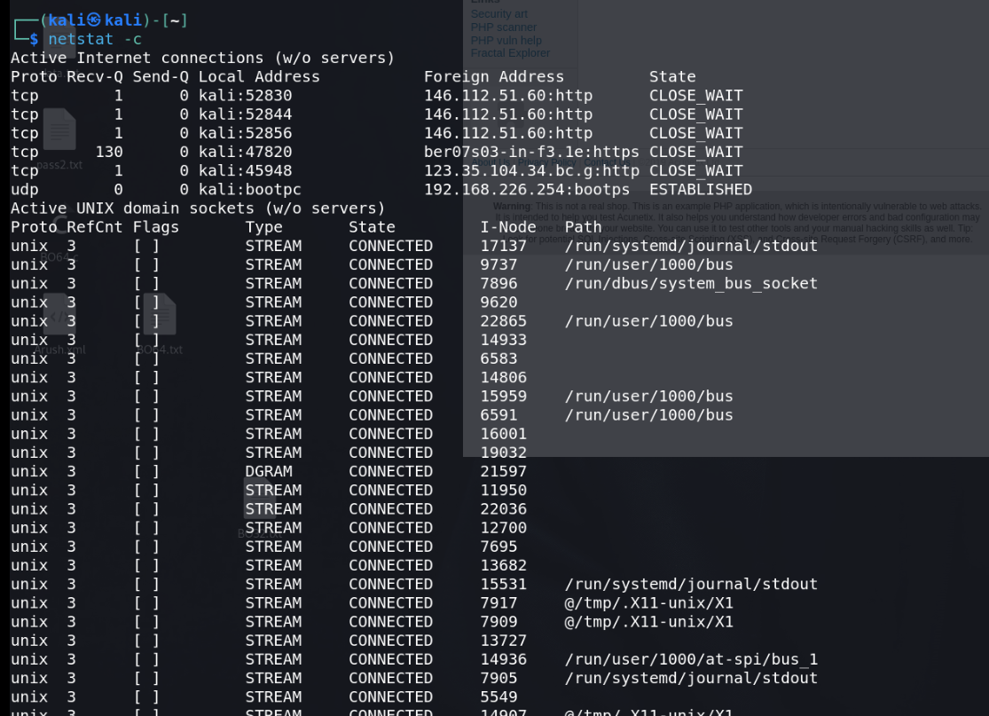

v

**LAB EXPERIMENT – 6**

**Mole**

**Nmap (Network Mapper)** is a huge tool and has many uses. Nmap is used to gather information about any device. Using the Nmap, we can gather information about any client that is within our network or outside our network, and we can gather information about clients just by knowing their IP. Nmap can be used to bypass firewalls, as well as all kinds of

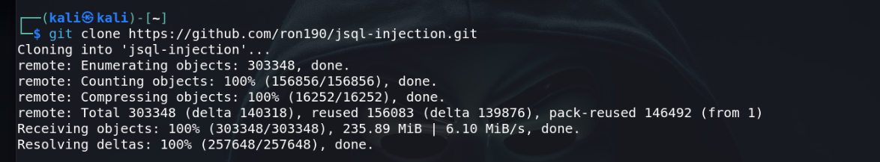



**LAB EXPERIMENT –7**

**Nmap**

**Nmap (Network Mapper)** is a huge tool and has many uses. Nmap is used to gather information about any device. Using the Nmap, we can gather information about any client that is within our network or outside our network, and we can gather information about clients just by knowing their IP. Nmap can be used to bypass firewalls, as well as all kinds of

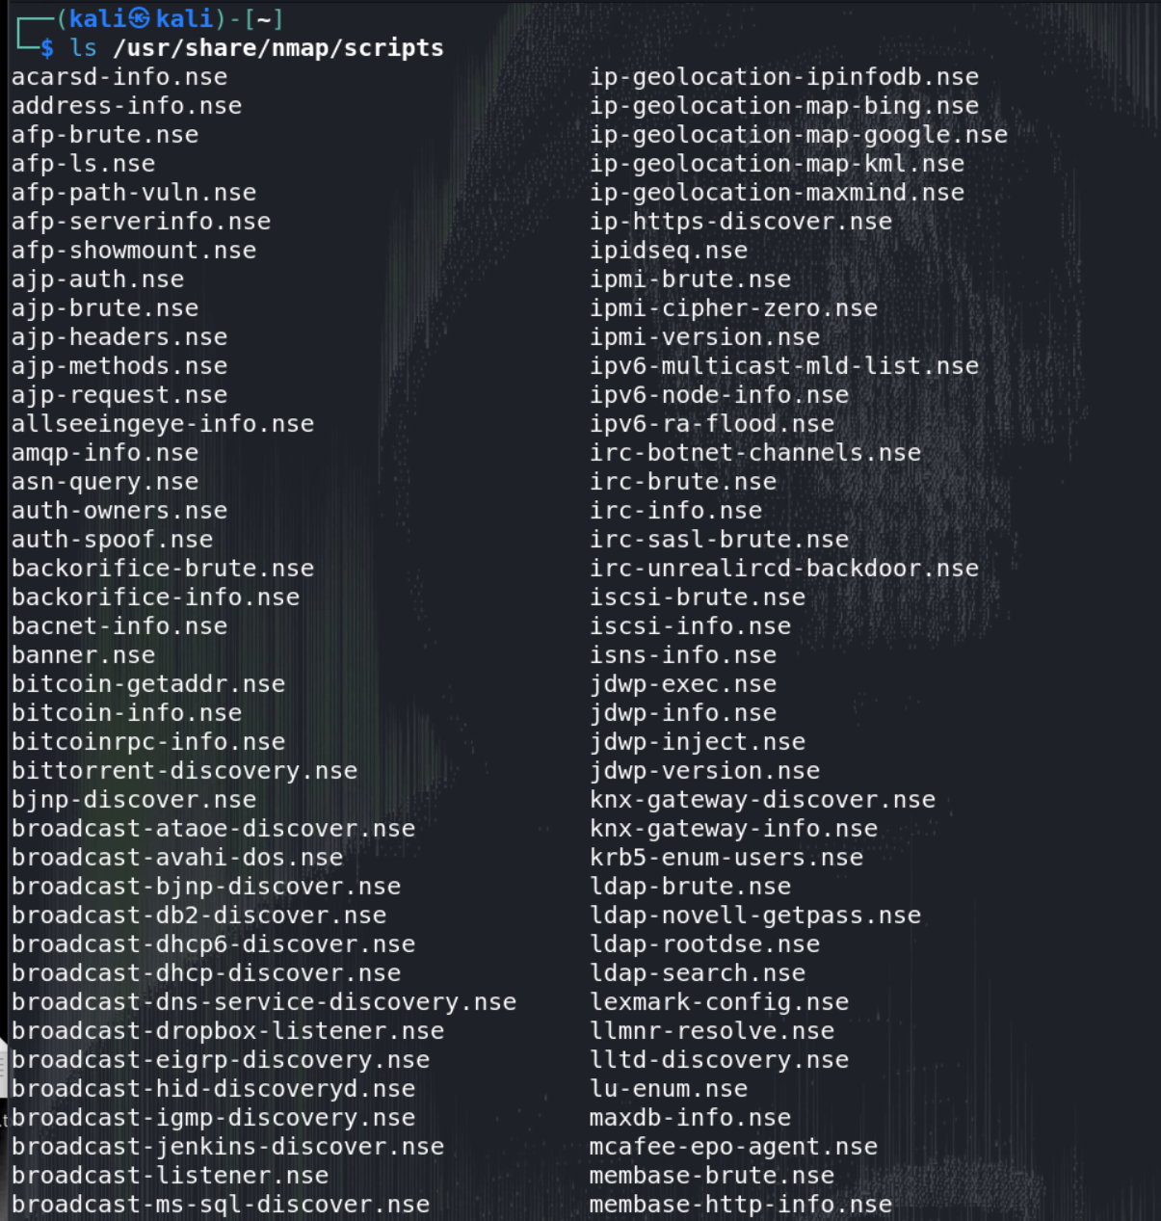

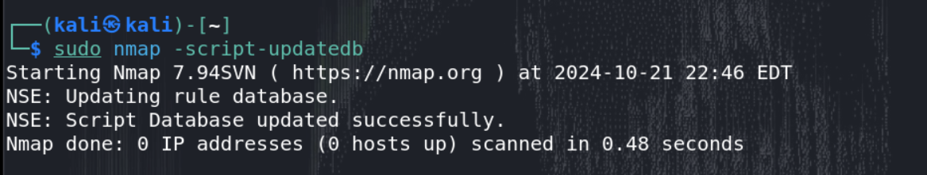

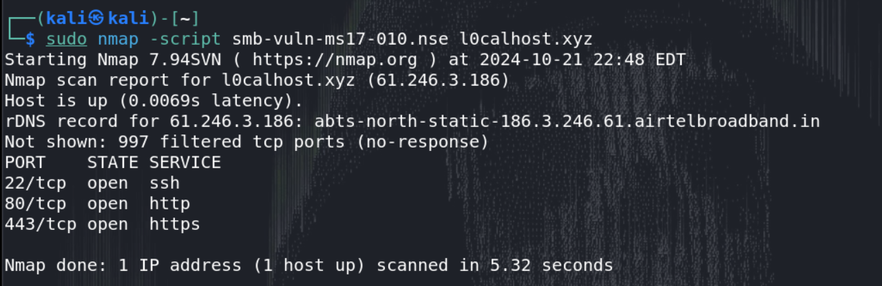

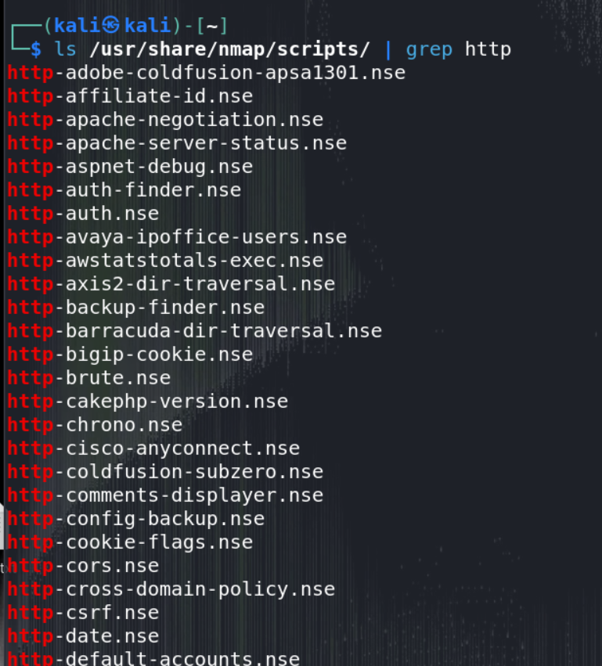

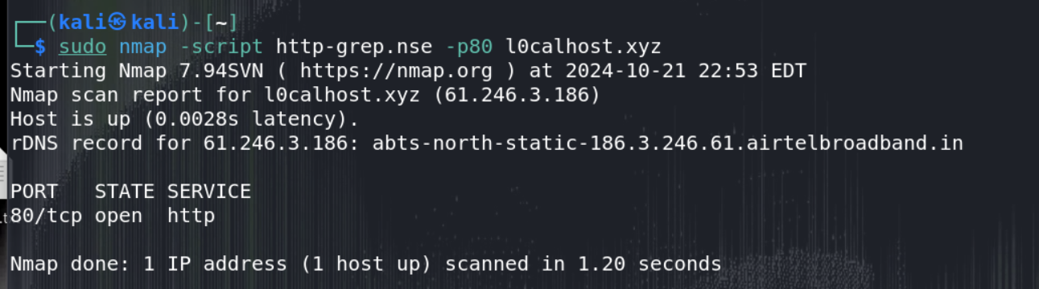

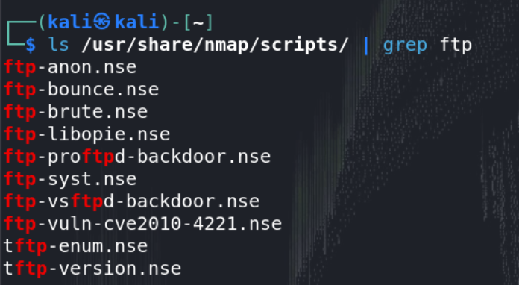

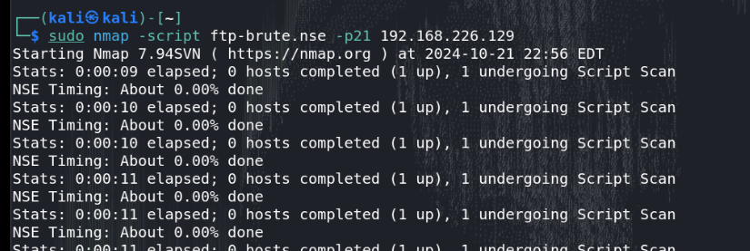

**LAB EXPERIMENT – 8**

**Elasticsearch and Kibana for Data Analysis**

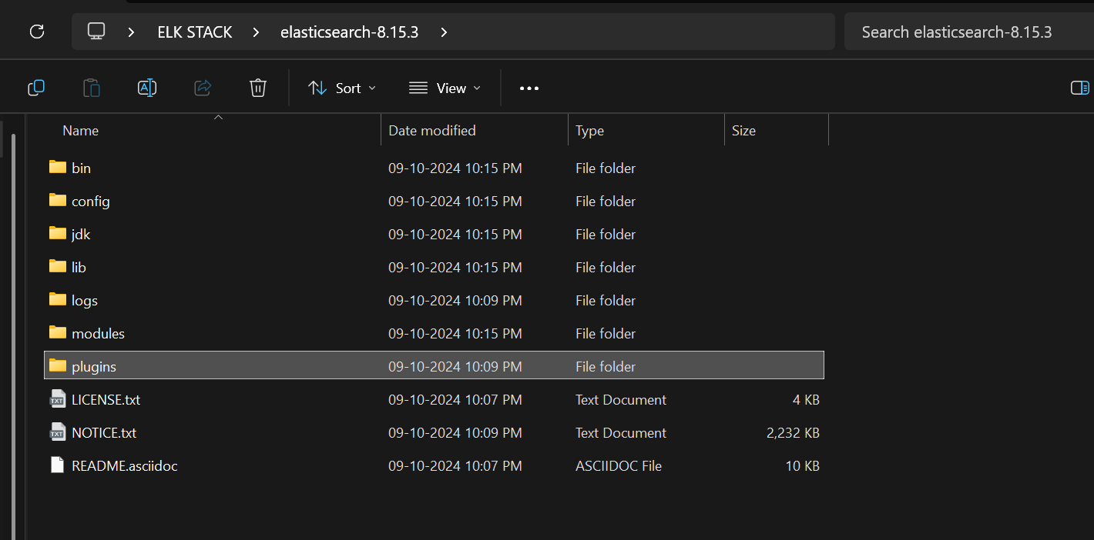

Add this line in elasticsearch.yml file present in config folder.

action.auto_create_index: .monitoring*,.watches,.triggered_watches,.watcher-history*,.ml*

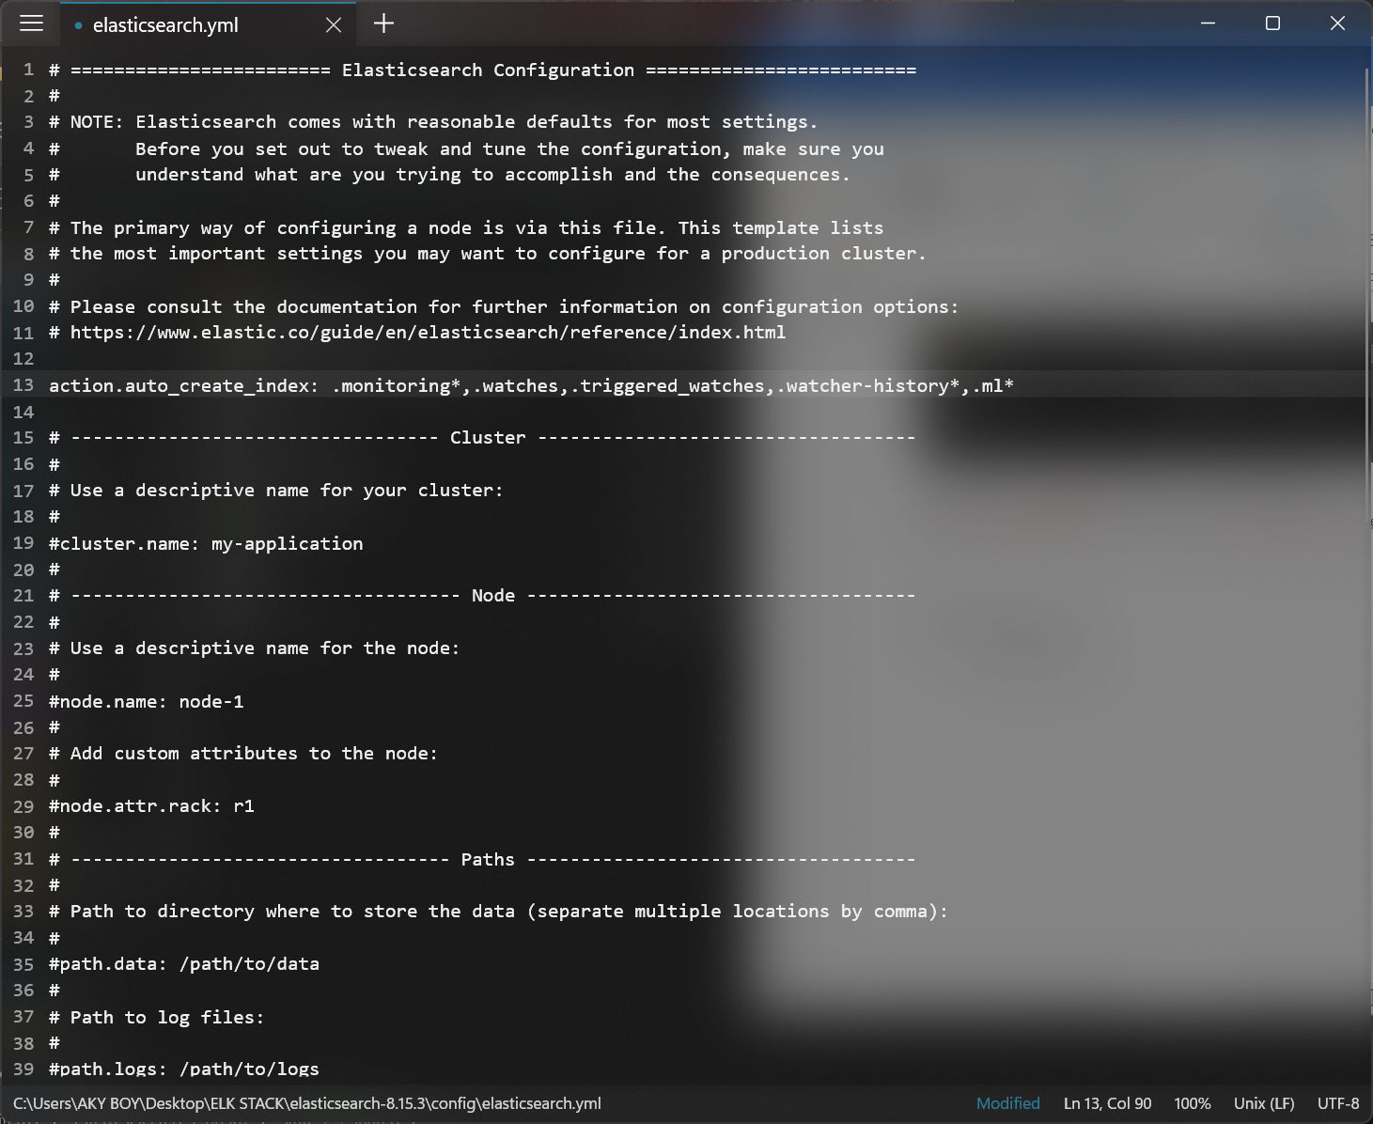

Start the Elastic search

cd bin

elasticsearch.bat

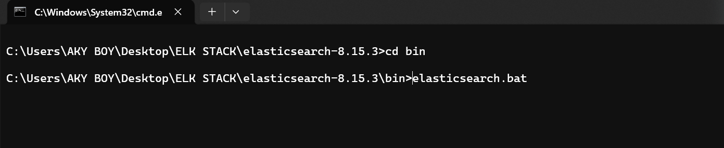

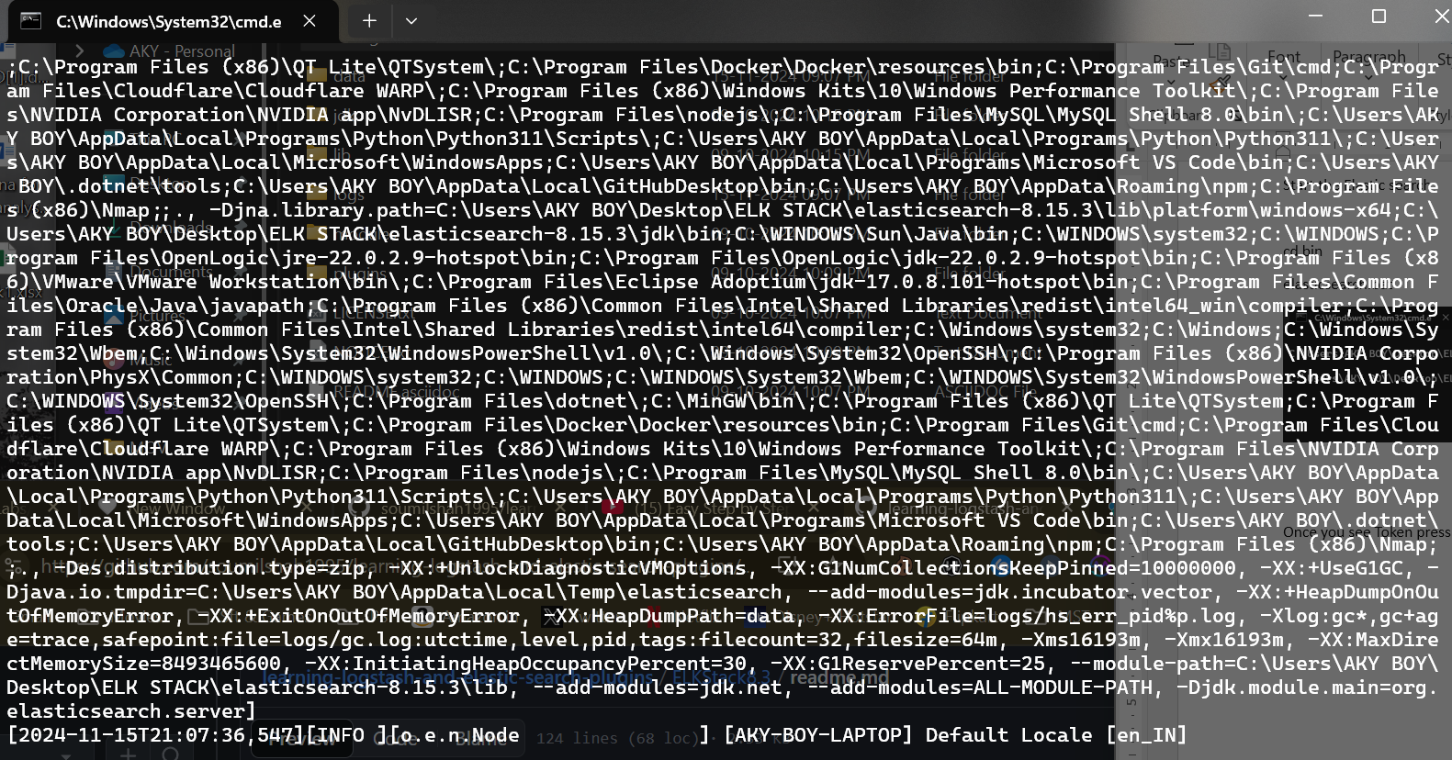

Once you see Token press CTR + C and stop it and copy Paste TOKEN

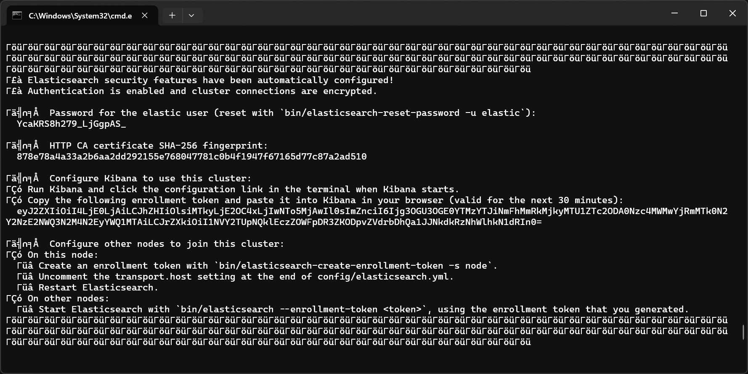

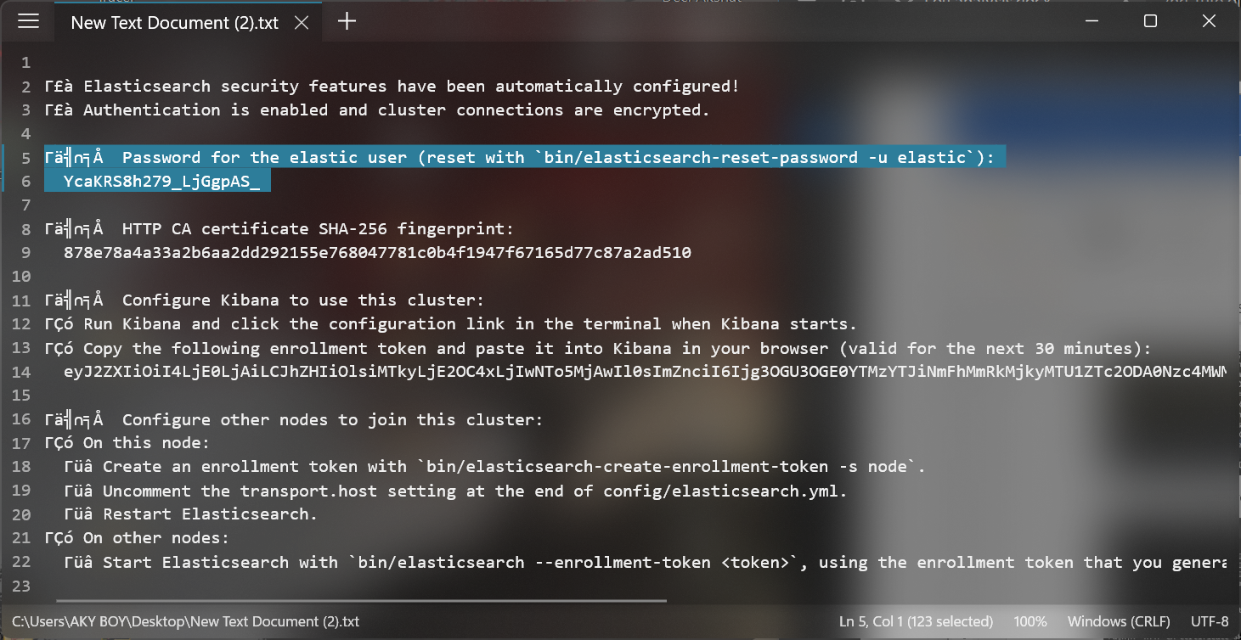

Open elasticsearc.yml file again

***********

SET this to false

enabled: true

*************

xpack.security.http.ssl:

enabled: false

keystore.path: certs/http.p12

xpack.security.transport.ssl:

enabled: false

verification_mode: certificate

keystore.path: certs/transport.p12

truststore.path: certs/transport.p12

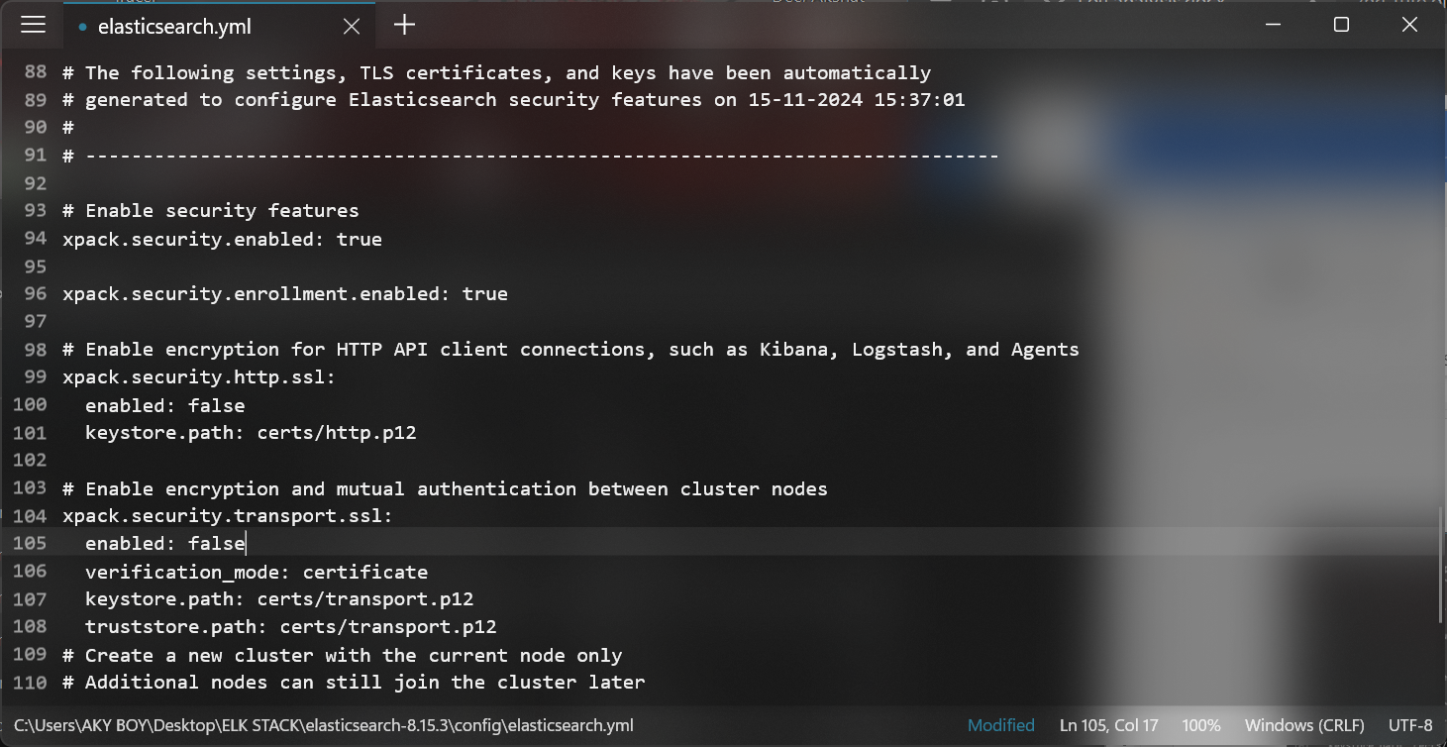

Start elastic search

elasticsearch.bat

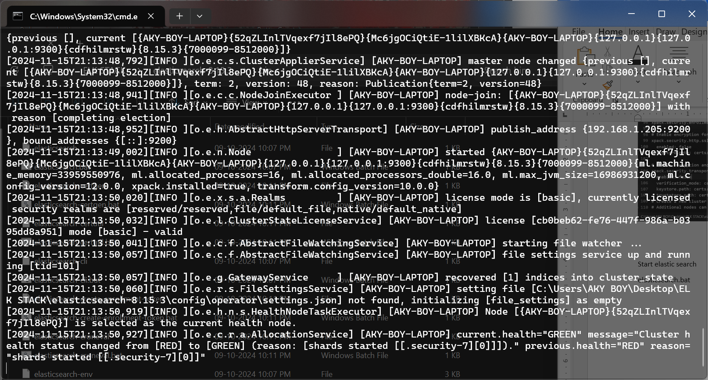

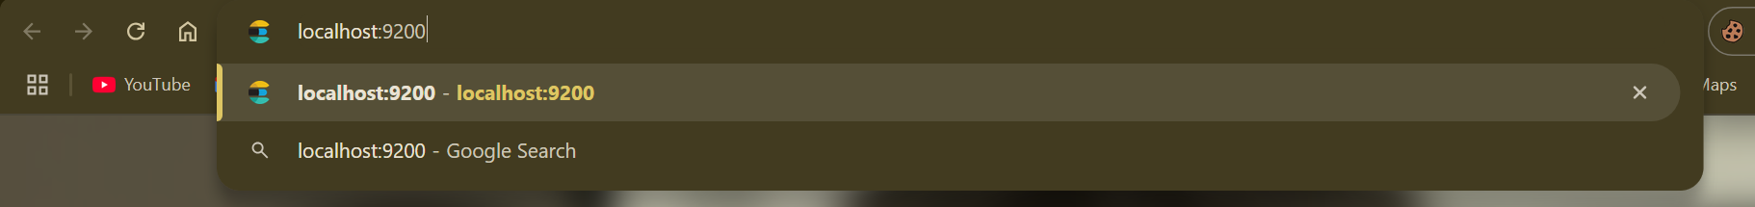

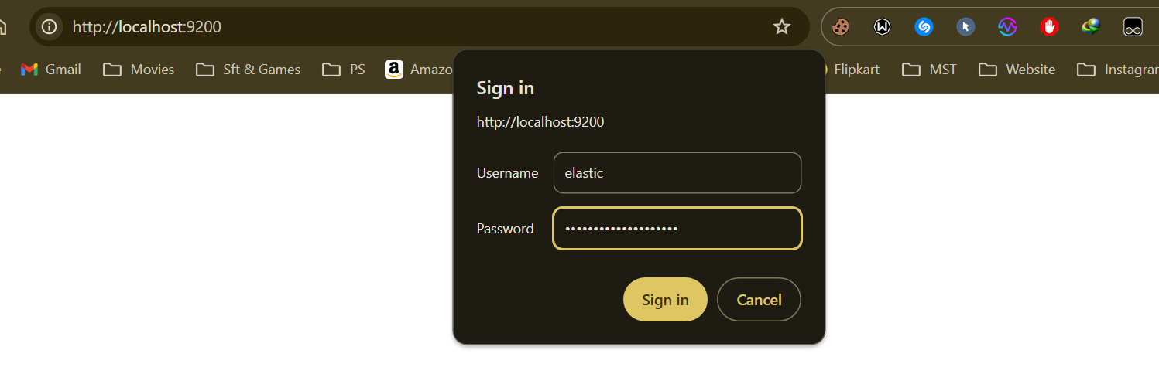

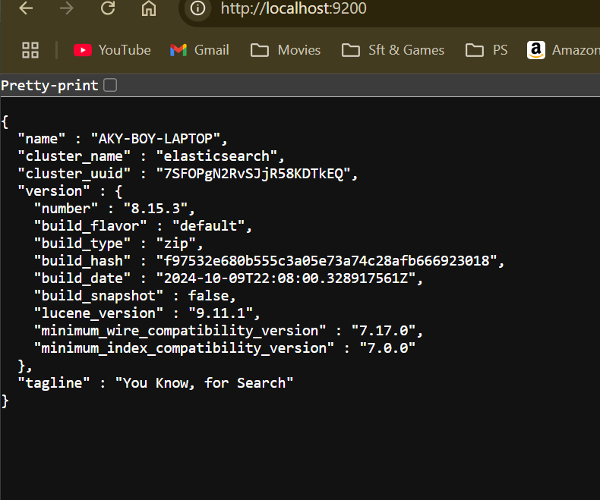

Elastic Search Works Perfectly

GO TO BIN directory and OPEN CMD

elasticsearch-reset-password -u elastic

elasticsearch-reset-password -u kibana_system

NOTE THE PASS ON NOTEPAD

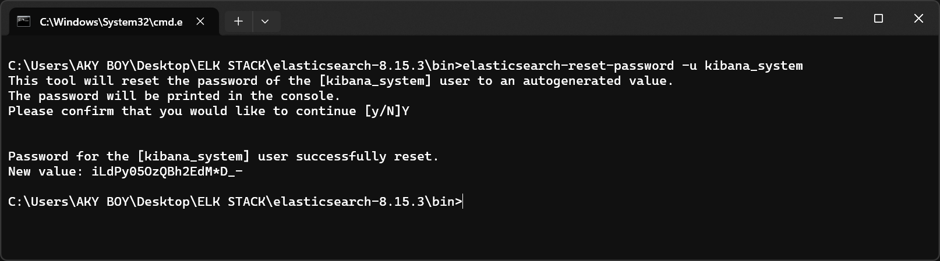

Kibana

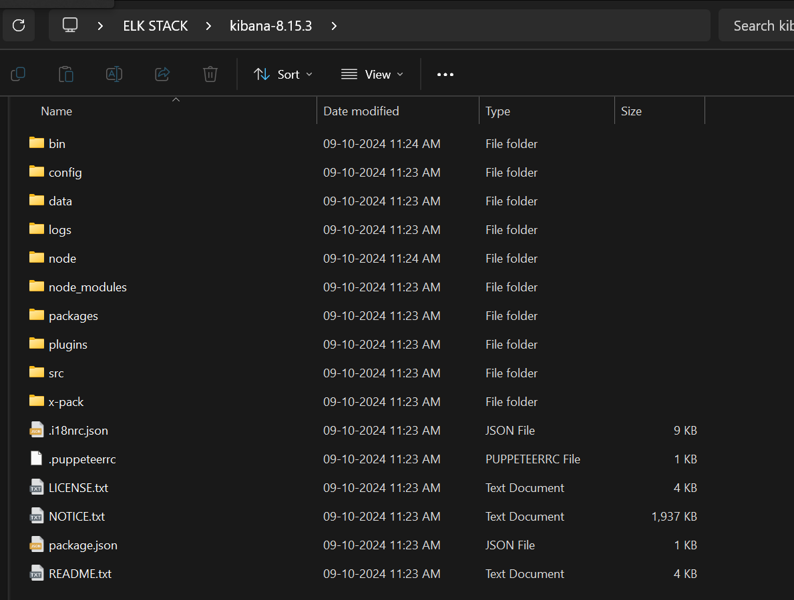

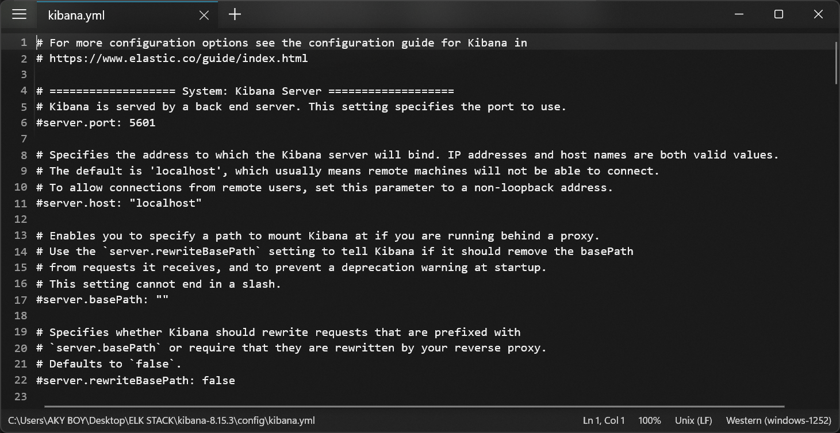

#server.port: 5601

#server.host: "localhost"

#elasticsearch.hosts: ["http://localhost:9200"]

#elasticsearch.username: "kibana_system"

#elasticsearch.password: "pass"

Replace it with elasticsearch.password: "iLdPy05OzQBh2EdM*D_-"

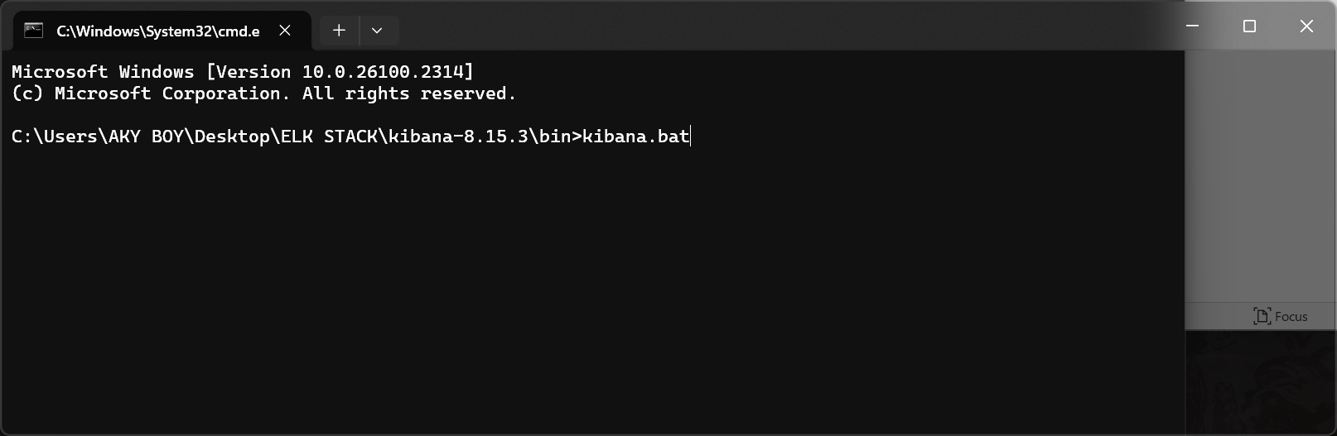

Find the redirecting localhost 9200 url in the cmd to redirect u to the kibana system.

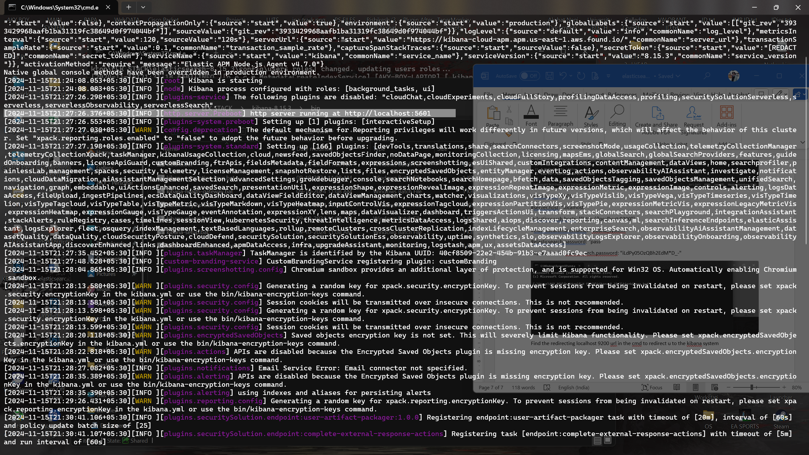

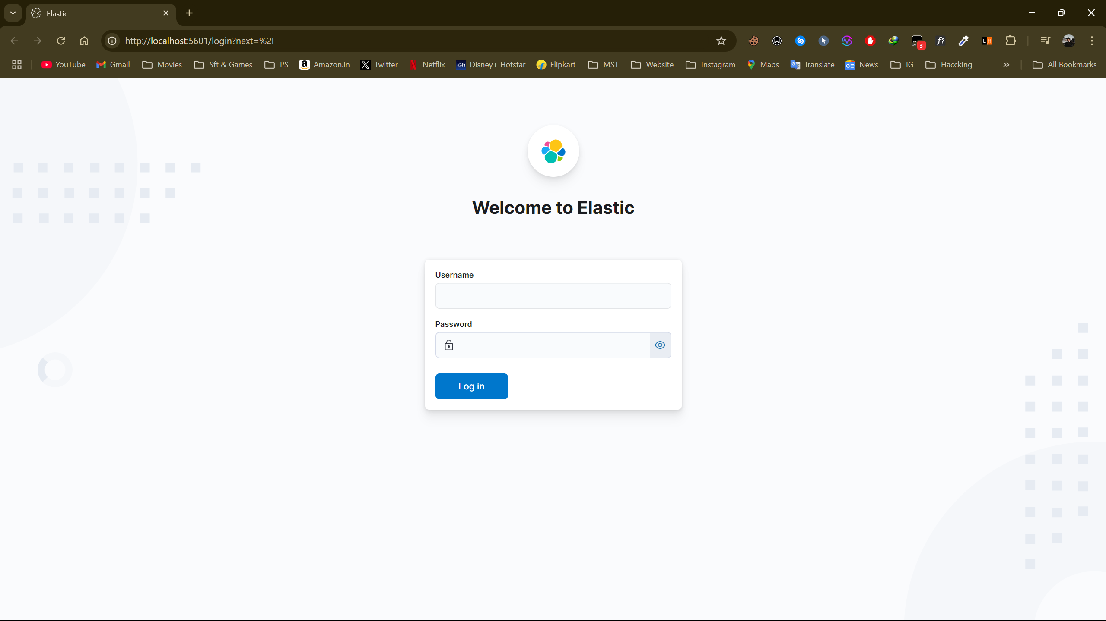

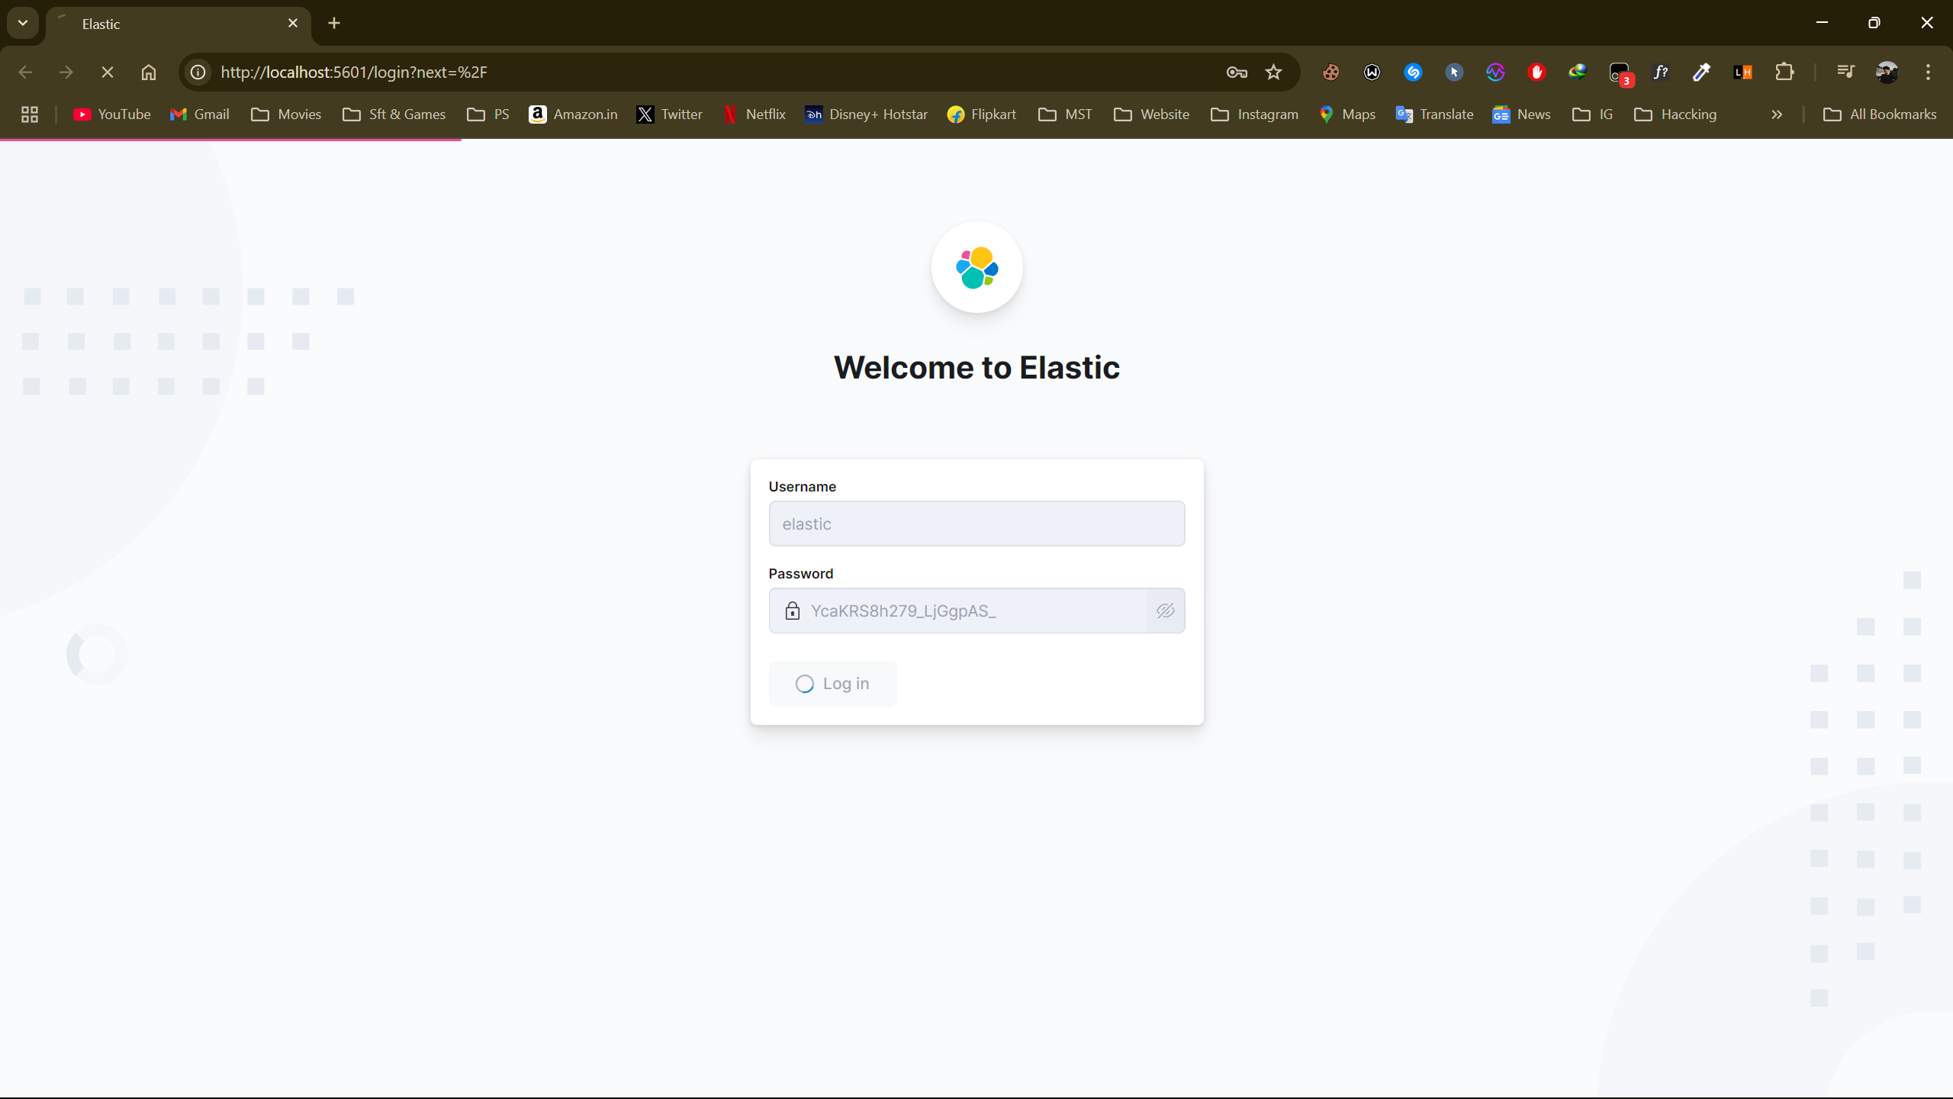

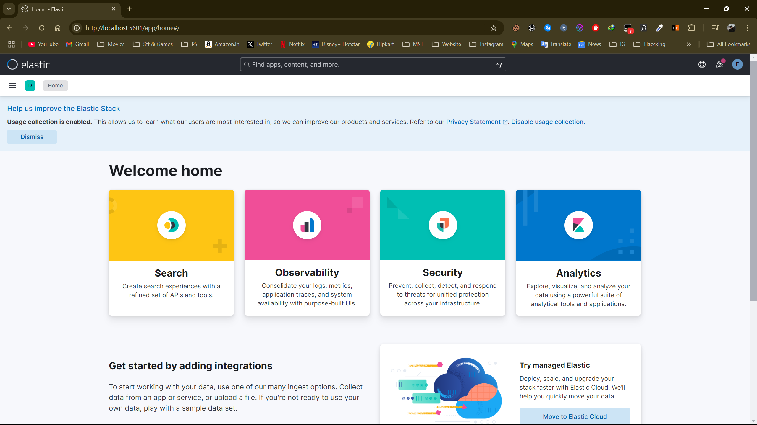

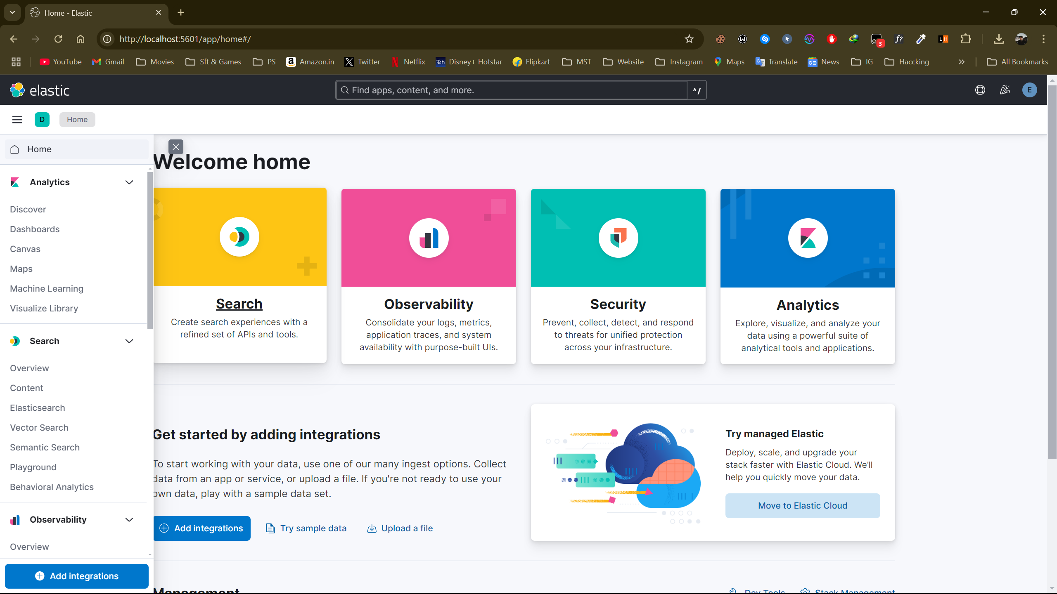

**Creating Visualizations in Kibana**

**Types of Visualizations**

Kibana supports a variety of visualization types:

* **Bar Charts**: Display trends or comparisons.
* **Line Charts**: Show continuous data over time.
* **Pie Charts**: Represent proportions or percentages.
* **Maps**: Visualize geospatial data.
* **Tables**: Display raw data in tabular format.
* **Metric Visualizations**: Highlight key metrics or single values.

**Steps to Create a Visualization**

1. **Navigate to Visualizations**:
   * Go to *Visualize Library* → *Create Visualization*.
2. **Choose a Visualization Type**:
   * Select the type that best fits your data and analysis goals.
3. **Select Data Source**:
   * Choose the index pattern or saved search to use as the data source.
4. **Configure Visualization Options**:
   * **Metrics**: Define the metrics (e.g., Average, Count, Sum) for aggregation.
   * **Buckets**: Split data into groups or categories.
   * Customize labels, colors, and other settings.
5. **Preview and Save**:
   * Review the visualization.
   * Click *Save* and name your visualization.

**Example: Create a Bar Chart**

1. Go to *Visualize Library* → *Create Visualization* → *Bar Chart*.
2. Select your index pattern.
3. In the **Metrics** section, choose Count as the aggregation type.
4. In the **Buckets** section, choose X-Axis, and then select a field to group by (e.g., category).
5. Adjust the chart's appearance and labels.
6. Save the visualization.

Dos Attack Data Set

* Installation already done in Last Tutorial.
* I performed a DoS attack on a Kali system and saved the DoS
* attack data using wireshark.
* Data set (CSV, JSON, pcap, pcapng)
* Then add this dataset to Kibana. (At home page there is option

upload a file)

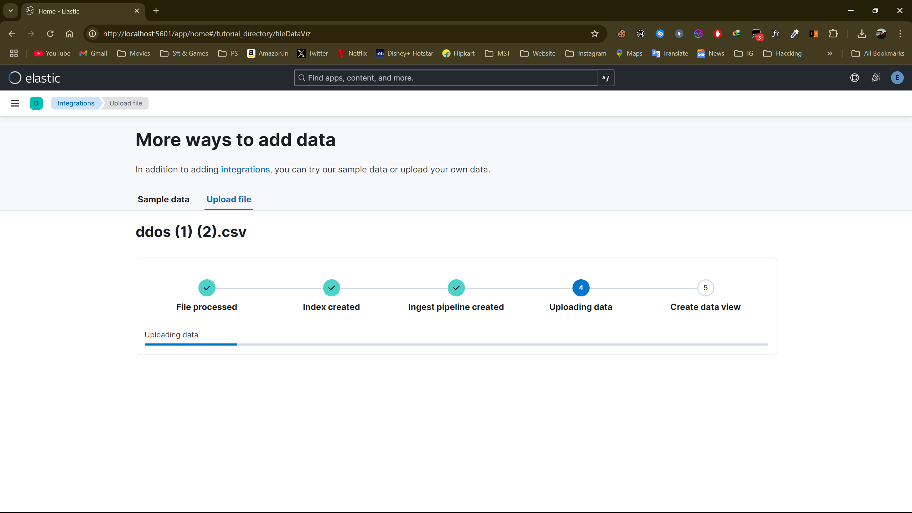

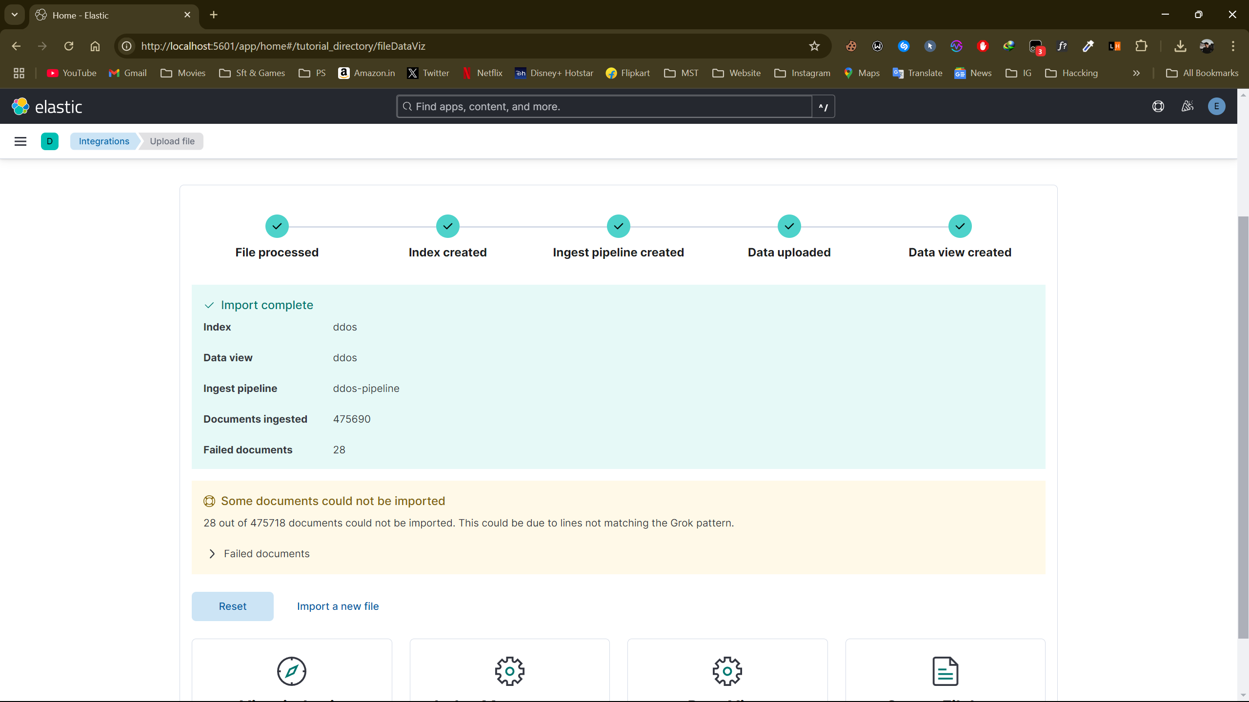

Go to the dashboard, then create a new visualization and

use the dataset that was uploaded. Select the field you

want to visualize.

